**PROG8185 – WEB TECHNOLOGIES**

**PROJECT_04**

**Submitted By**

**Vidhi Bhavinbhai Patel - 8715921**

**Vandana Ghori - 8715197**

**Sree Renjini Kolappillil Rajendran - 8698374**

**Guided By**

**Hamad Zawawi**

**19th April, 2021**



**Technologies Used:**

* NodeJS
* MongoDB
* PostMan

**Database Schema:**

**Products:**

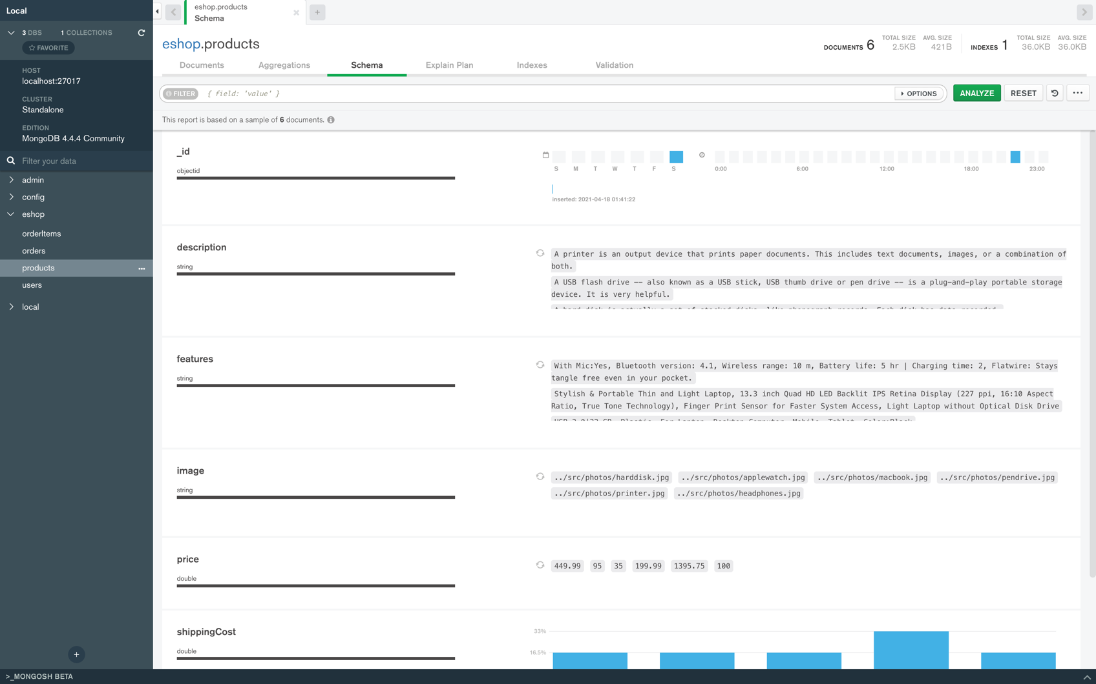



**Users:**

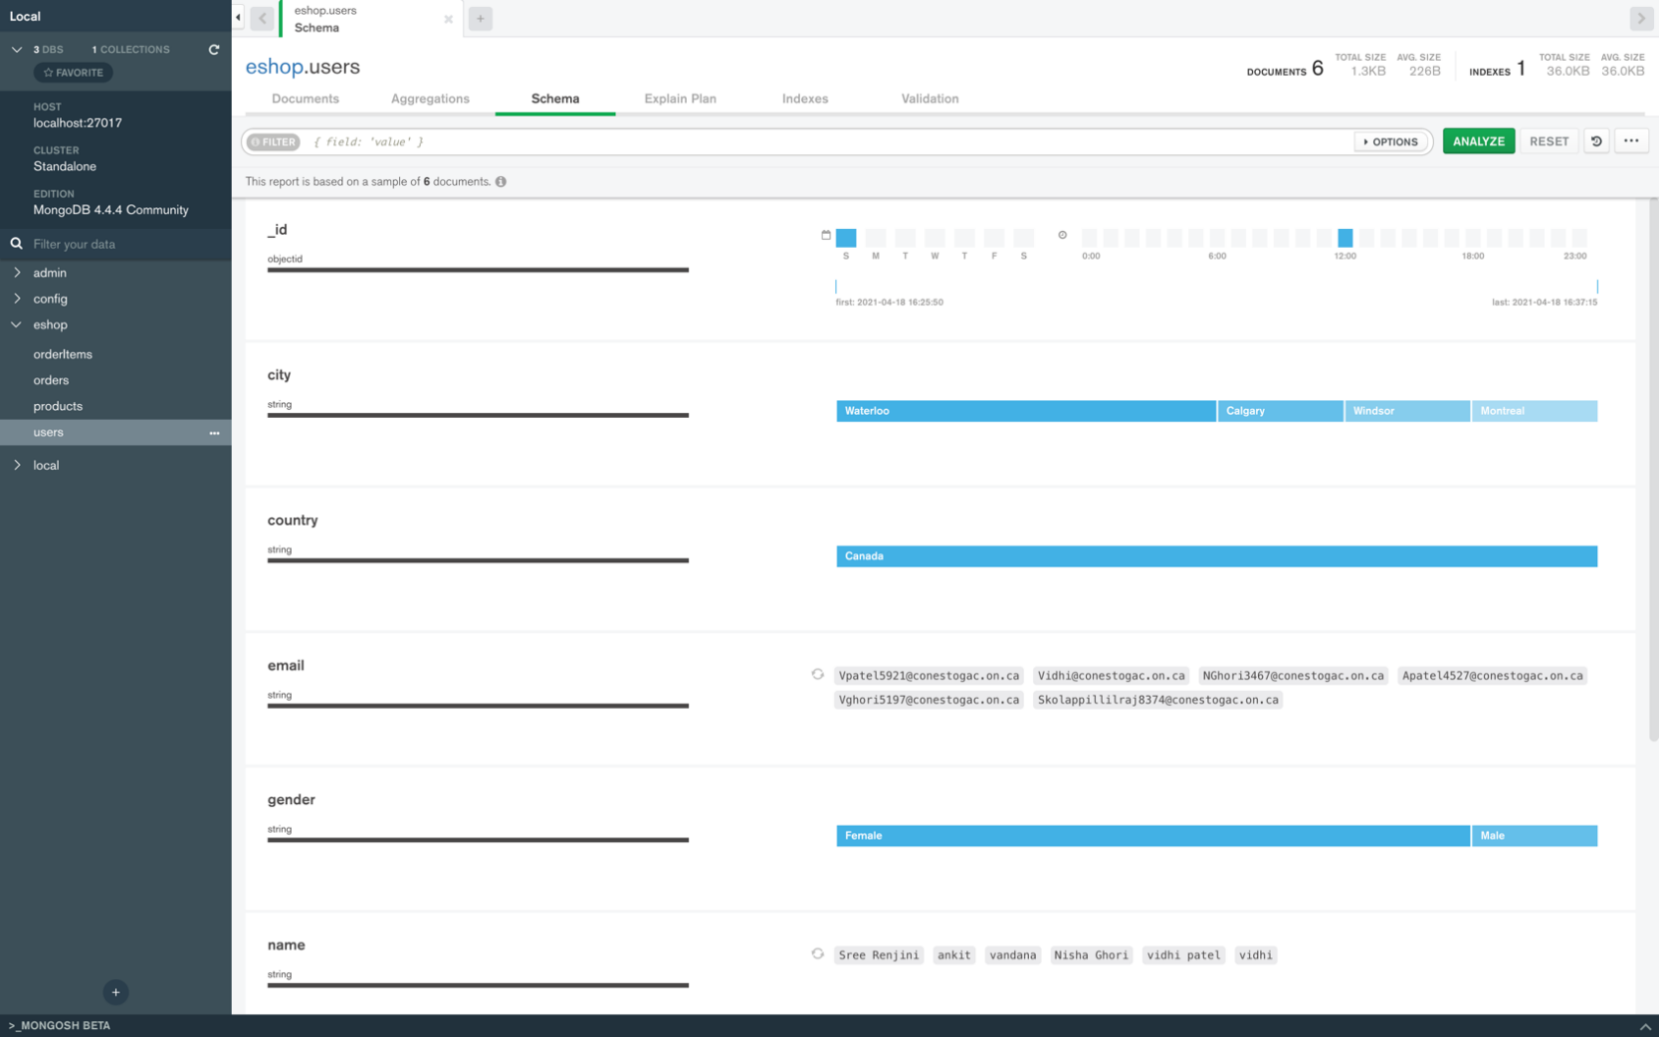

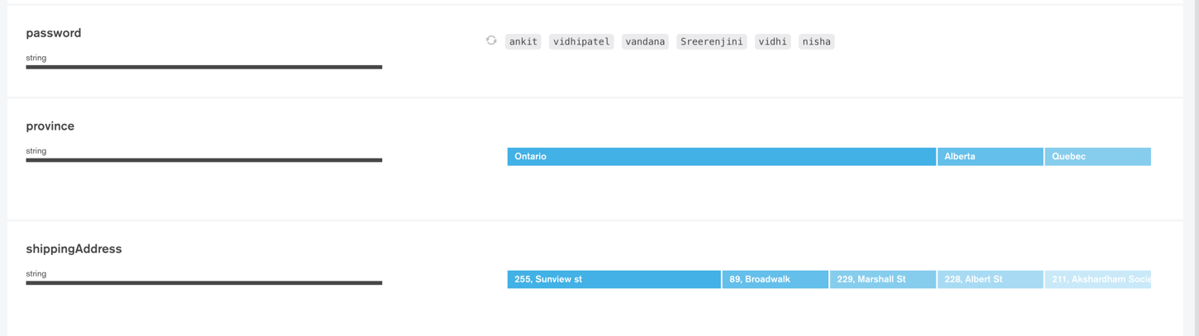

**Orders:**

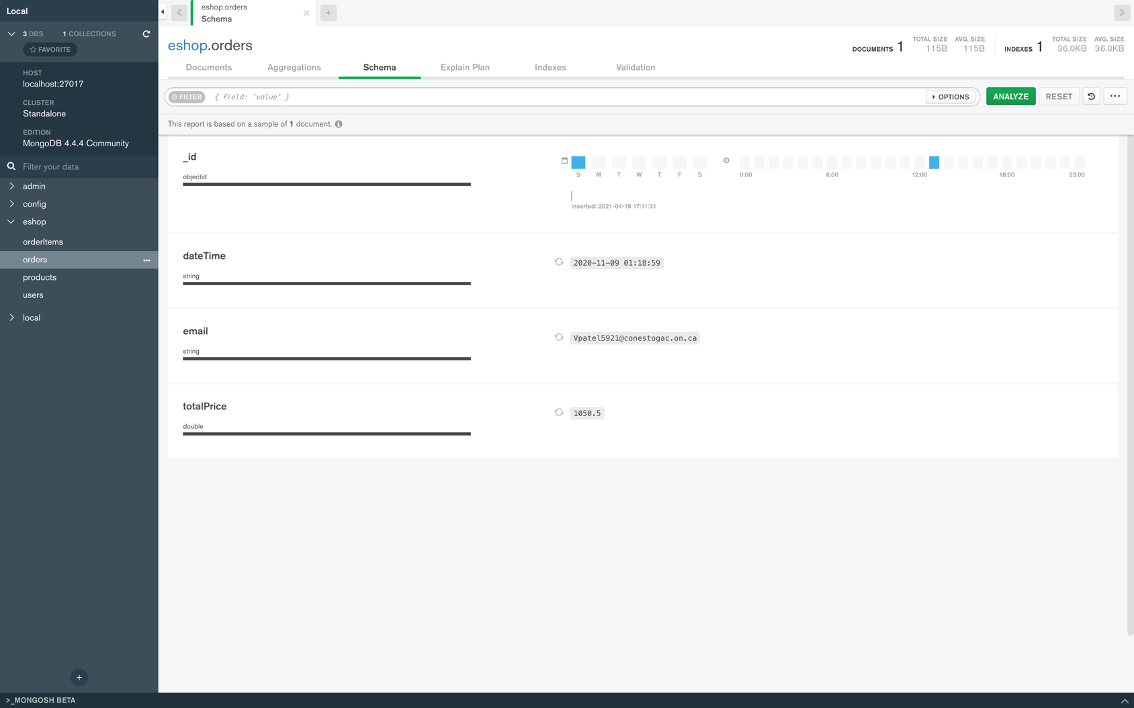

**OrderItems:**

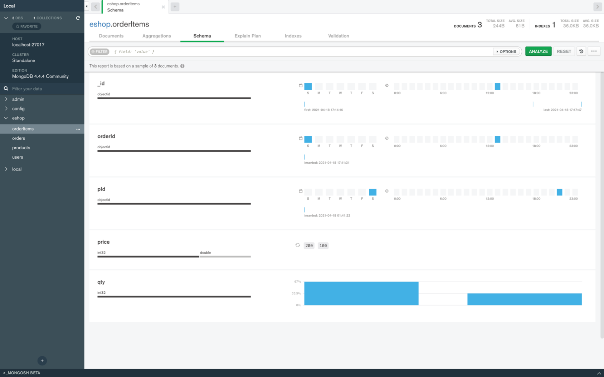

**CartItems:**

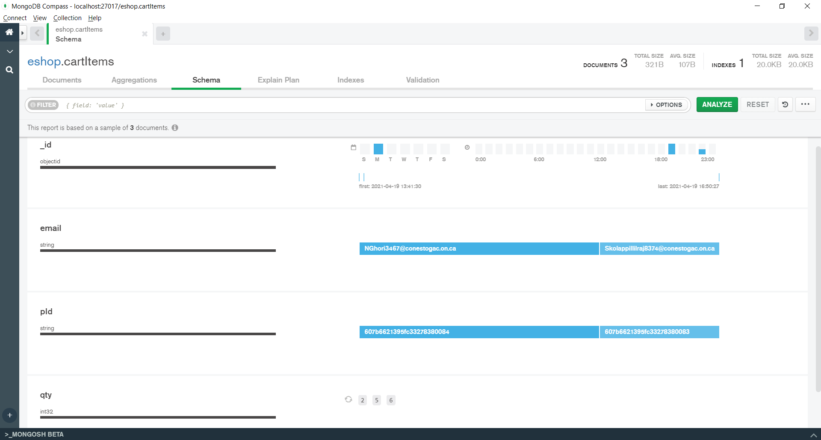

**Comments:**

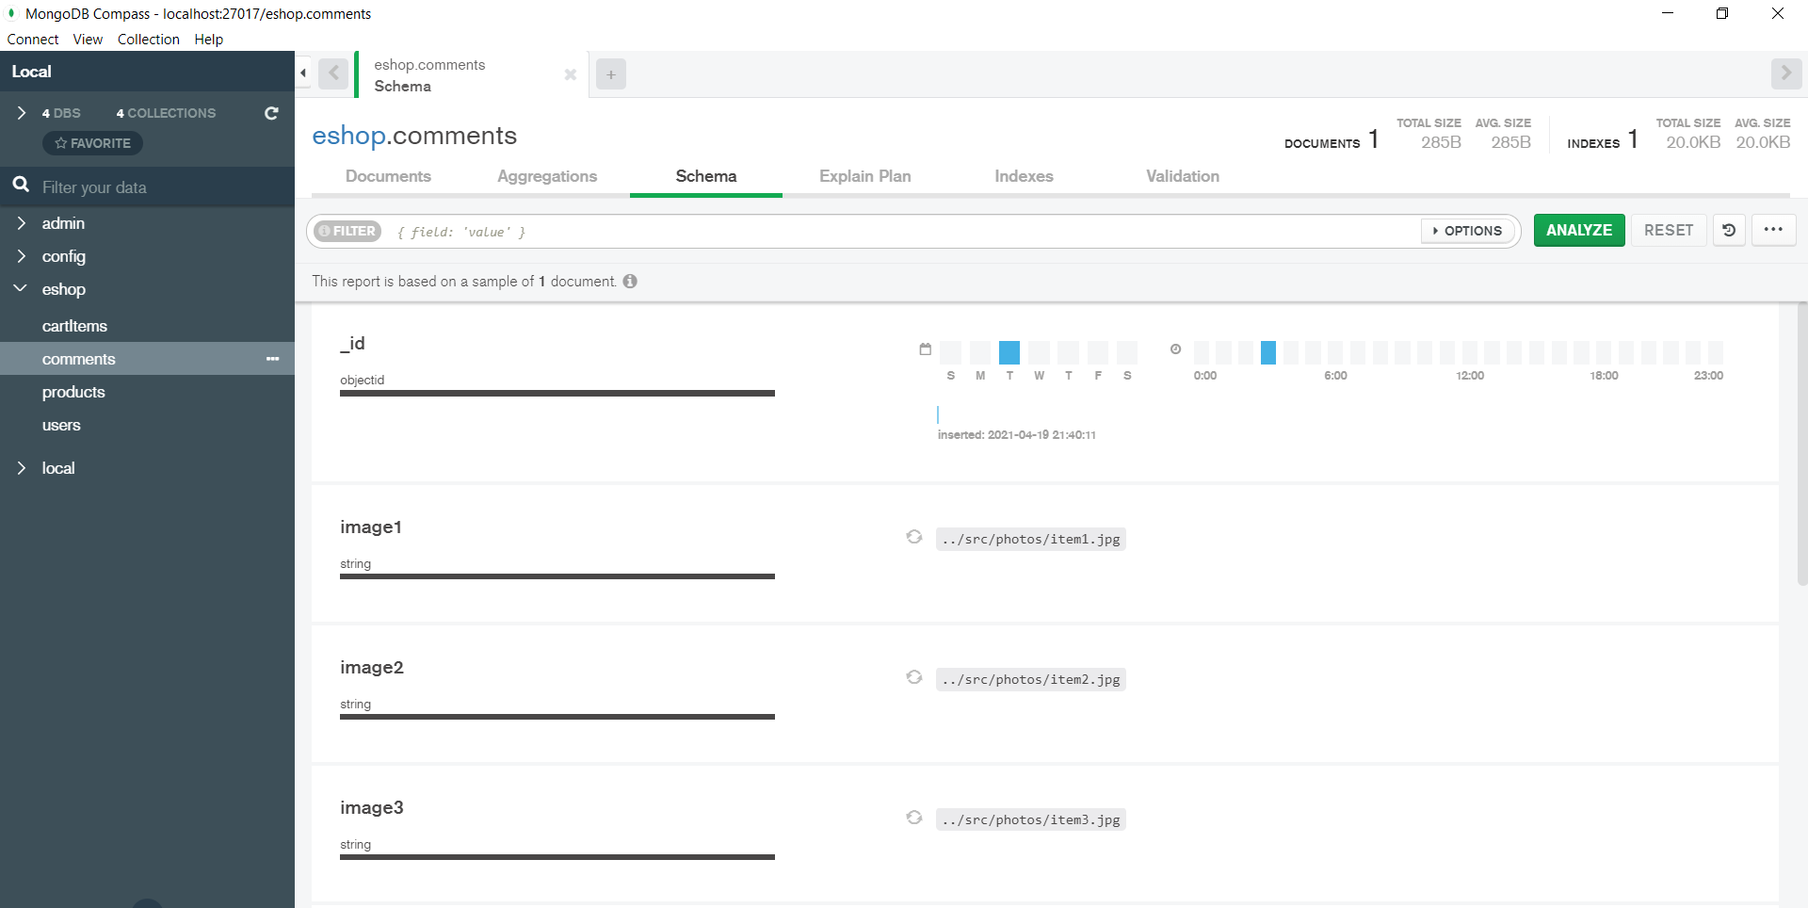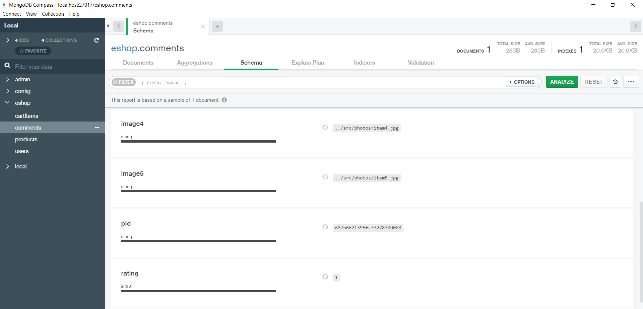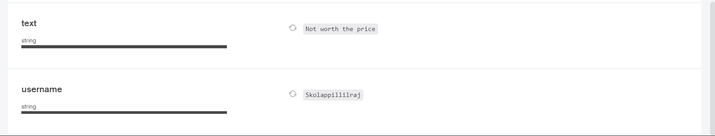

**Postman Test Results:**

1. **Products:**

**End Point**: /products

* 1. **POST method**: it is used to add new product into database.

Request body JSON sample:

{

"title": "Apple Watch Series 3",

"image": "../src/photos/applewatch.jpg",

"description": "Apple Watch Series 3 brings built-in cellular, powerful new health and fitness enhancements.",

"features": "GPS and Alimeter, Swimproof, Voice Based Siri, 3 Activity Rings Tracking - Move, Excercise, Stand, Smart Coaching, Breathe Application, Heart Rate Monitor, Notifier, Fitness & Outdoor",

"price": 199.99,

"shippingCost": 10

}

Response:

{

"success": **true**,

"message": "The product is added successfully."

}

**Test case 1.1.1:**

All data is provided correctly in request.

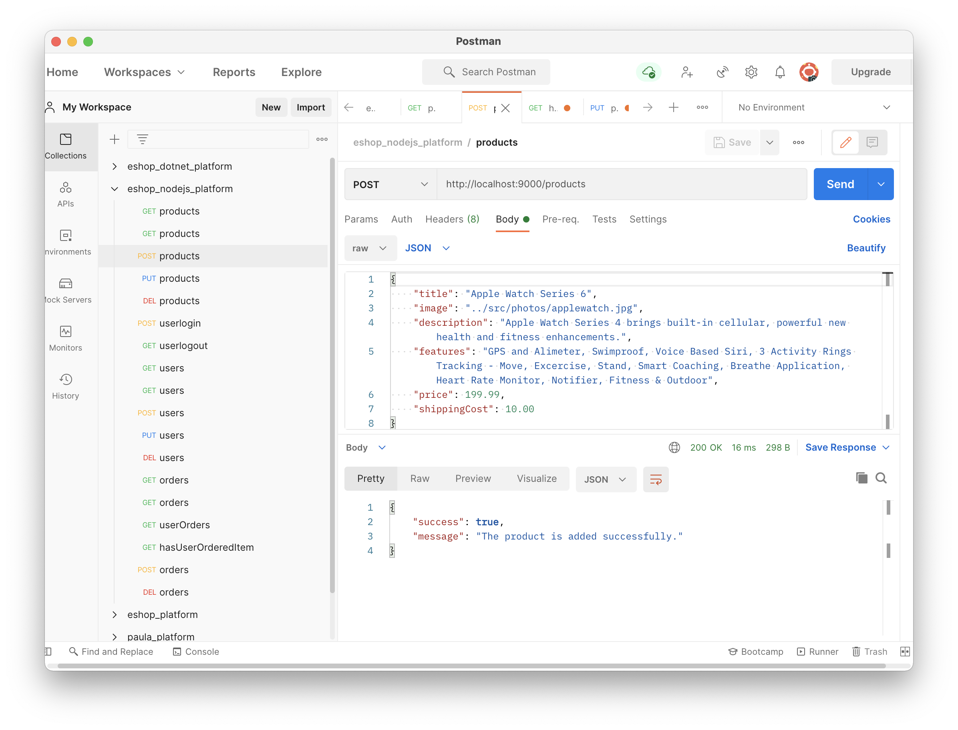

**Test case 1.1.2:**

The request body has some missing data. Product object has insufficient data.

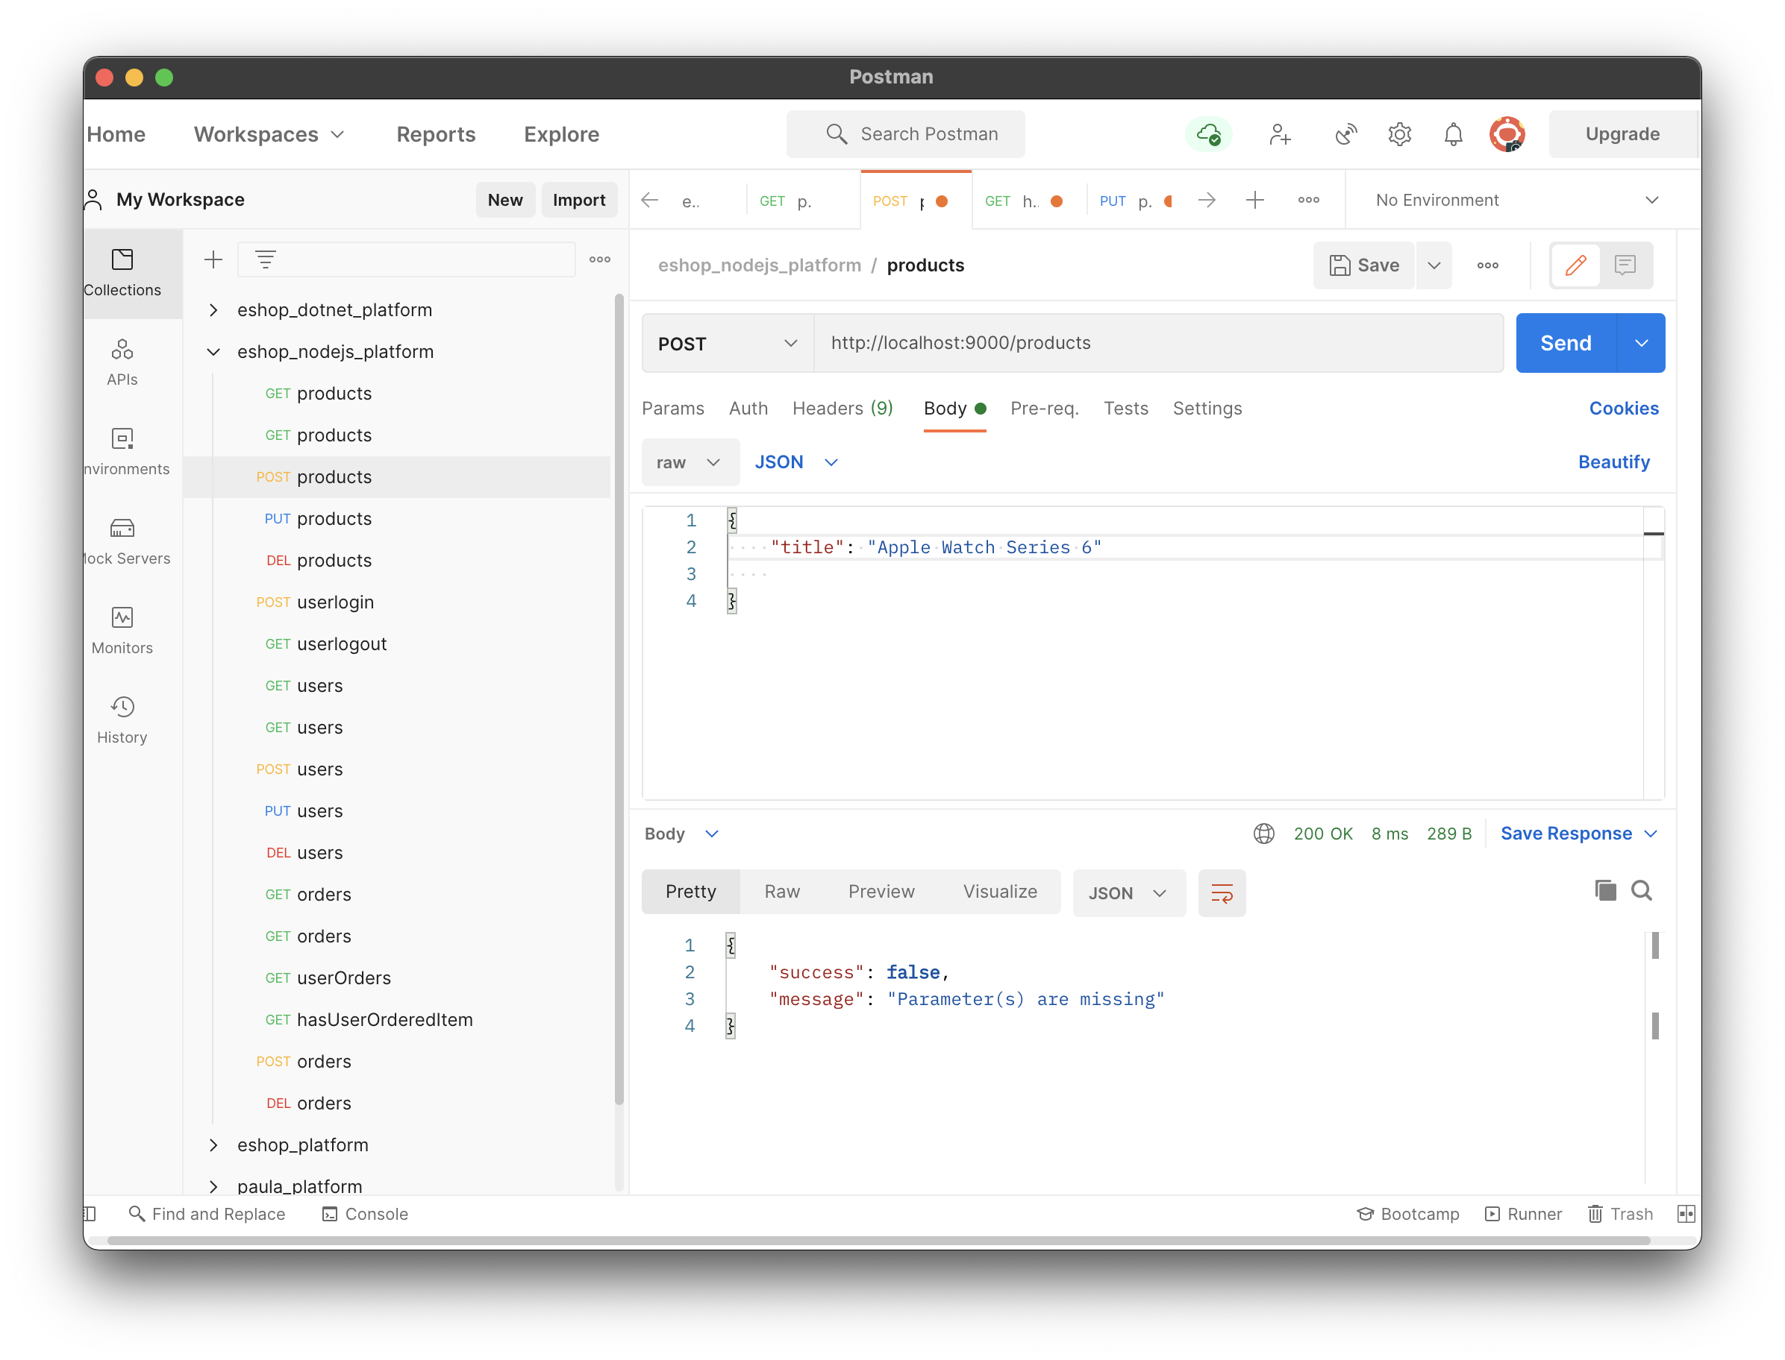

* 1. **GET method**: it is used to get product(s) info from database. If any particular product id is provided into URL, it returns info for the product, otherwise it returns all products exist into the database.

Request: /products/{product id}

Response JSON sample:

{

"_id": "607b8e4225fddd3809faa137",

"title": "Hard Disk",

"image": "../src/photos/harddisk.jpg",

"description": "A hard disk is actually a set of stacked disks, like phonograph records. Each disk has data recorded.",

"features": "Portable Hard Drive, Capacity: 2 TB, Connectivity: USB 3.0, USB 2.0, Capacity : 2TB, Color: Black, Model Name: WDBHDW0020BBK-EESN",

"price": 100,

"shippingCost": 4.99

}

**Test case 1.2.1:**

Request data provided is correct and the product exists in database.

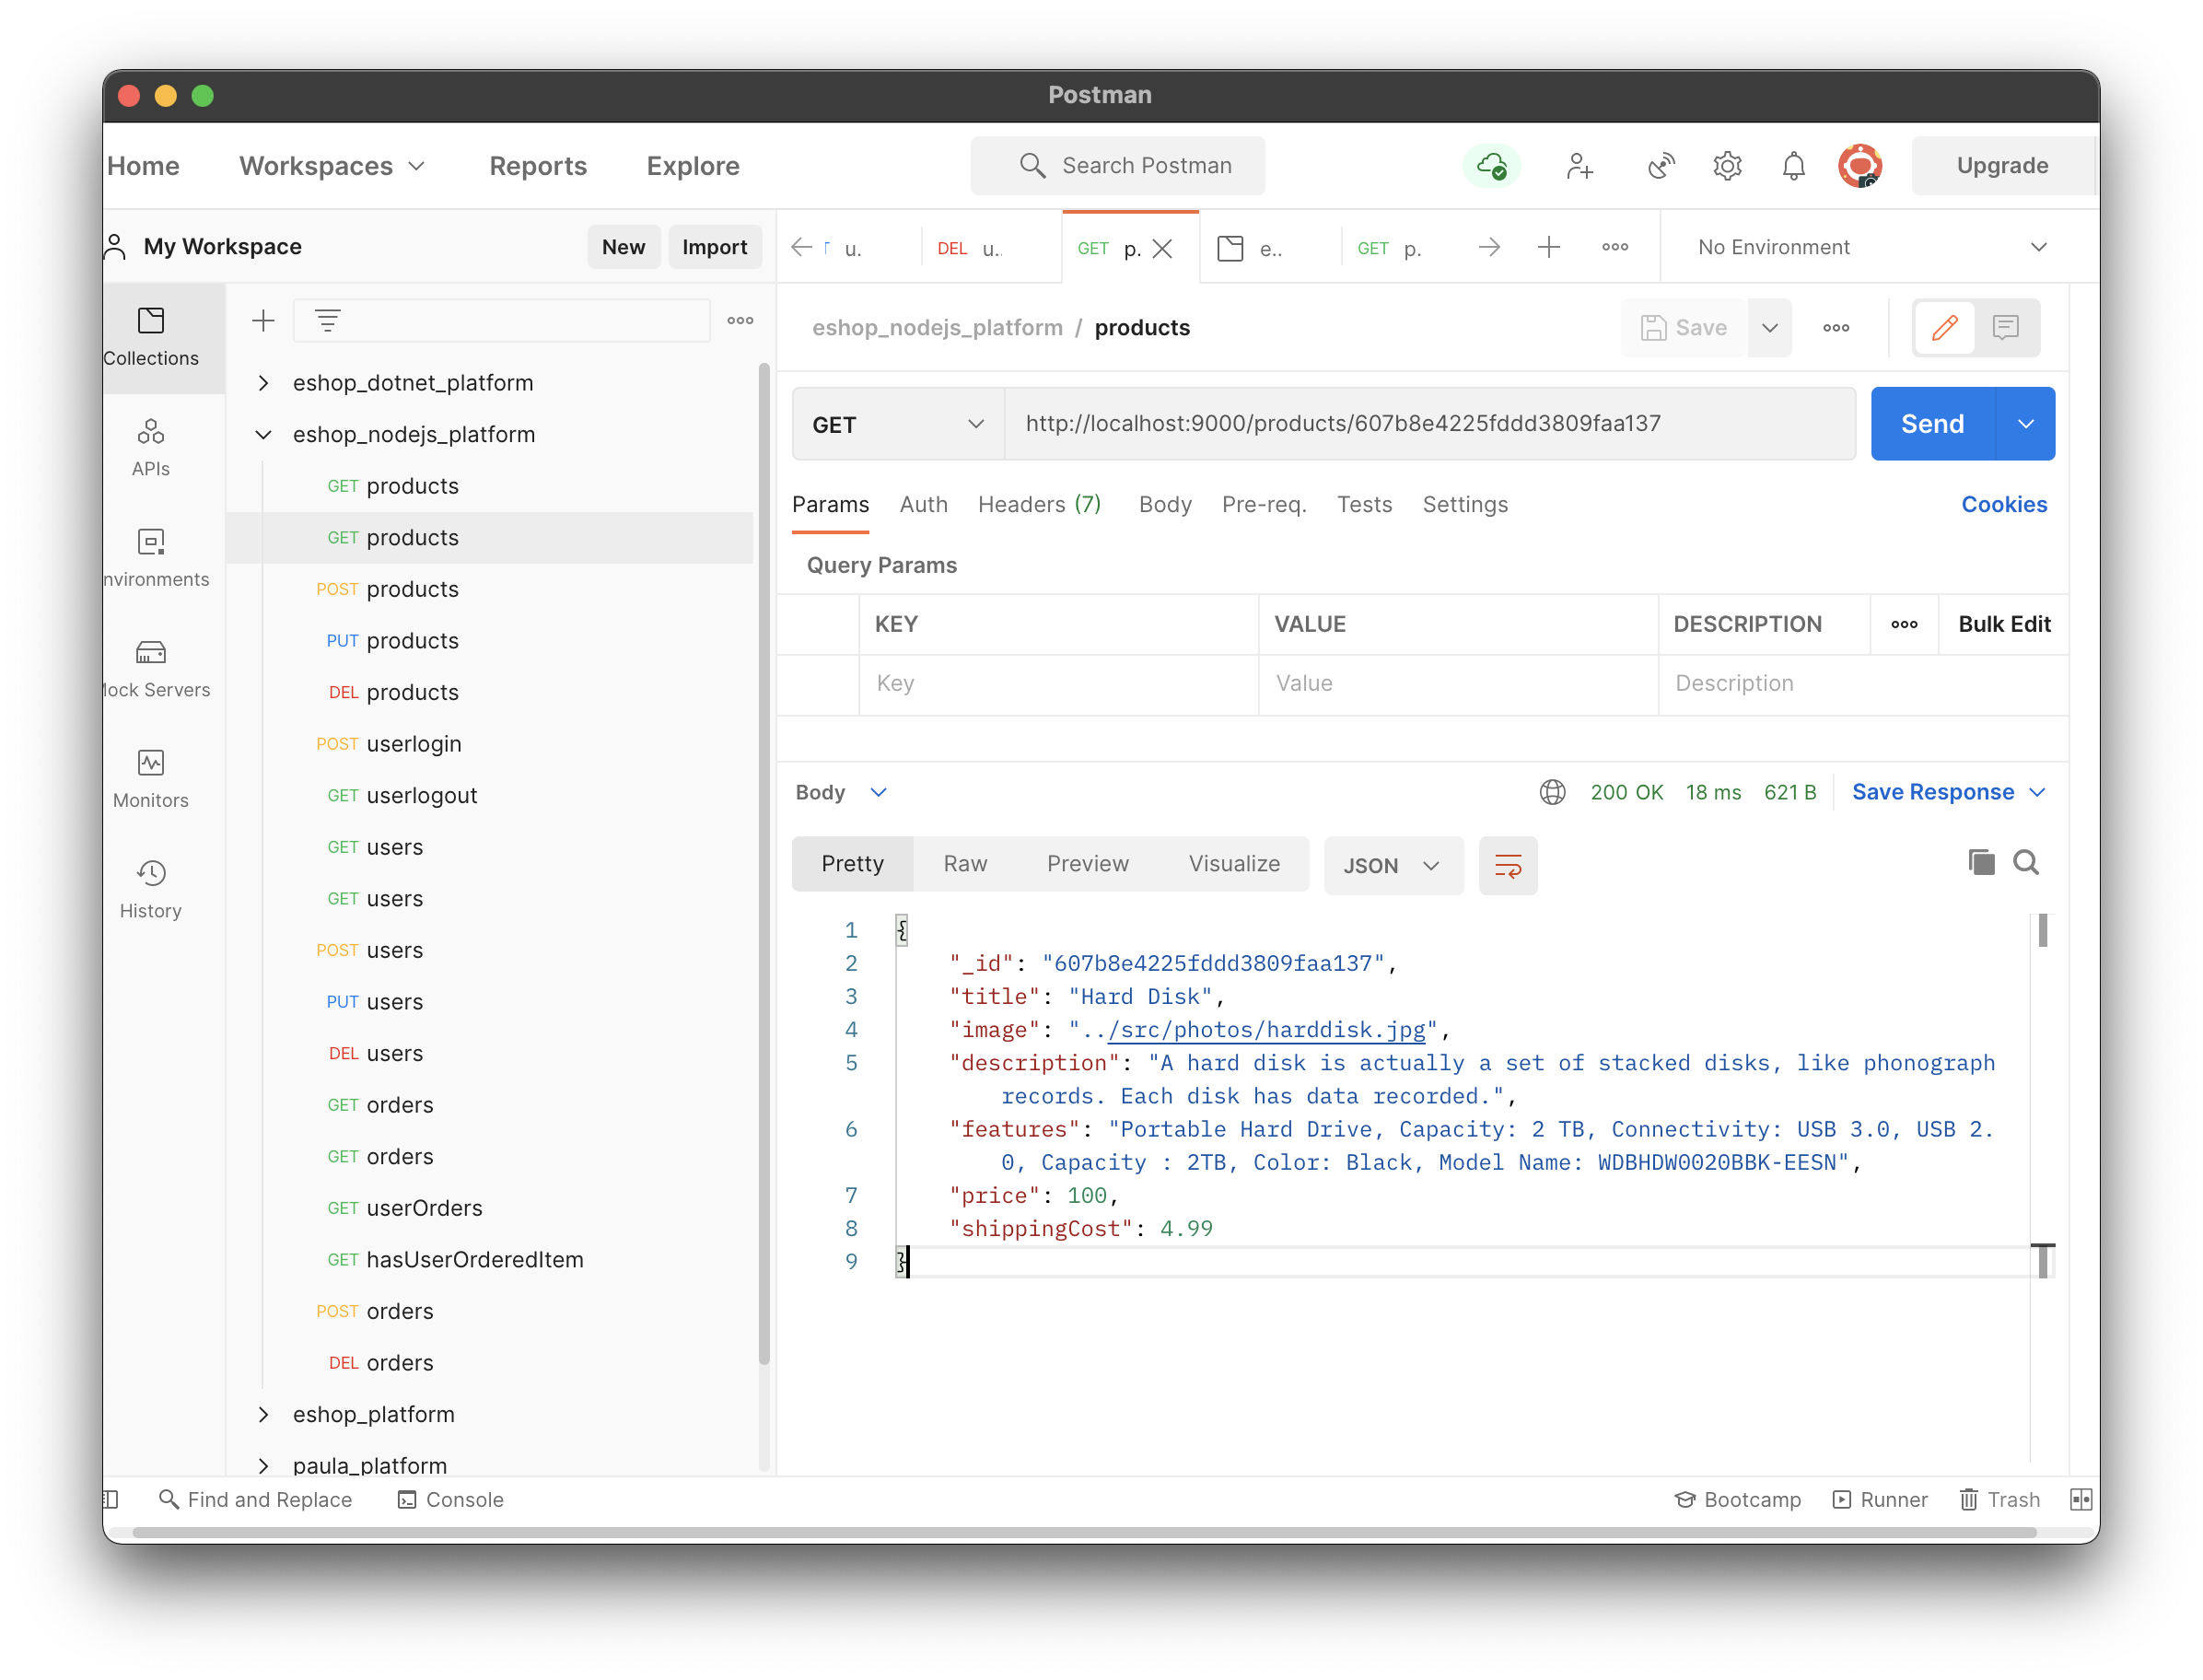

**Test case 1.2.2:**

Request data is provided correctly but the product does not exist into database.

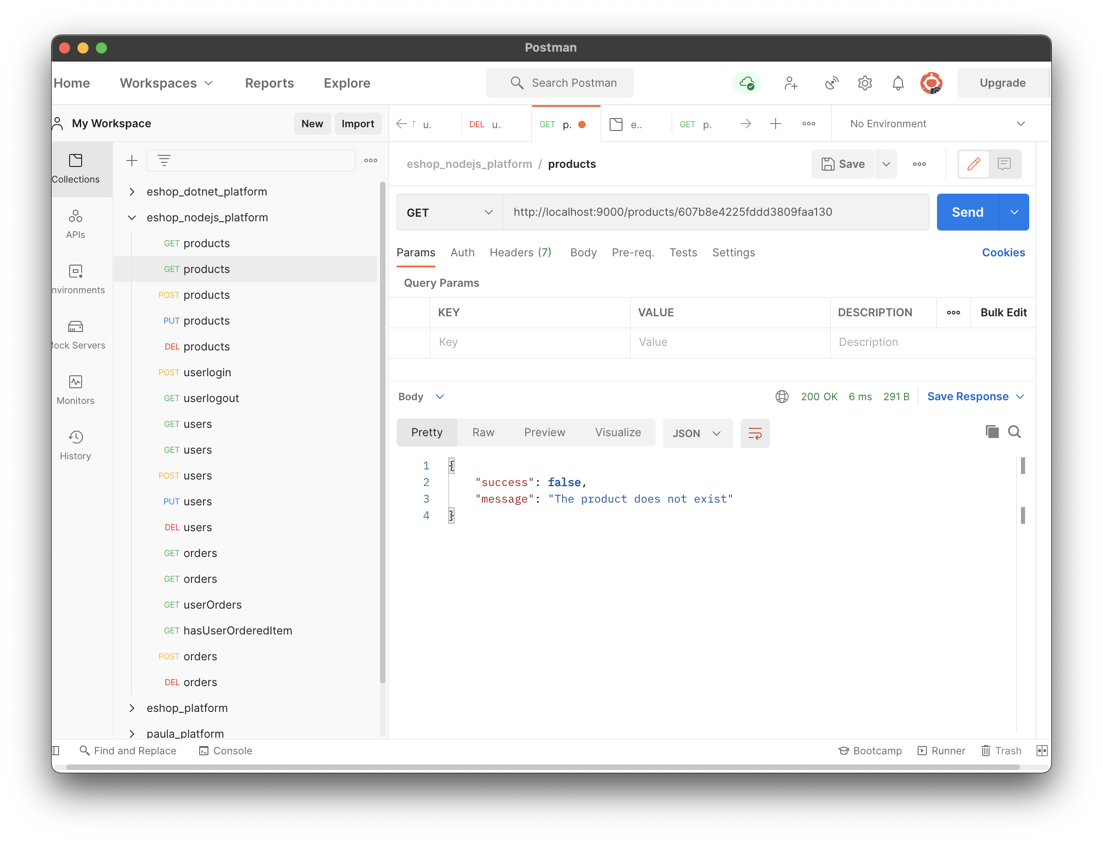

**Test case 1.2.3:**

The request has no product id to get all products.

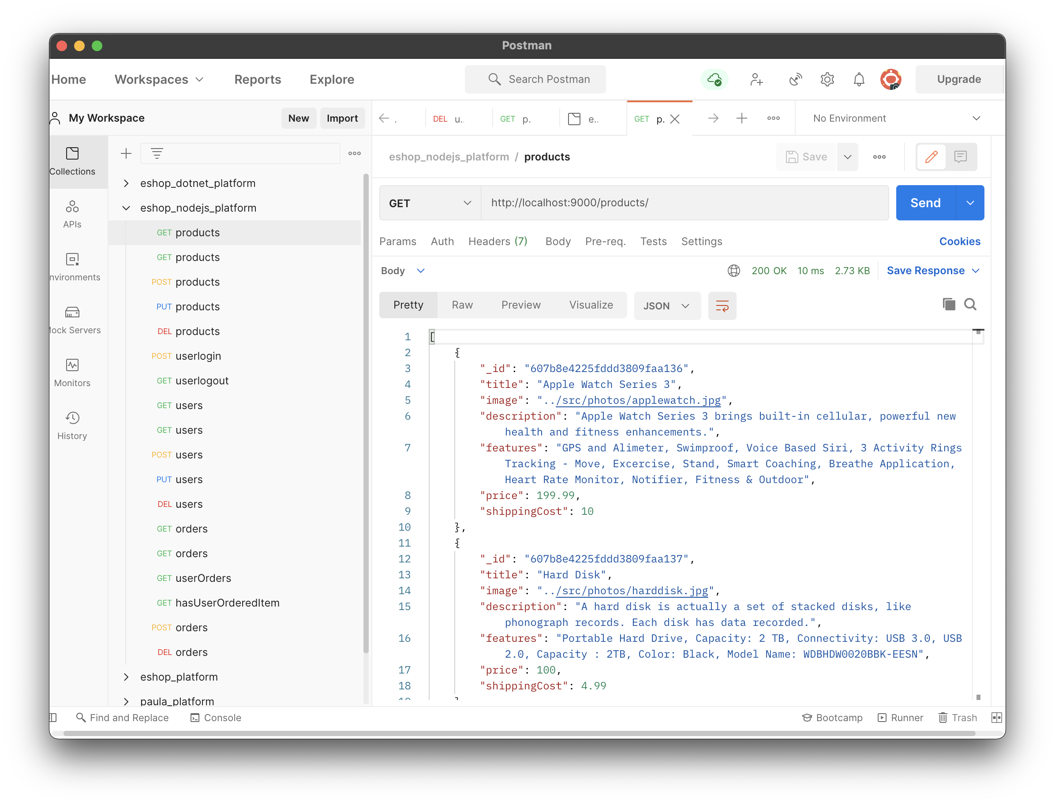

* 1. **PUT method**: it is used update any particular product info into database.

Request: /products/{product id}

Body JSON sample:

{

"title": "Apple Watch Series 3",

"image": "../src/photos/applewatch.jpg",

"description": "Apple Watch Series 3 brings built-in cellular, powerful new health and fitness enhancements.",

"features": "GPS and Alimeter, Swimproof, Voice Based Siri, 3 Activity Rings Tracking - Move, Excercise, Stand, Smart Coaching, Breathe Application, Heart Rate Monitor, Notifier, Fitness & Outdoor",

"price": 199.99,

"shippingCost": 12

}

Response JSON sample:

{

"success": **true**,

"message": "The product is updated successfully."

}

**Test case 1.3.1:**

Request data is provided correctly and the product exists in database.

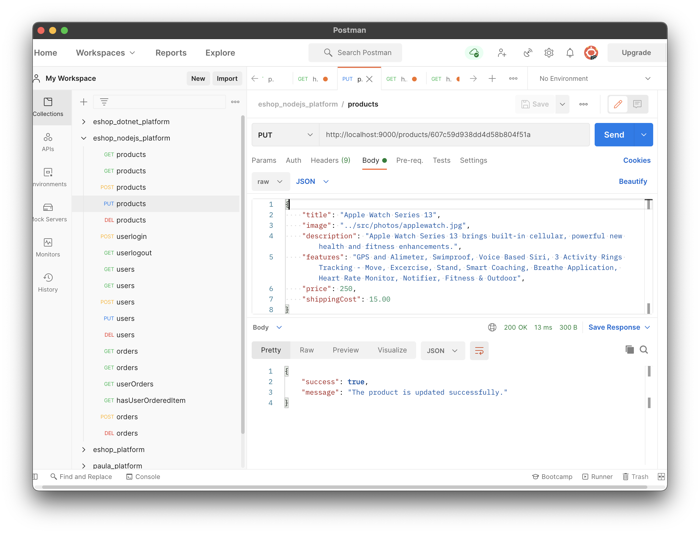

**Test case 1.3.2:**

Request data is provided correctly but the product does not exist into database.

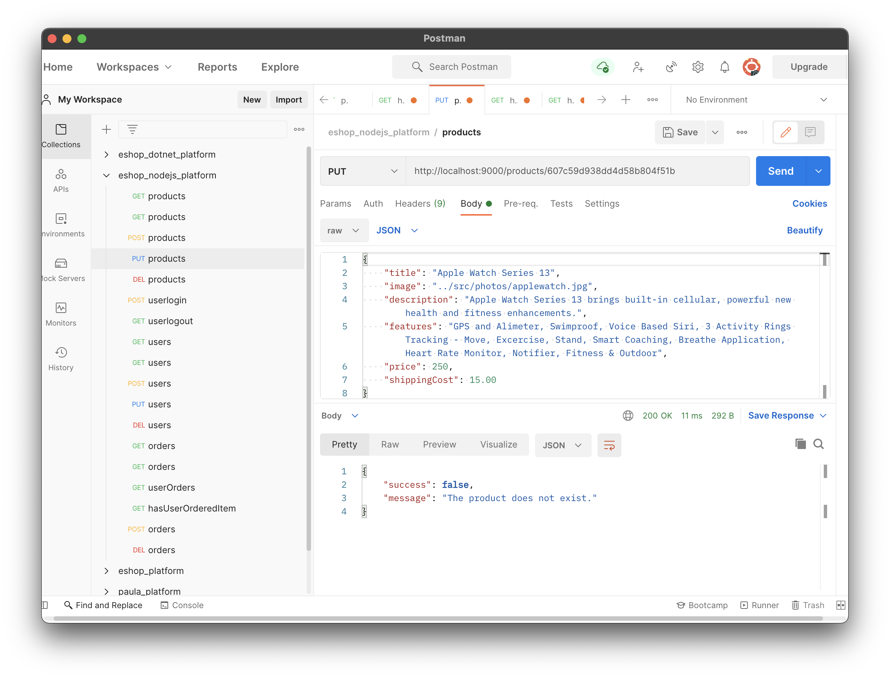

**Test case 1.3.3:**

The request has insufficient product info in body.

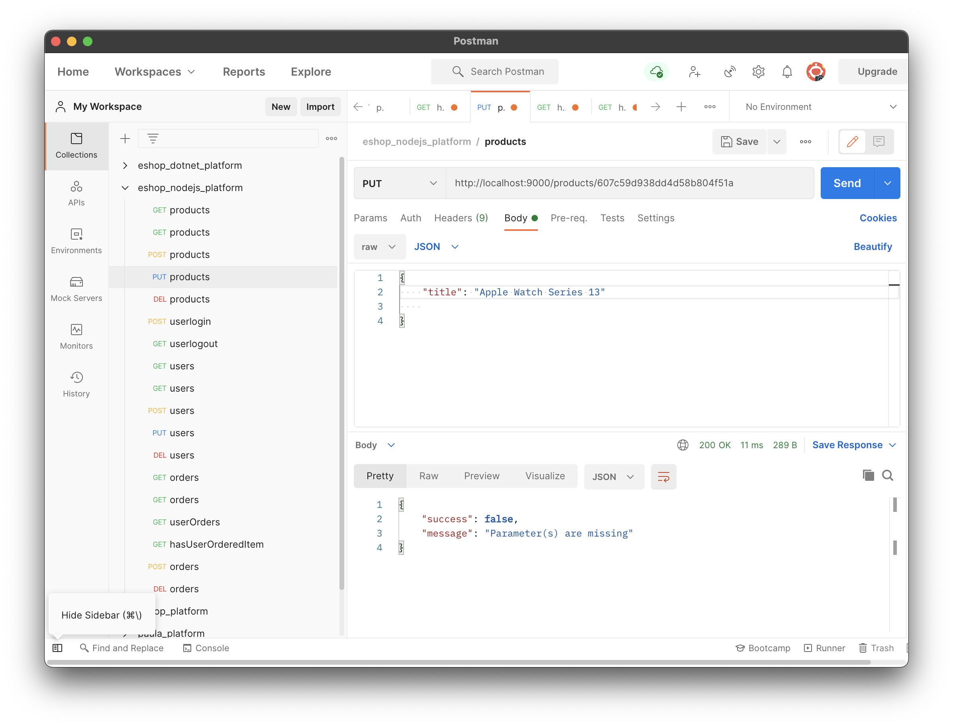

* 1. **DELETE method**: it is used delete any particular product info from database.

Request: /products/{product id}

Response JSON sample:

{

"success": **true**,

"error": "The product is deleted successfully."

}

**Test case 1.4.1:**

Request data is provided correctly and the product exists in database.

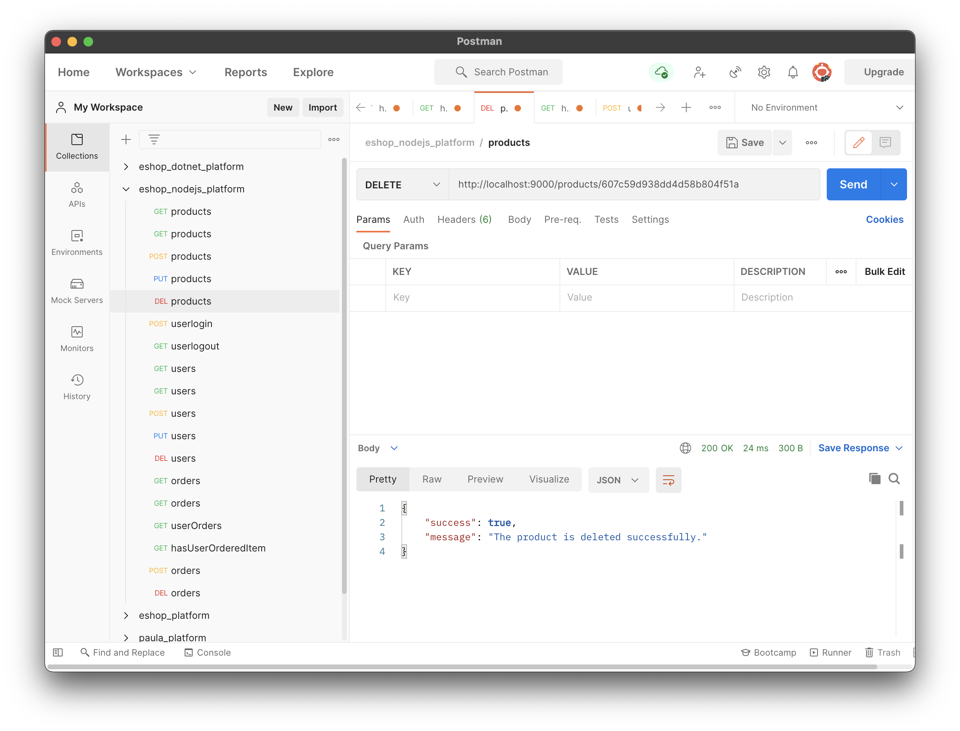

1. **Users:**
   1. **POST method**: it is used to add new user into database.

**API** : /users

Request body JSON sample:

{

    "email": "NGhori34671@conestogac.on.ca",

    "password": "nisha",

    "name": "Nisha",

    "shippingAddress": "210, Akshardham Society, Laxmikant Ashram Road, Katargam.",

    "city": "Surat",

    "province": "Gujarat",

    "country": "India",

    "gender": "Female"

}

Response:

{

"success": **true**,

"message": "The user is registered successfully."

}

**Test case 2.1.1:**

All data is provided correctly in request.

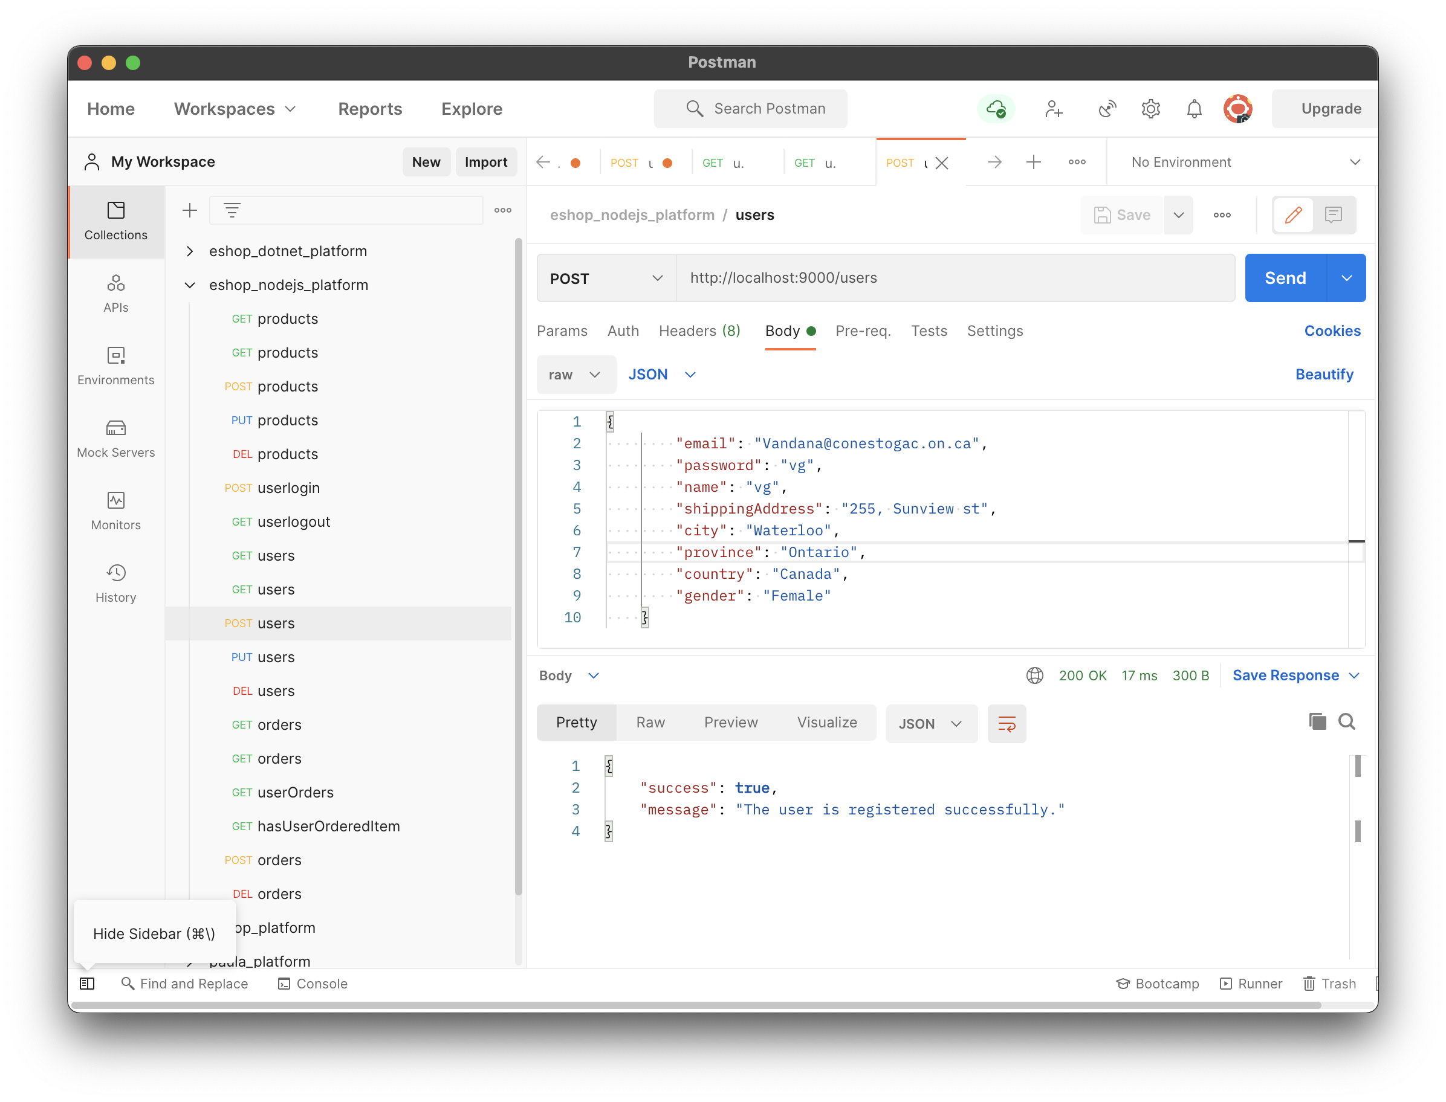

**Test case 2.1.2:**

The request body has some missing data. User object has insufficient data.

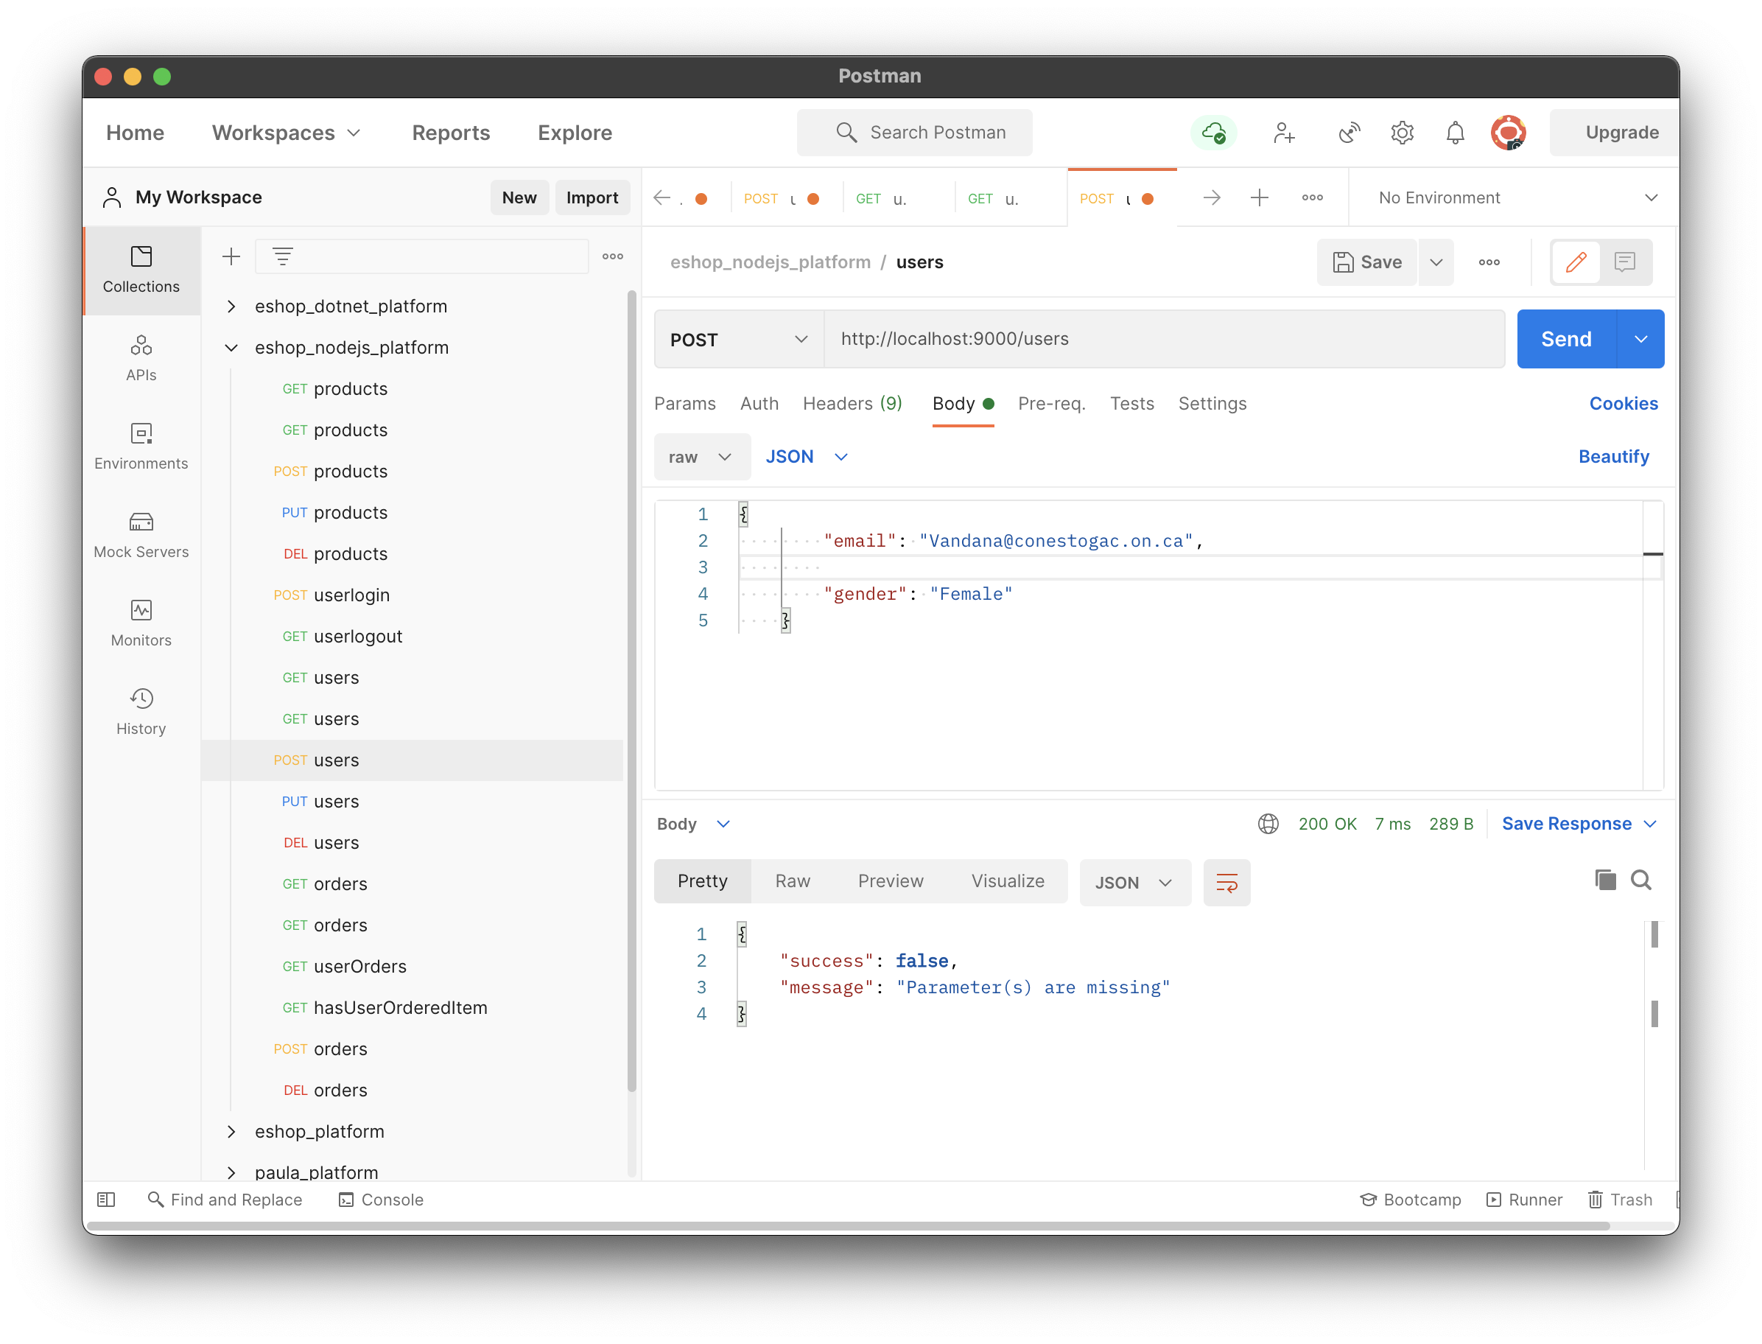

* 1. **GET method**: it is used to get user(s) info from database. If any particular email ID is provided into URL, it returns info for the user, otherwise it returns all users exist into the database.

Request: /users/{email}

Response JSON sample:

{

"_id": "607c5d8e25fddd3809faa140",

"email": "Vpatel5921@conestogac.on.ca",

"password": "vidhi",

"name": "vidhi",

"shippingAddress": "255, Sunview st",

"city": "Waterloo",

"province": "Ontario",

"country": "Canada",

"gender": "Female"

}

**Test case 2.2.1:**

Request data is provided correctly and the user does exist into database.

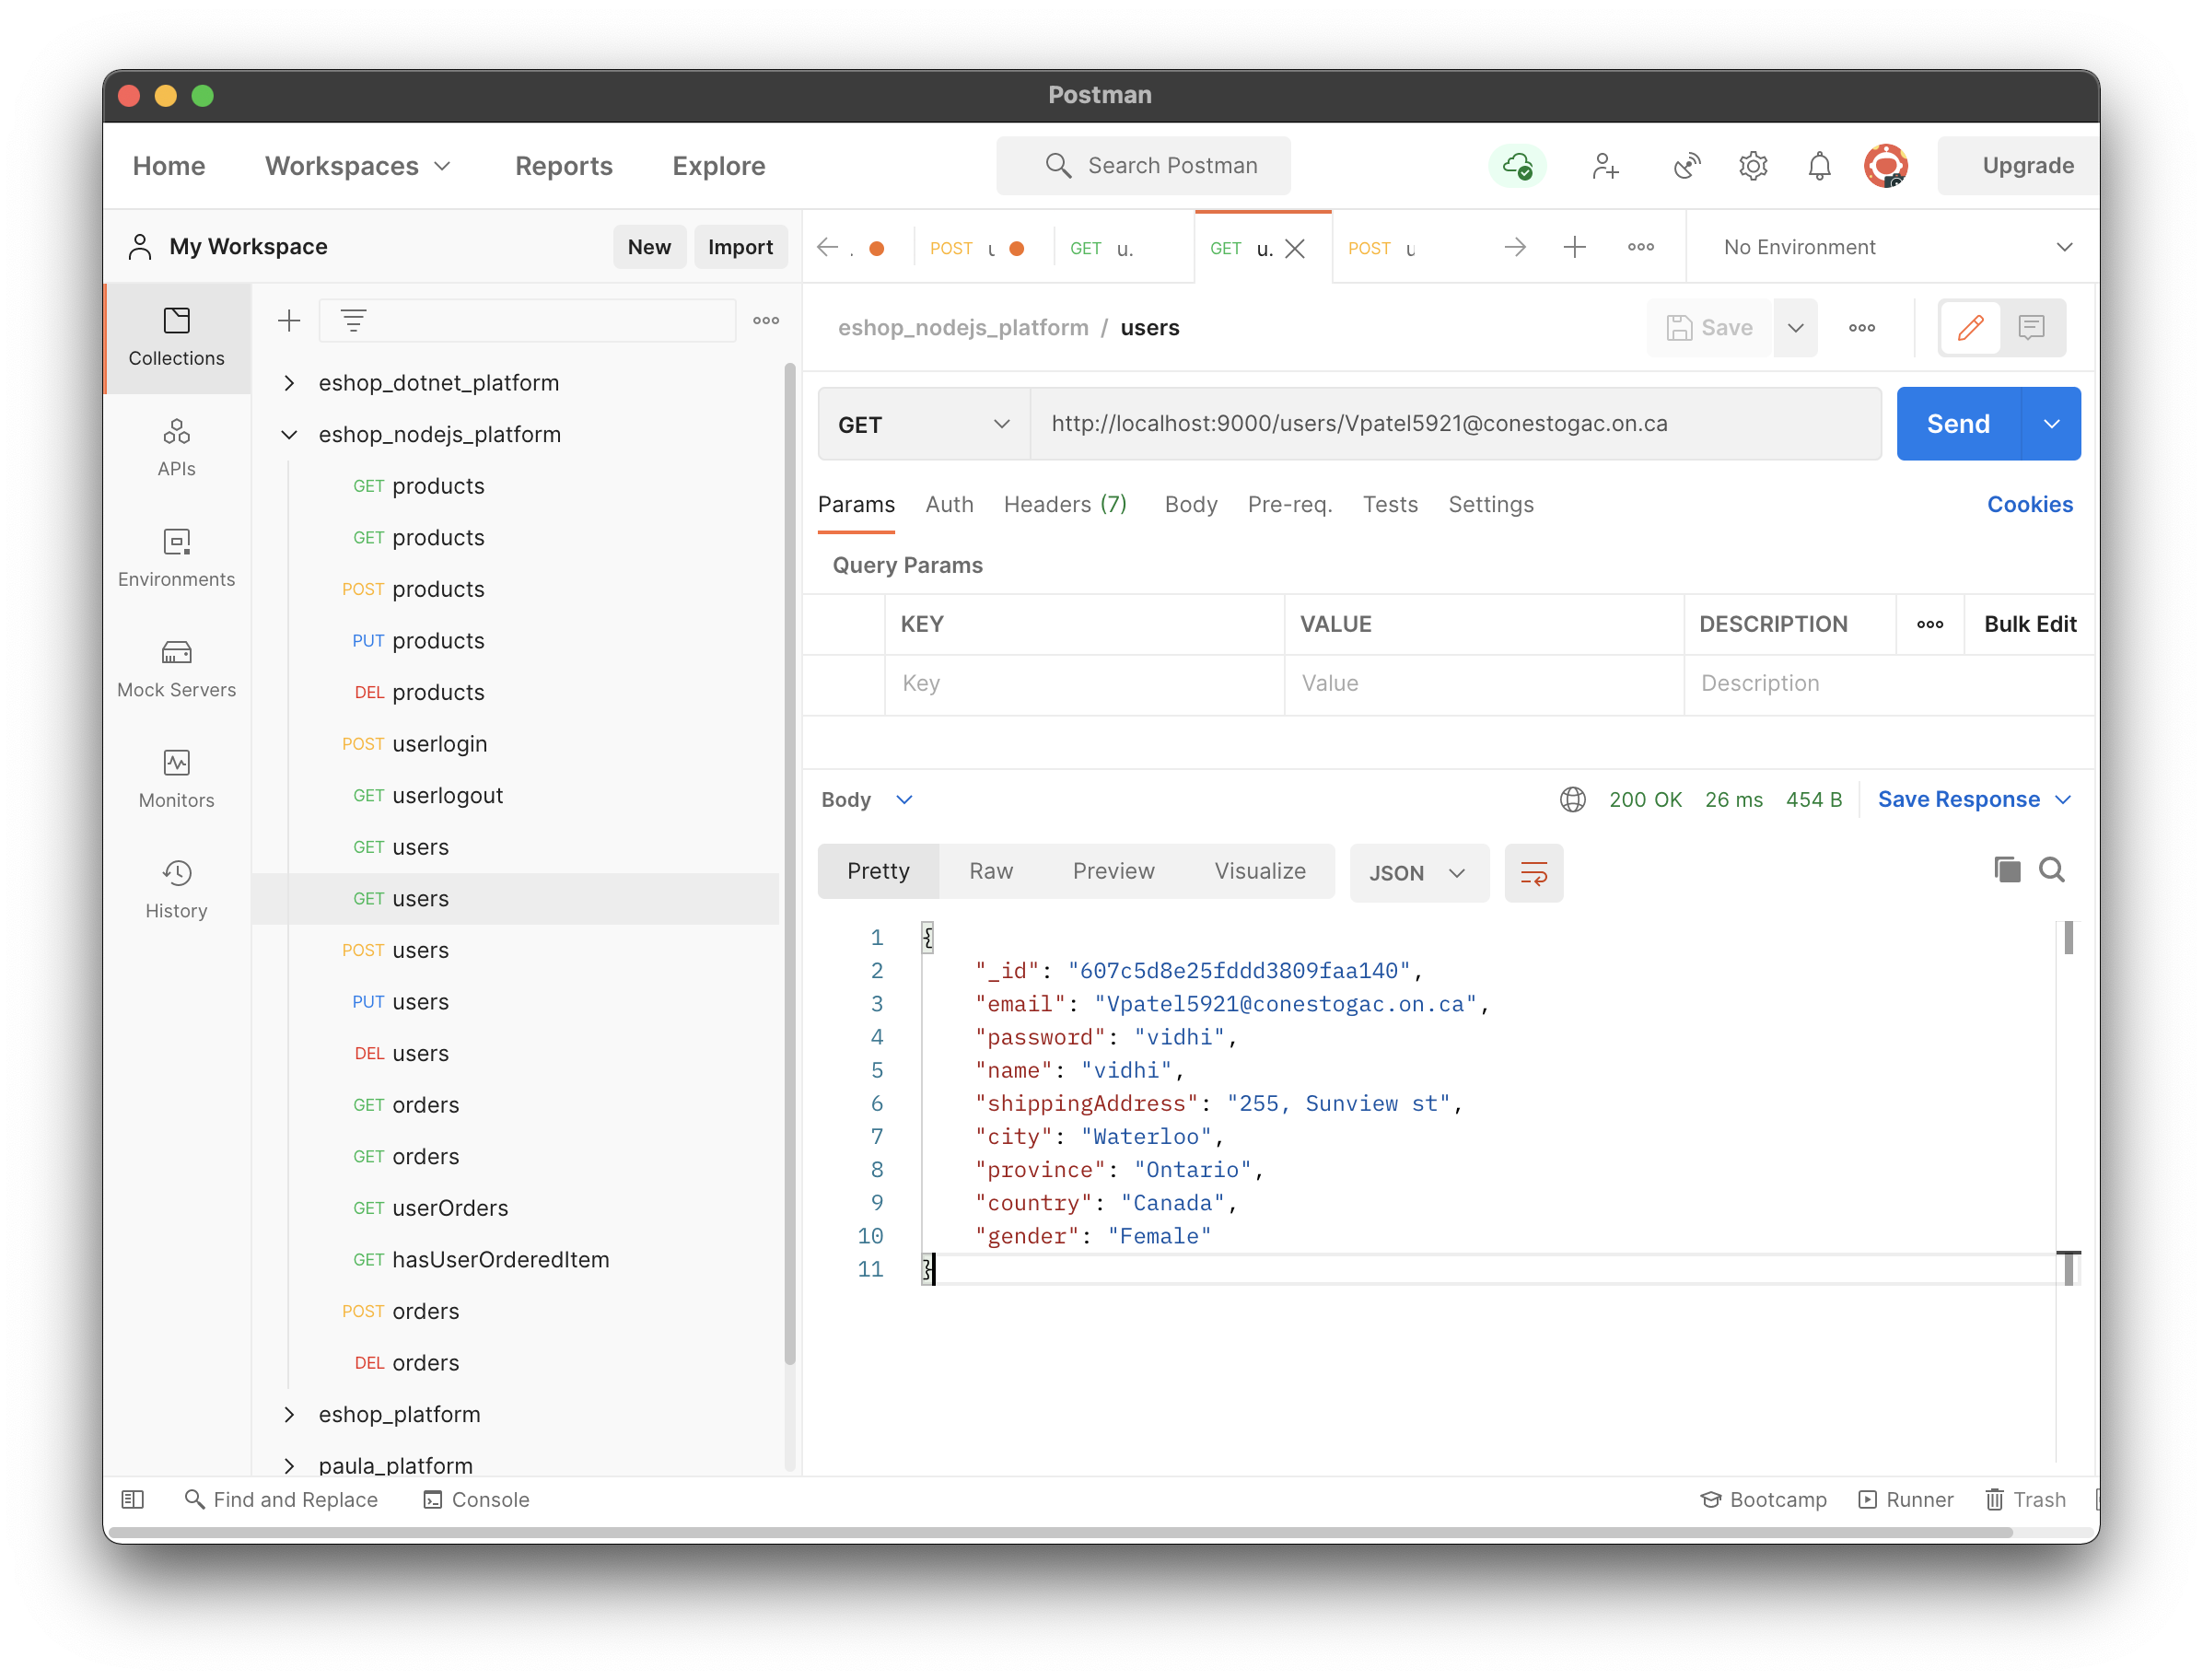

**Test case 2.2.2:**

Request data is provided correctly but the user does not exist into database.

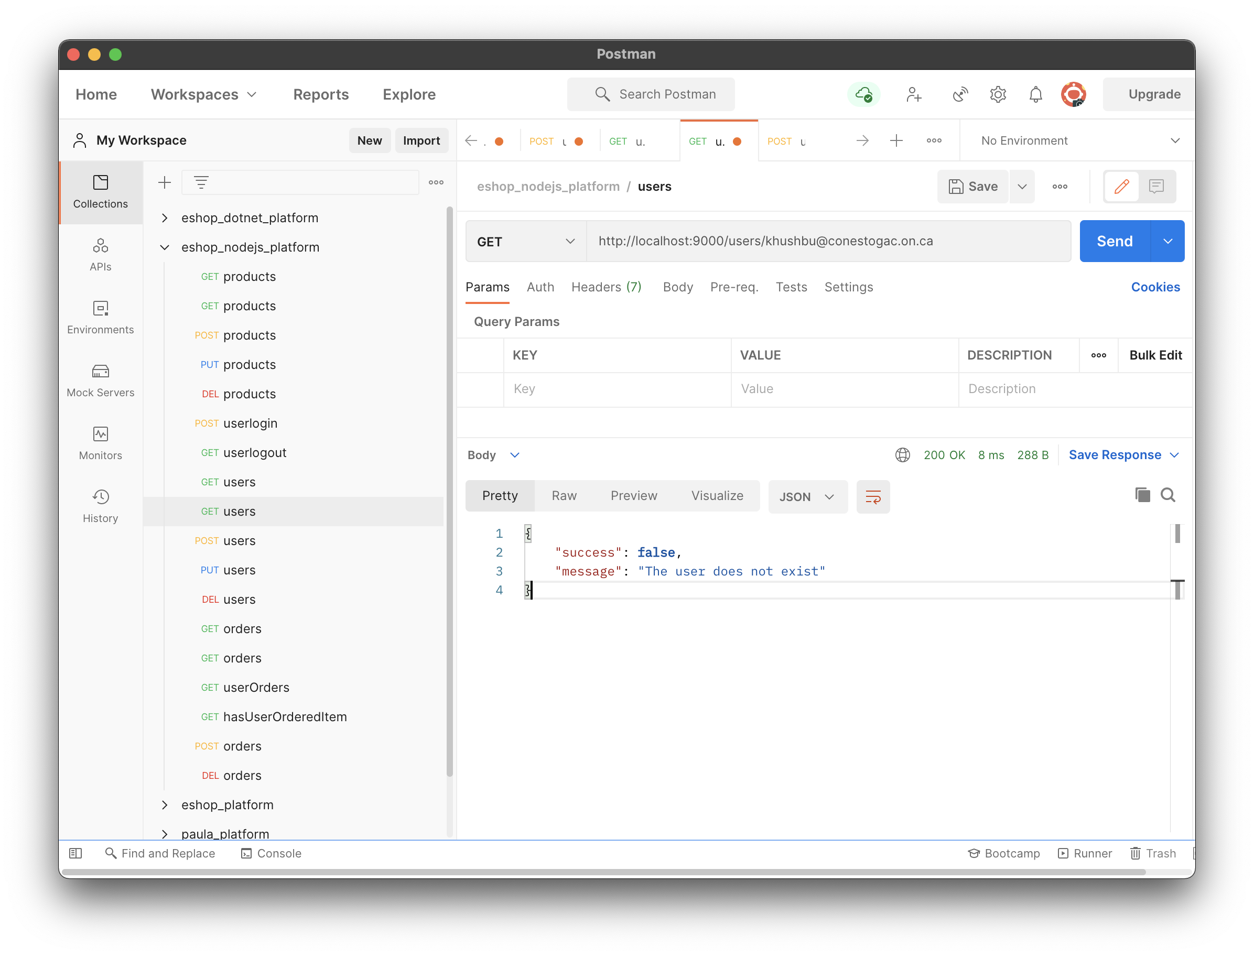

**Test case 2.2.3:**

The request has no email ID to get user, hence all users information extracted.

API : /users

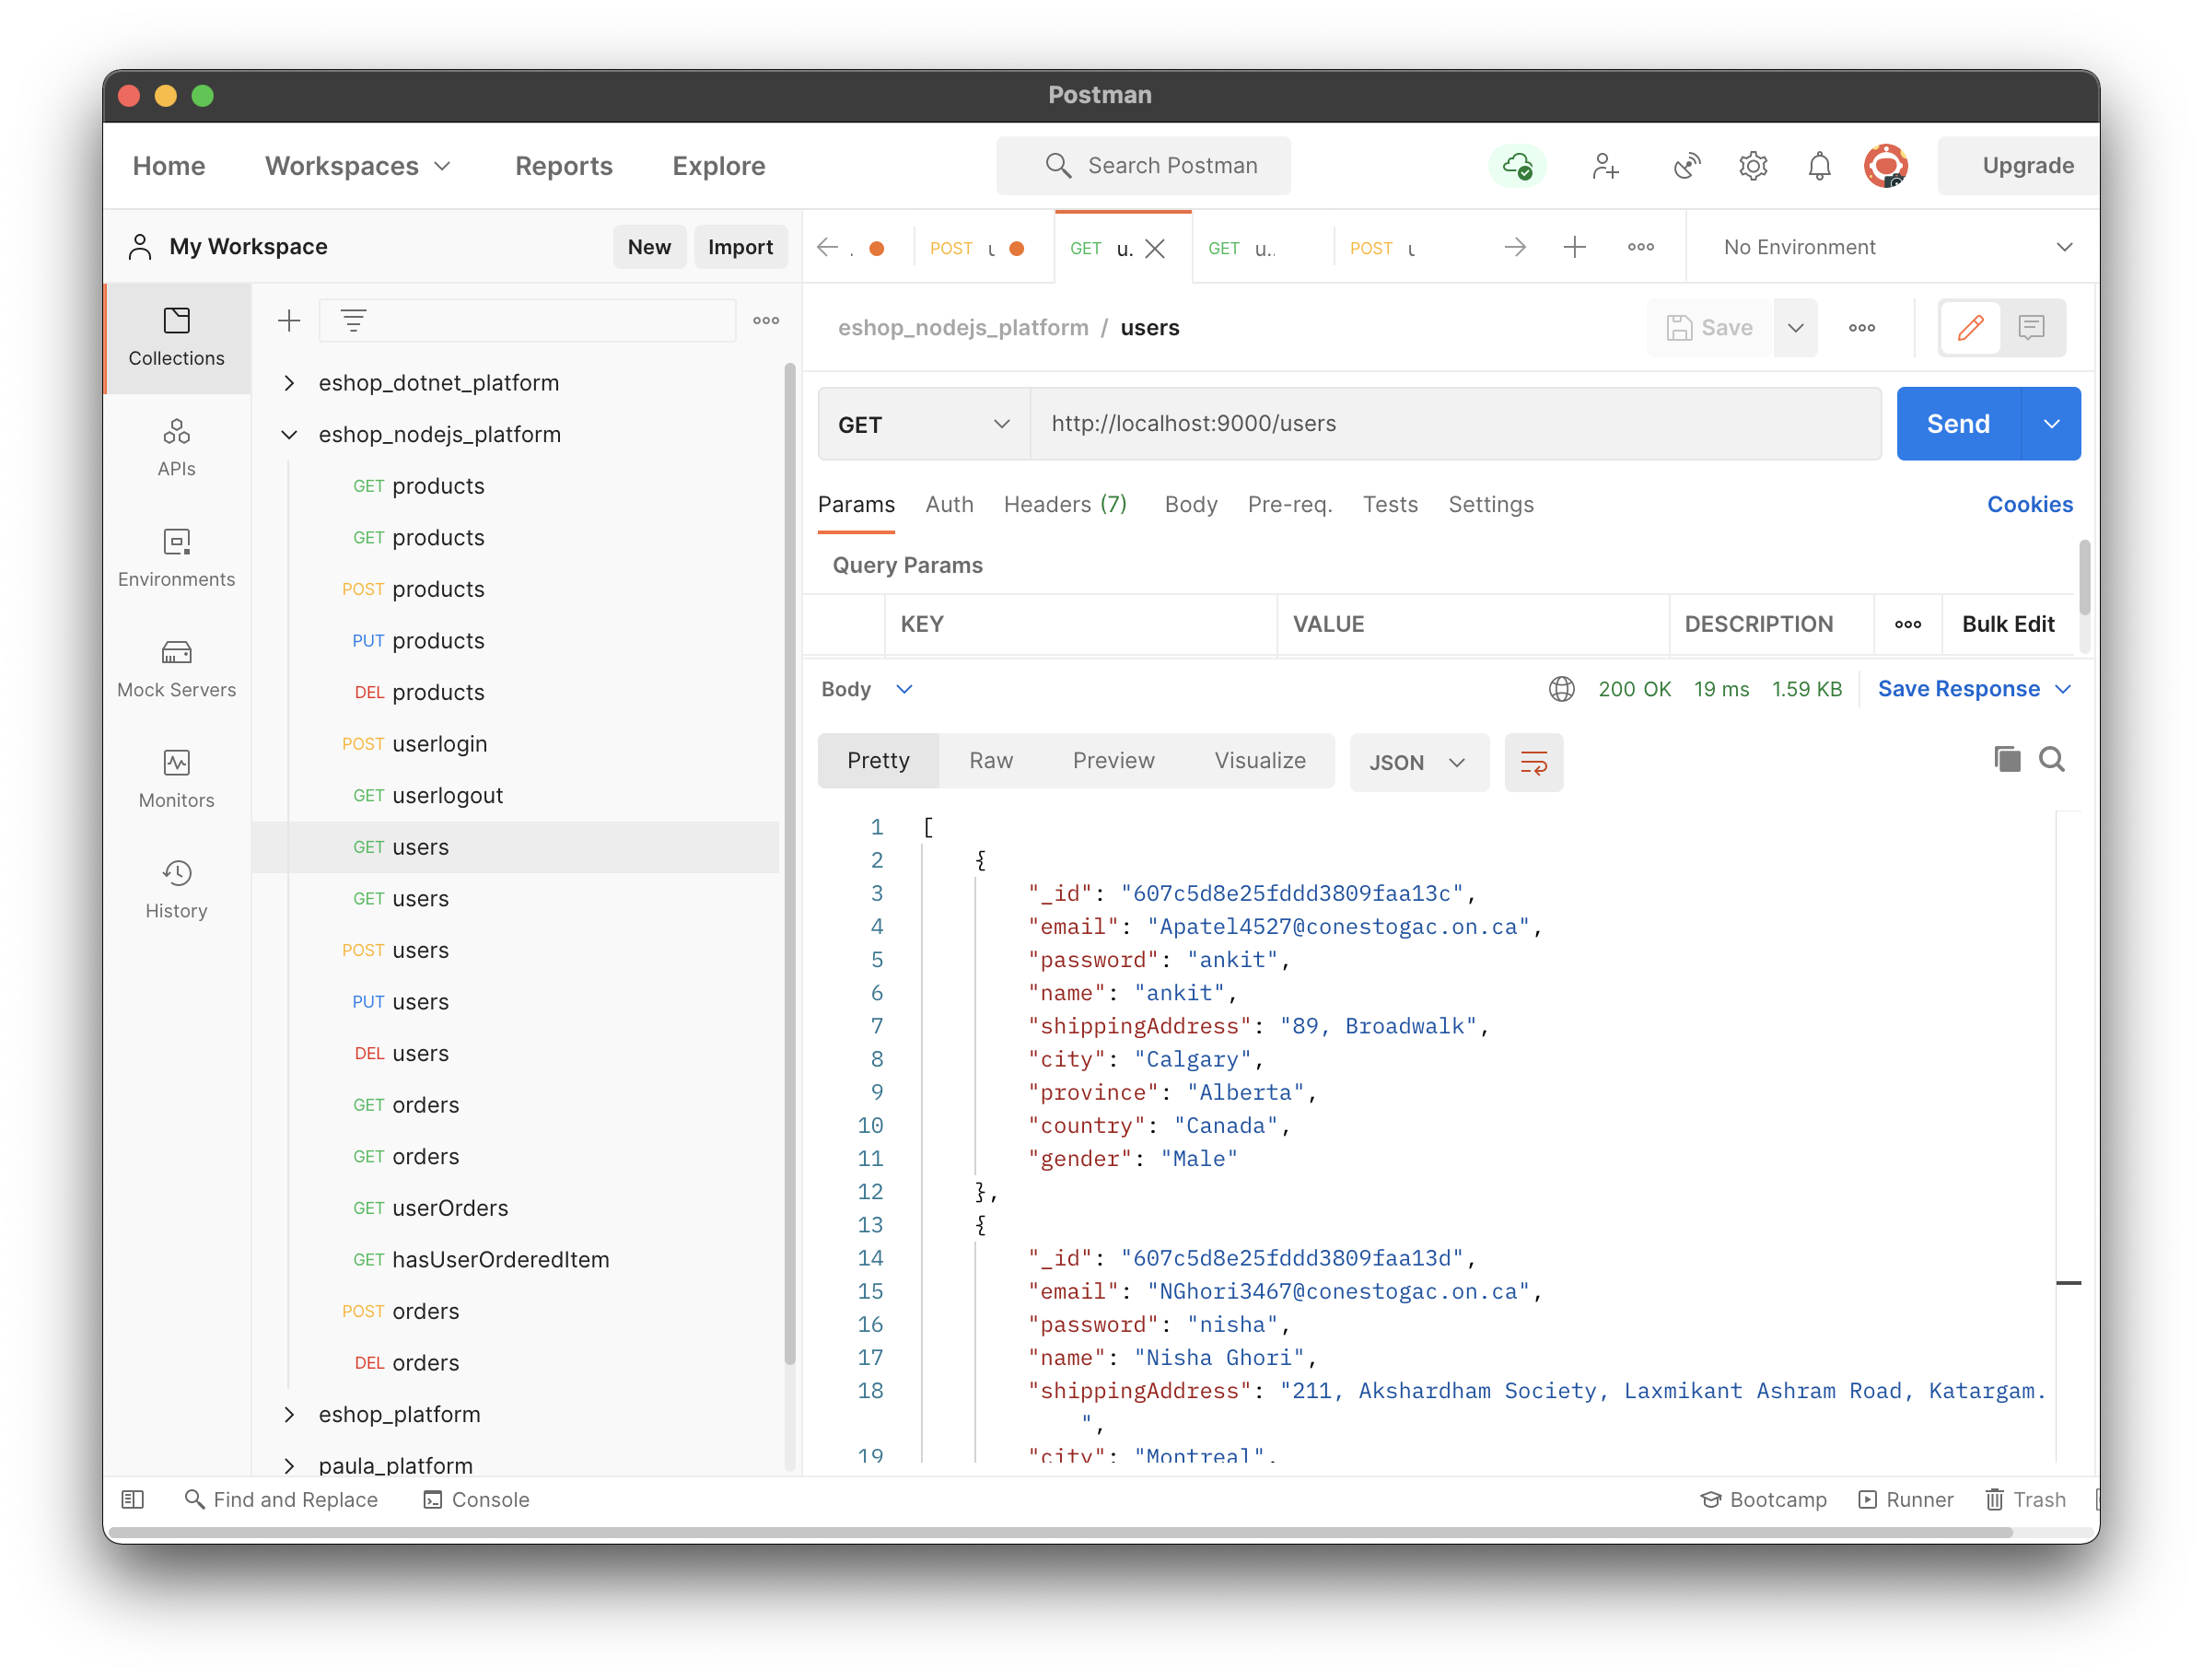

* 1. **PUT method**: it is used update any particular product info into database.

Request: /users/{id}

Body JSON sample:

{

    "email": "NGhori3467@conestogac.on.ca",

    "password": "nisha",

    "name": "Nisha Ghori",

    "shippingAddress": "211, Akshardham Society, Laxmikant Ashram Road, Katargam.",

    "city": "Ahmedabad",

    "province": "Gujarat",

    "country": "India",

    "gender": "Female"

}

Response JSON sample:

{

"success": **true**,

"message": "The user is updated successfully."

}

**Test case 2.3.1:**

Request data is provided correctly and the user exists in database.

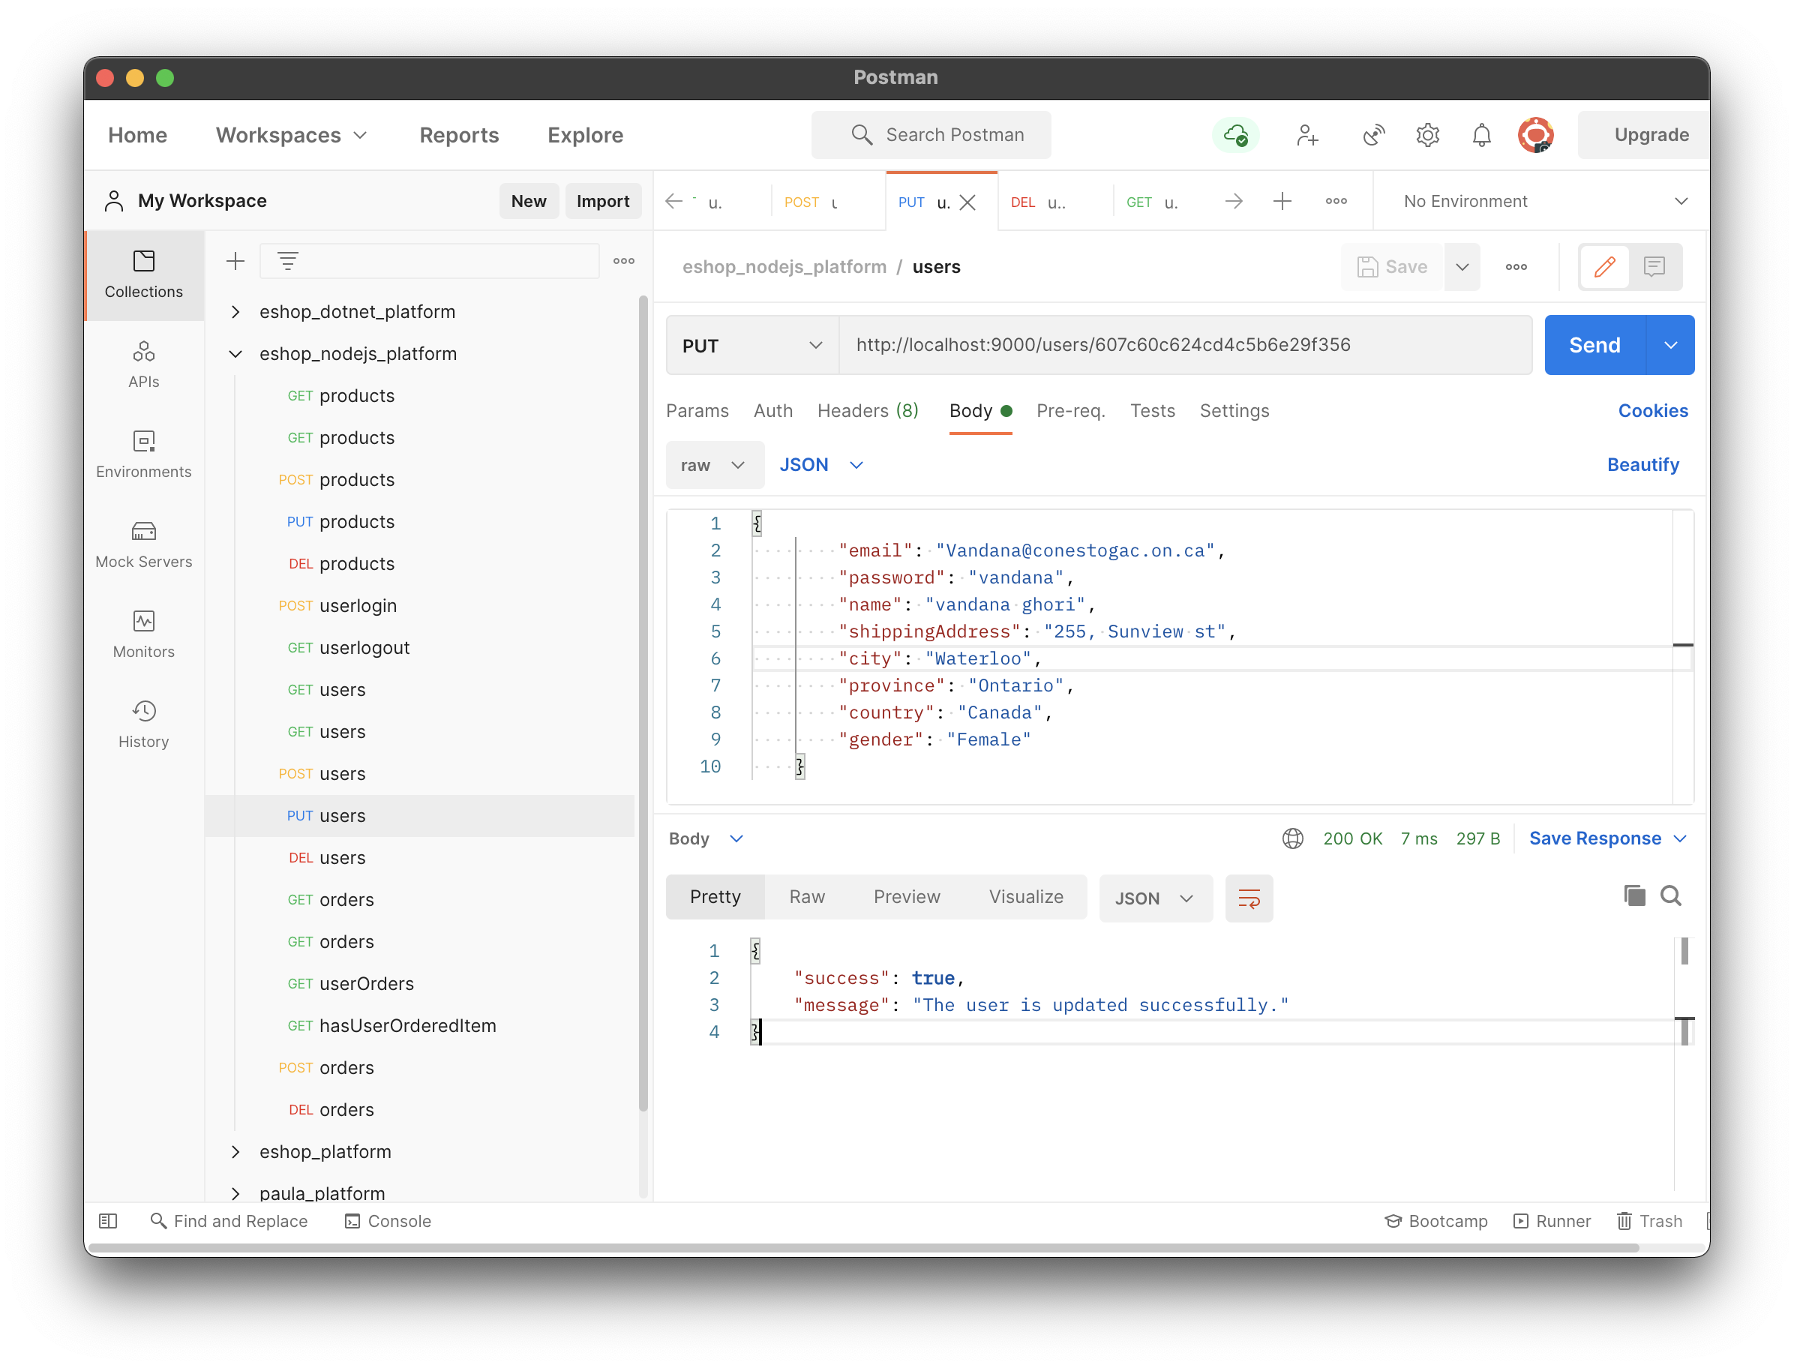

**Test case 2.3.2:**

Request data is provided correctly but the user does not exist into database.

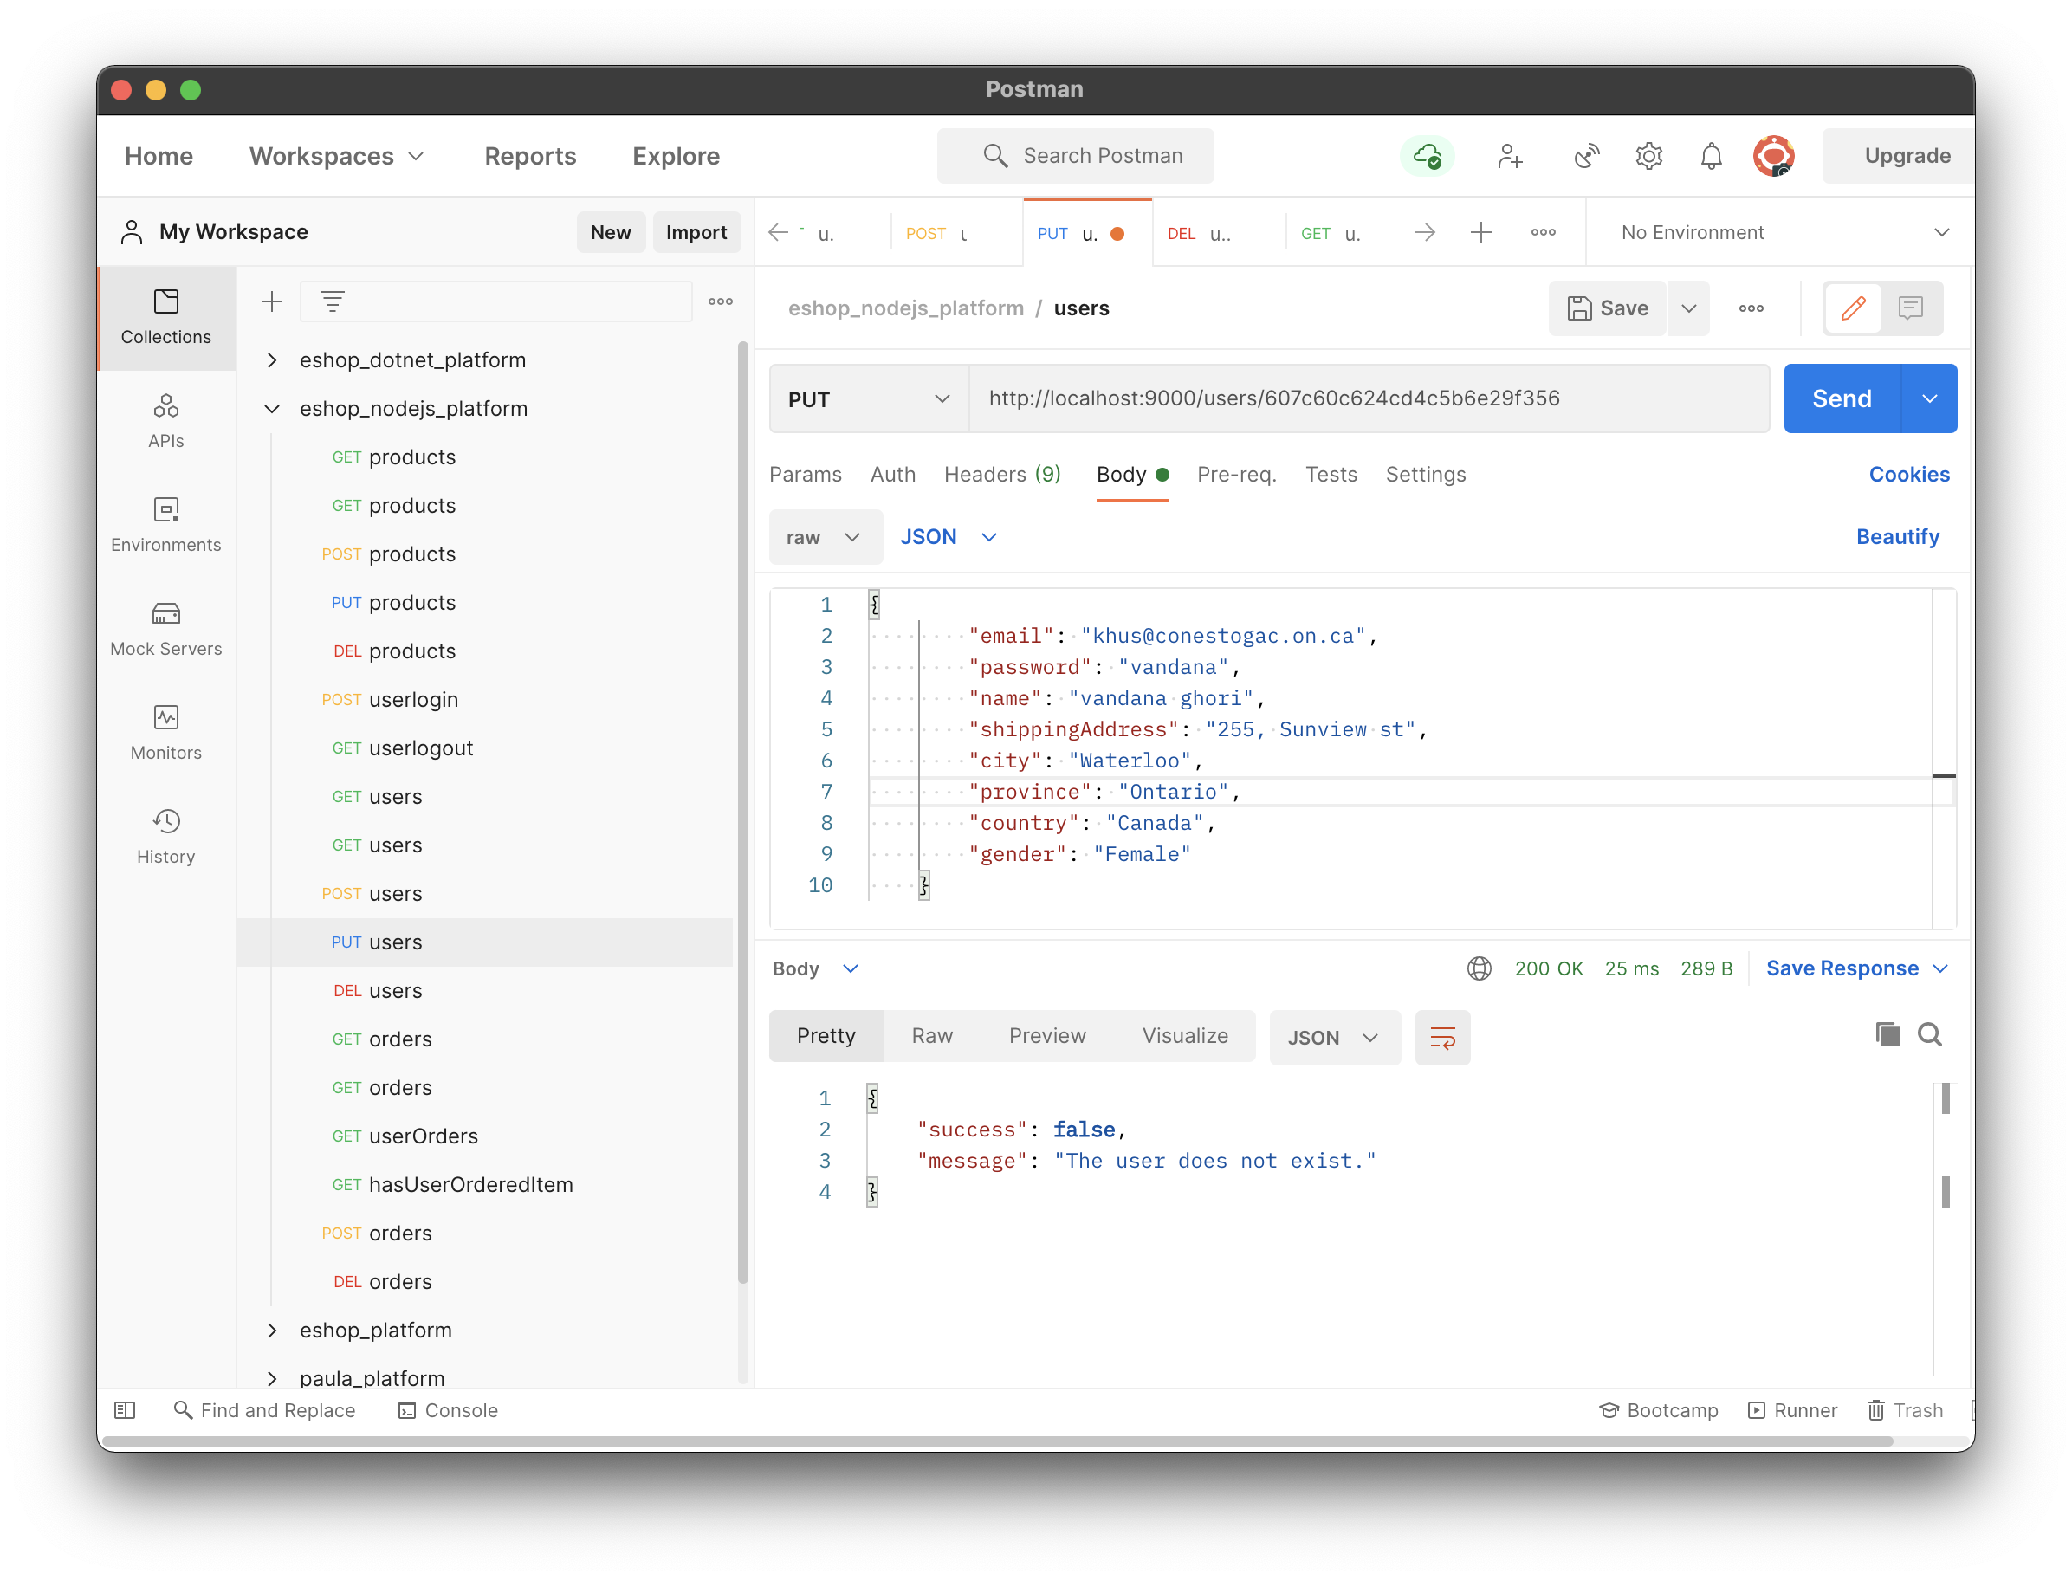

**Test case 2.3.3:**

The request has no email ID to update the user details.

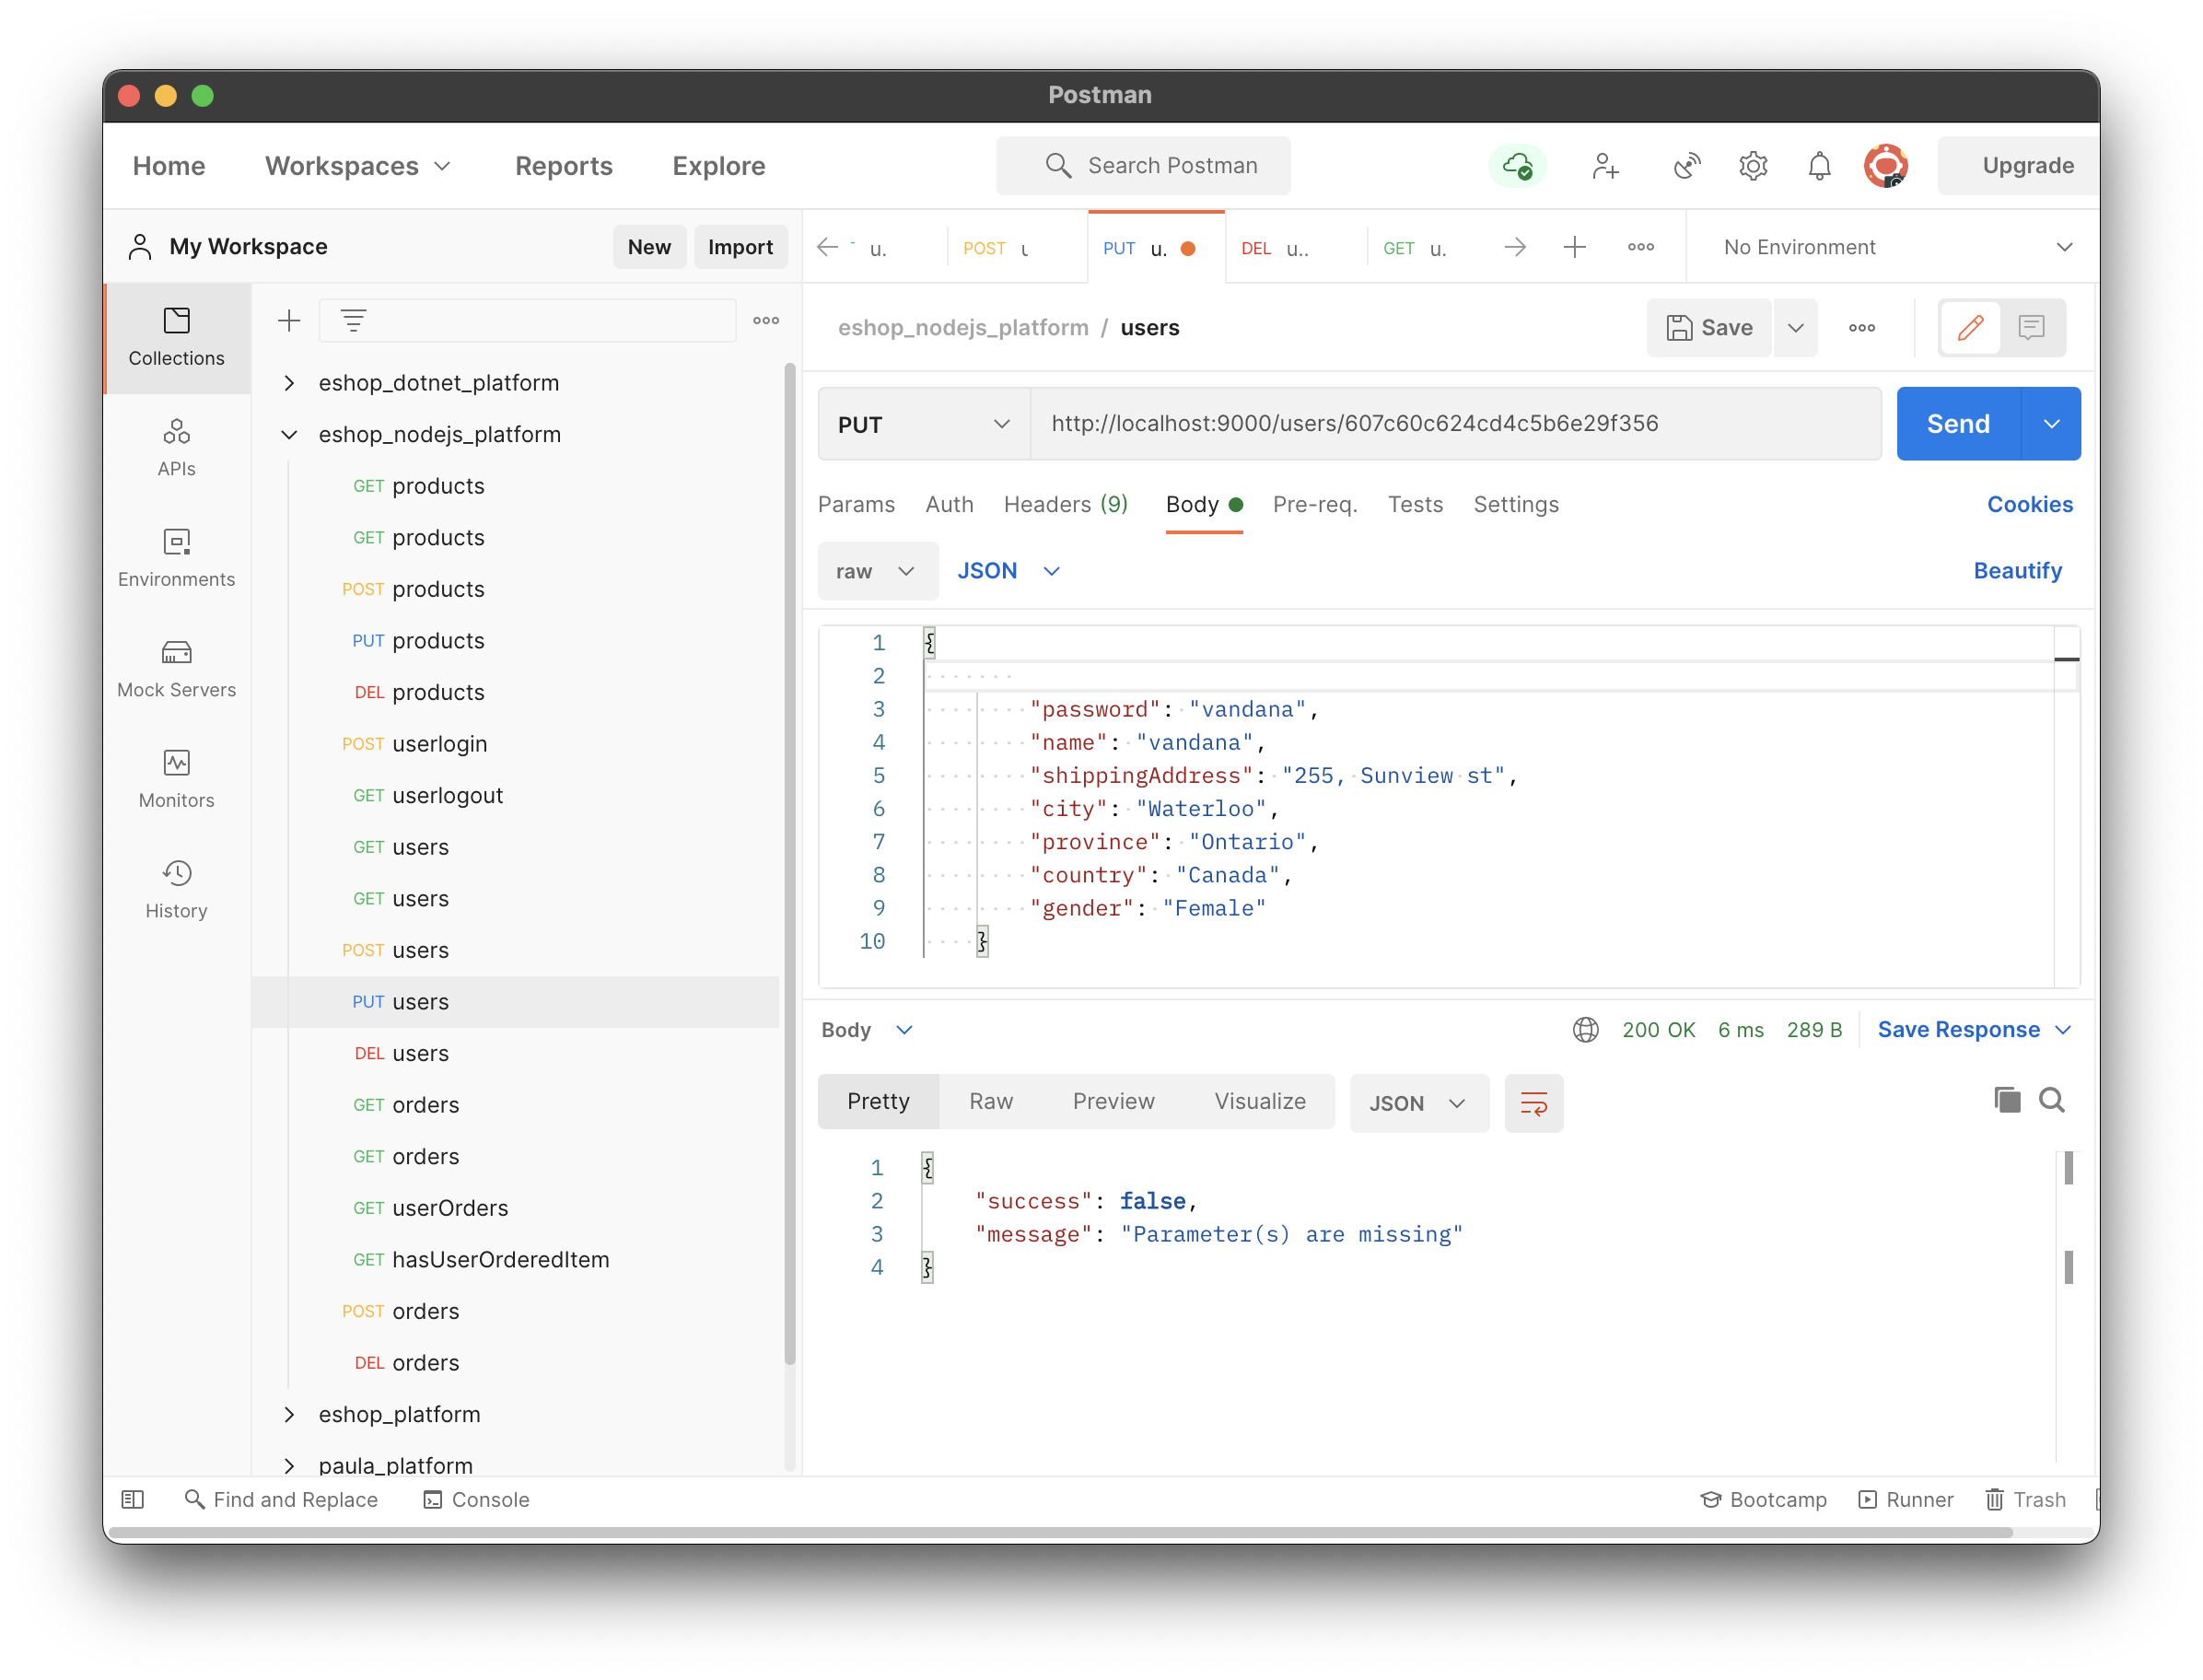

**Test case 2.3.4:**

The request has insufficient user details info in body.

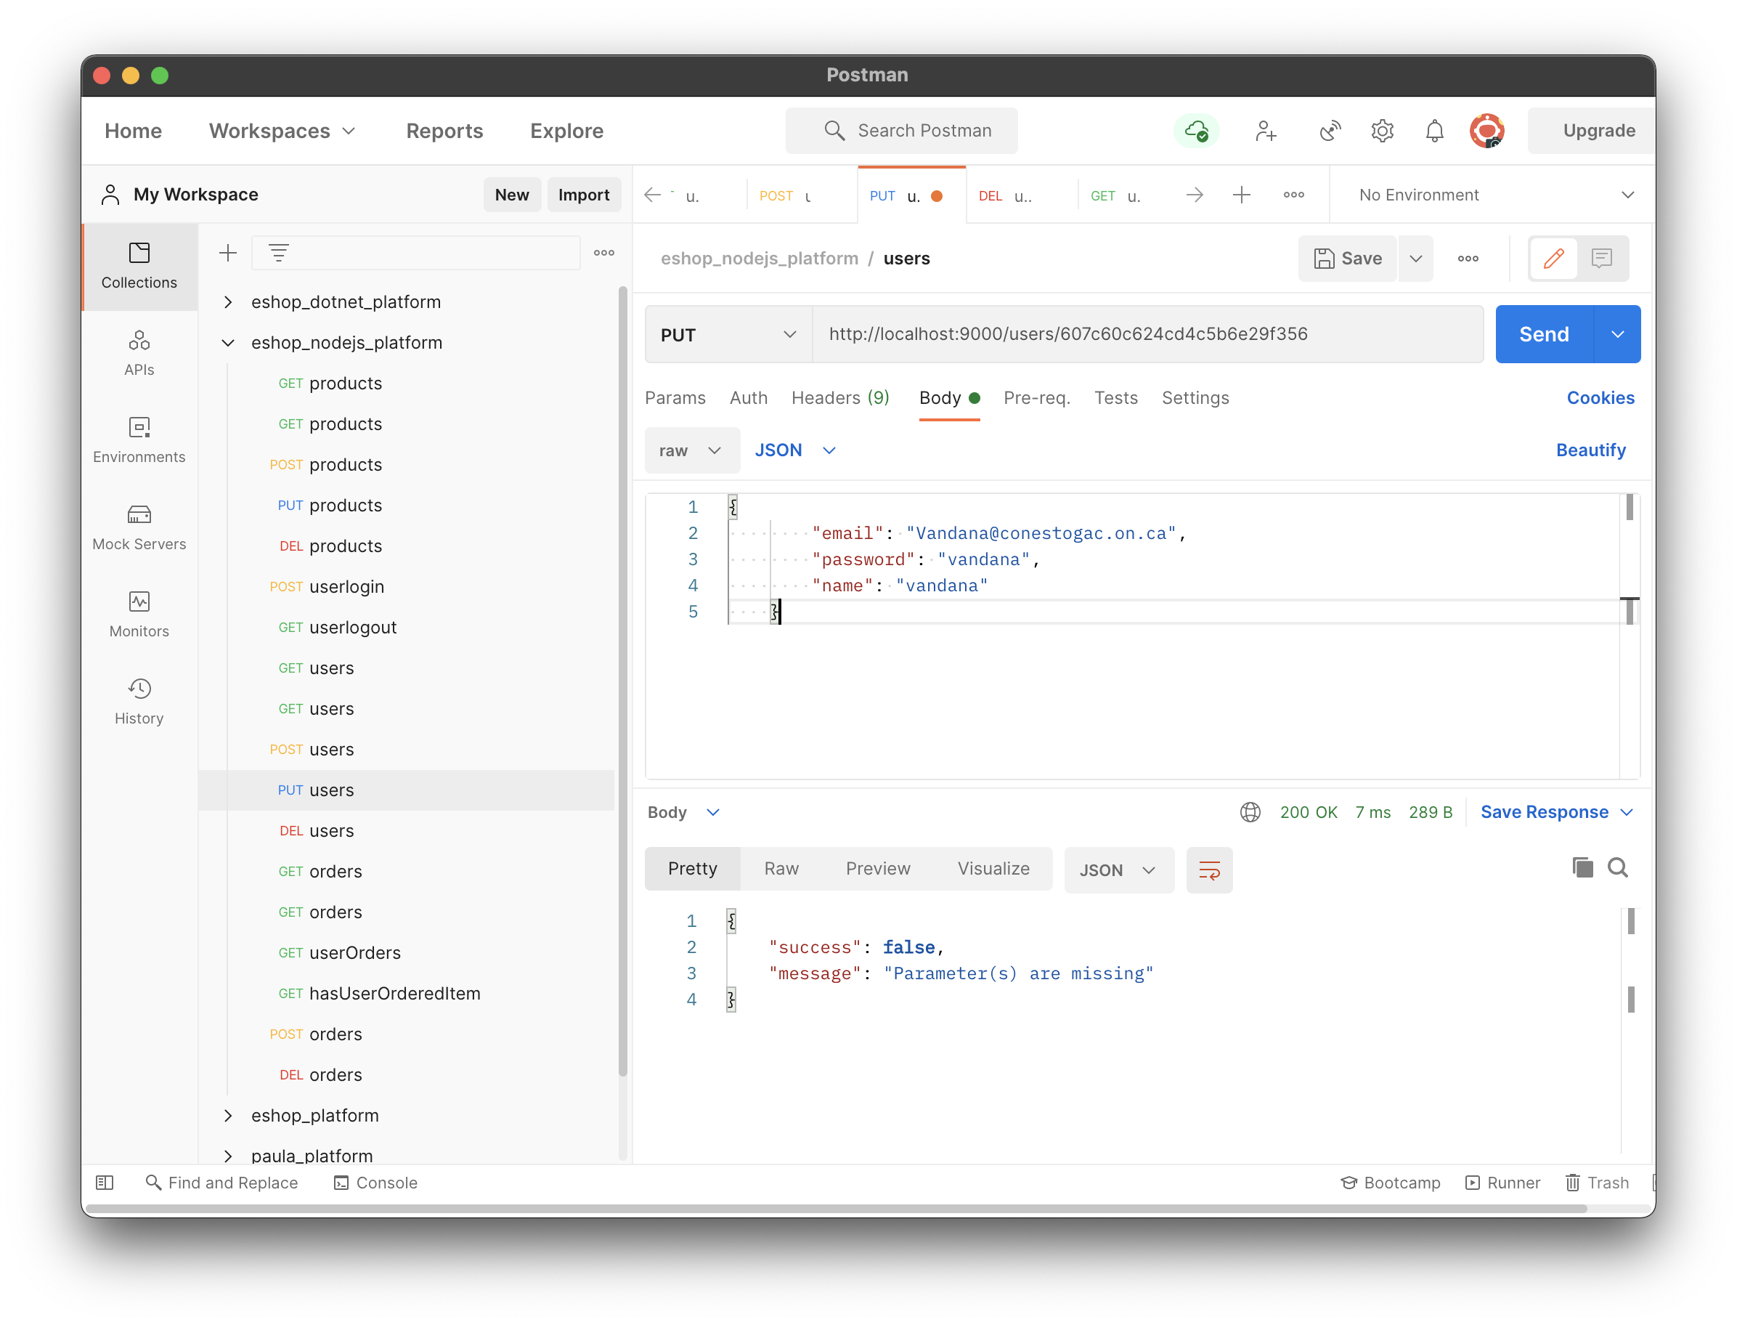

* 1. **DELETE method**: it is used delete any particular user info from database.

Request: /users/{id}

Response JSON sample:

{

"success": **true**,

"message": "The user is deleted successfully."

}

**Test case 2.4.1:**

The request has email ID to delete the user.

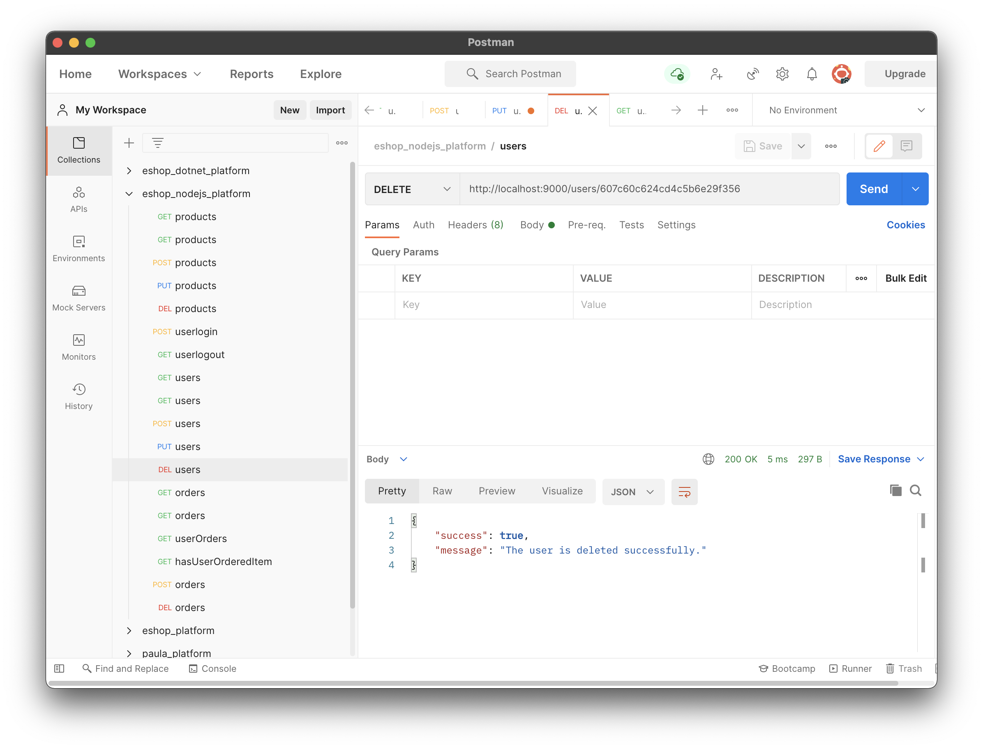

1. **Login:**
   1. **POST method**: it is used to add new user into database.

**API** : /userlogin

Request body JSON sample:

{

    "email": "NGhori3467@conestogac.on.ca",

    "password": "nisha"

}

Response:

{

"success": **true**,

"message": "The user is logged in successfully."

}

**Test case 3.1.1:**

All data is provided correctly in request.

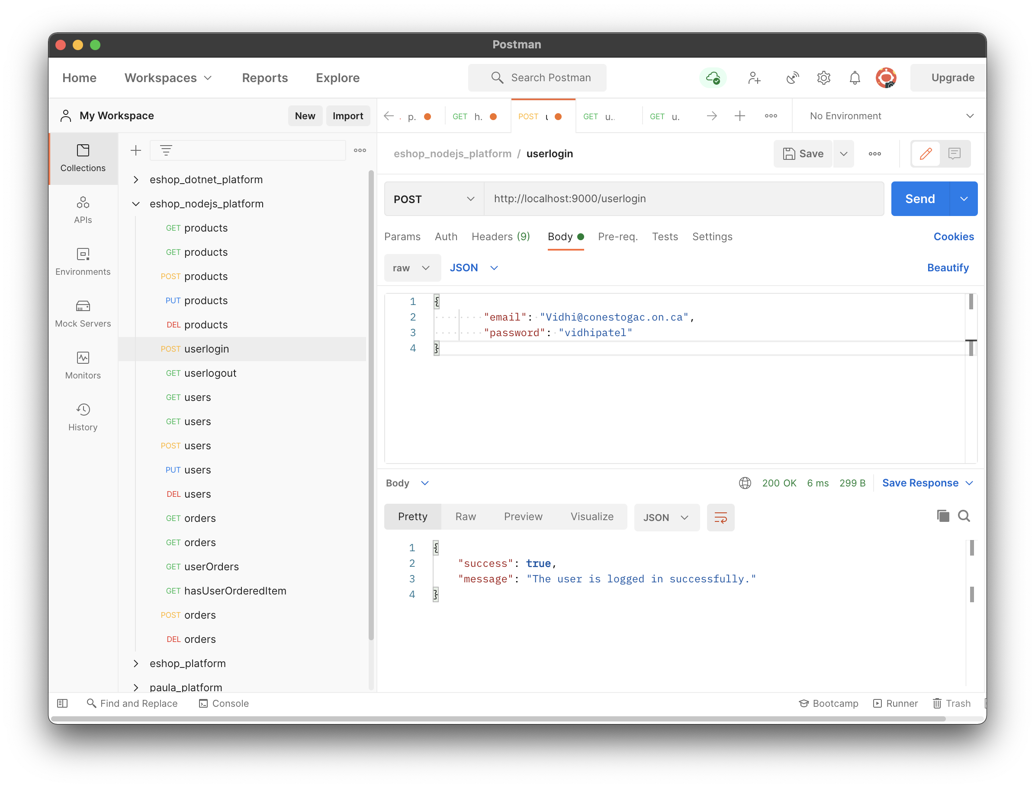

**Test case 3.1.2:**

All data is provided incorrectly in request.

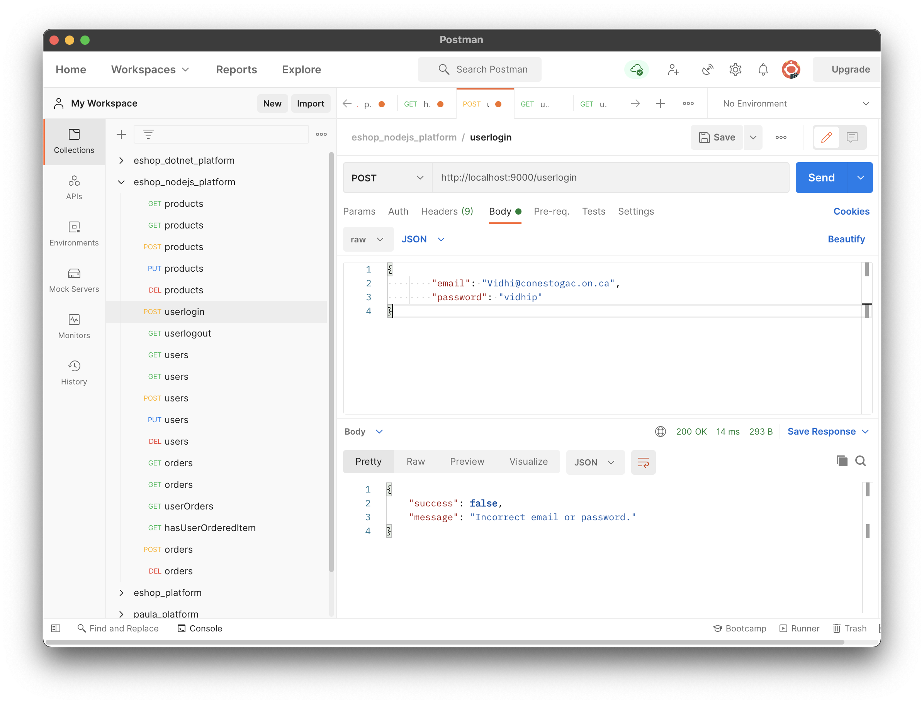

1. **Orders:**
   1. **POST method**: it is used to add new order into database.

**API** : /orders

Request body JSON sample:

{

"email": "Vidhipatel@conestogac.on.ca",

"dateTime": "2020-11-09 01:18:59",

"totalPrice": 1050.5,

"items": [

{

"pId": "607b8e4225fddd3809faa138",

"qty": 2,

"price": 200

},

{

"pId": "607b8e4225fddd3809faa137",

"qty": 1,

"price": 100

},

{

"pId": "607b8e4225fddd3809faa139",

"qty": 1,

"price": 700.5

}

]

}

Response:

{

"success": **true**,

"message": "The order is added successfully."

}

**Test case 4.1.1:**

All data is provided correctly in request.

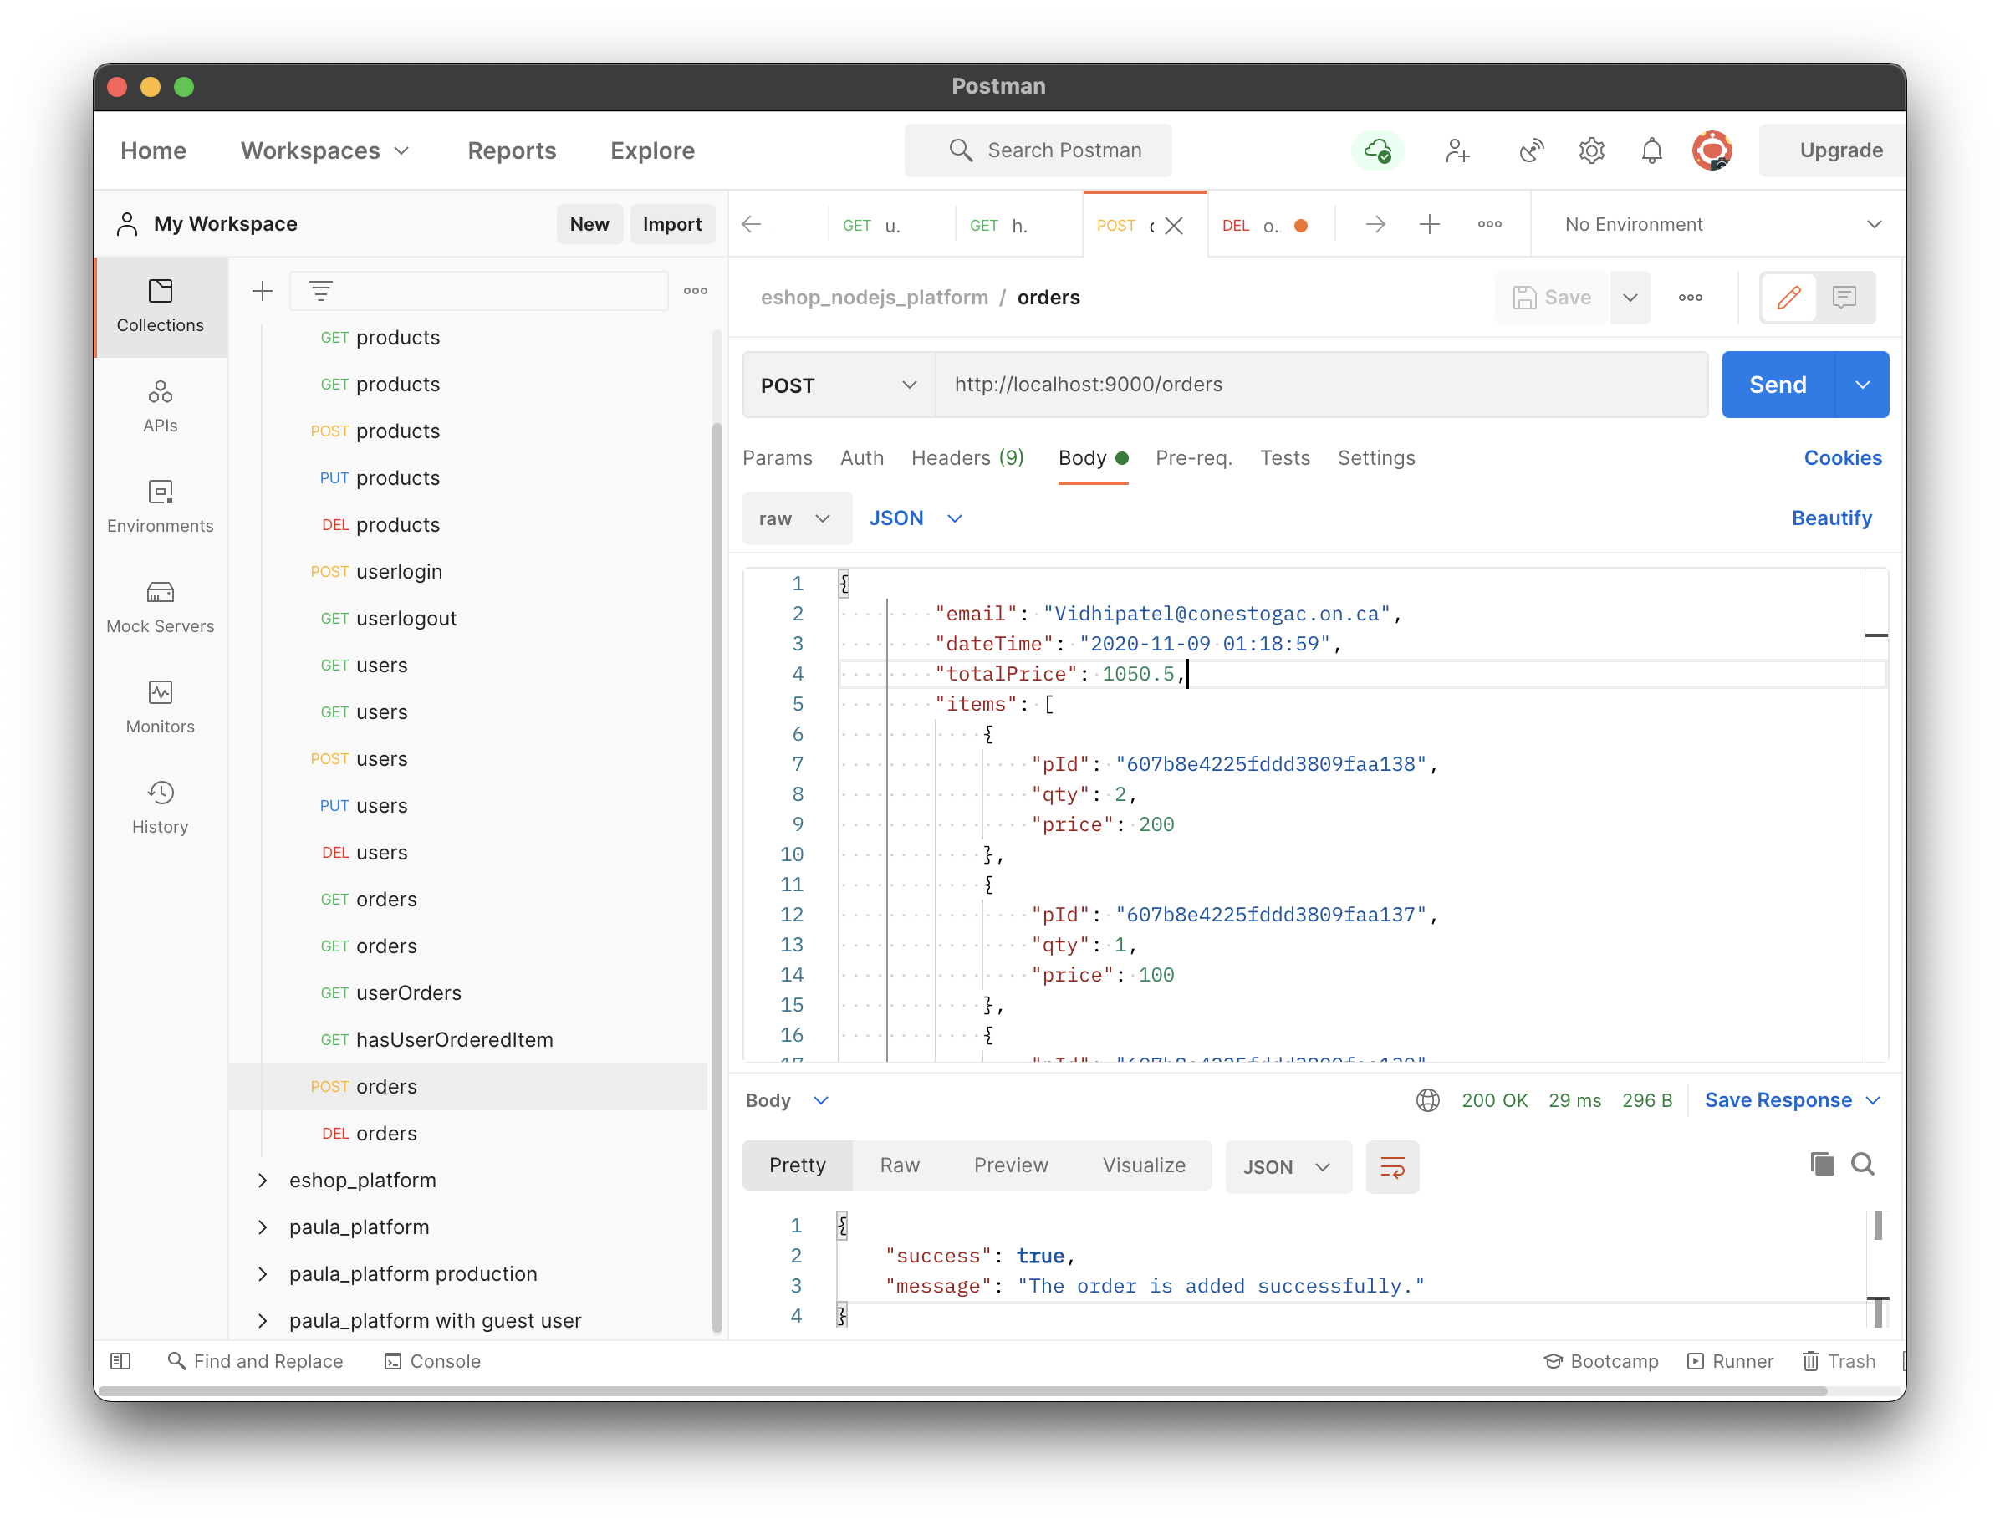

**Test case 4.1.2:**

The request body has some missing data. Order object has insufficient data.

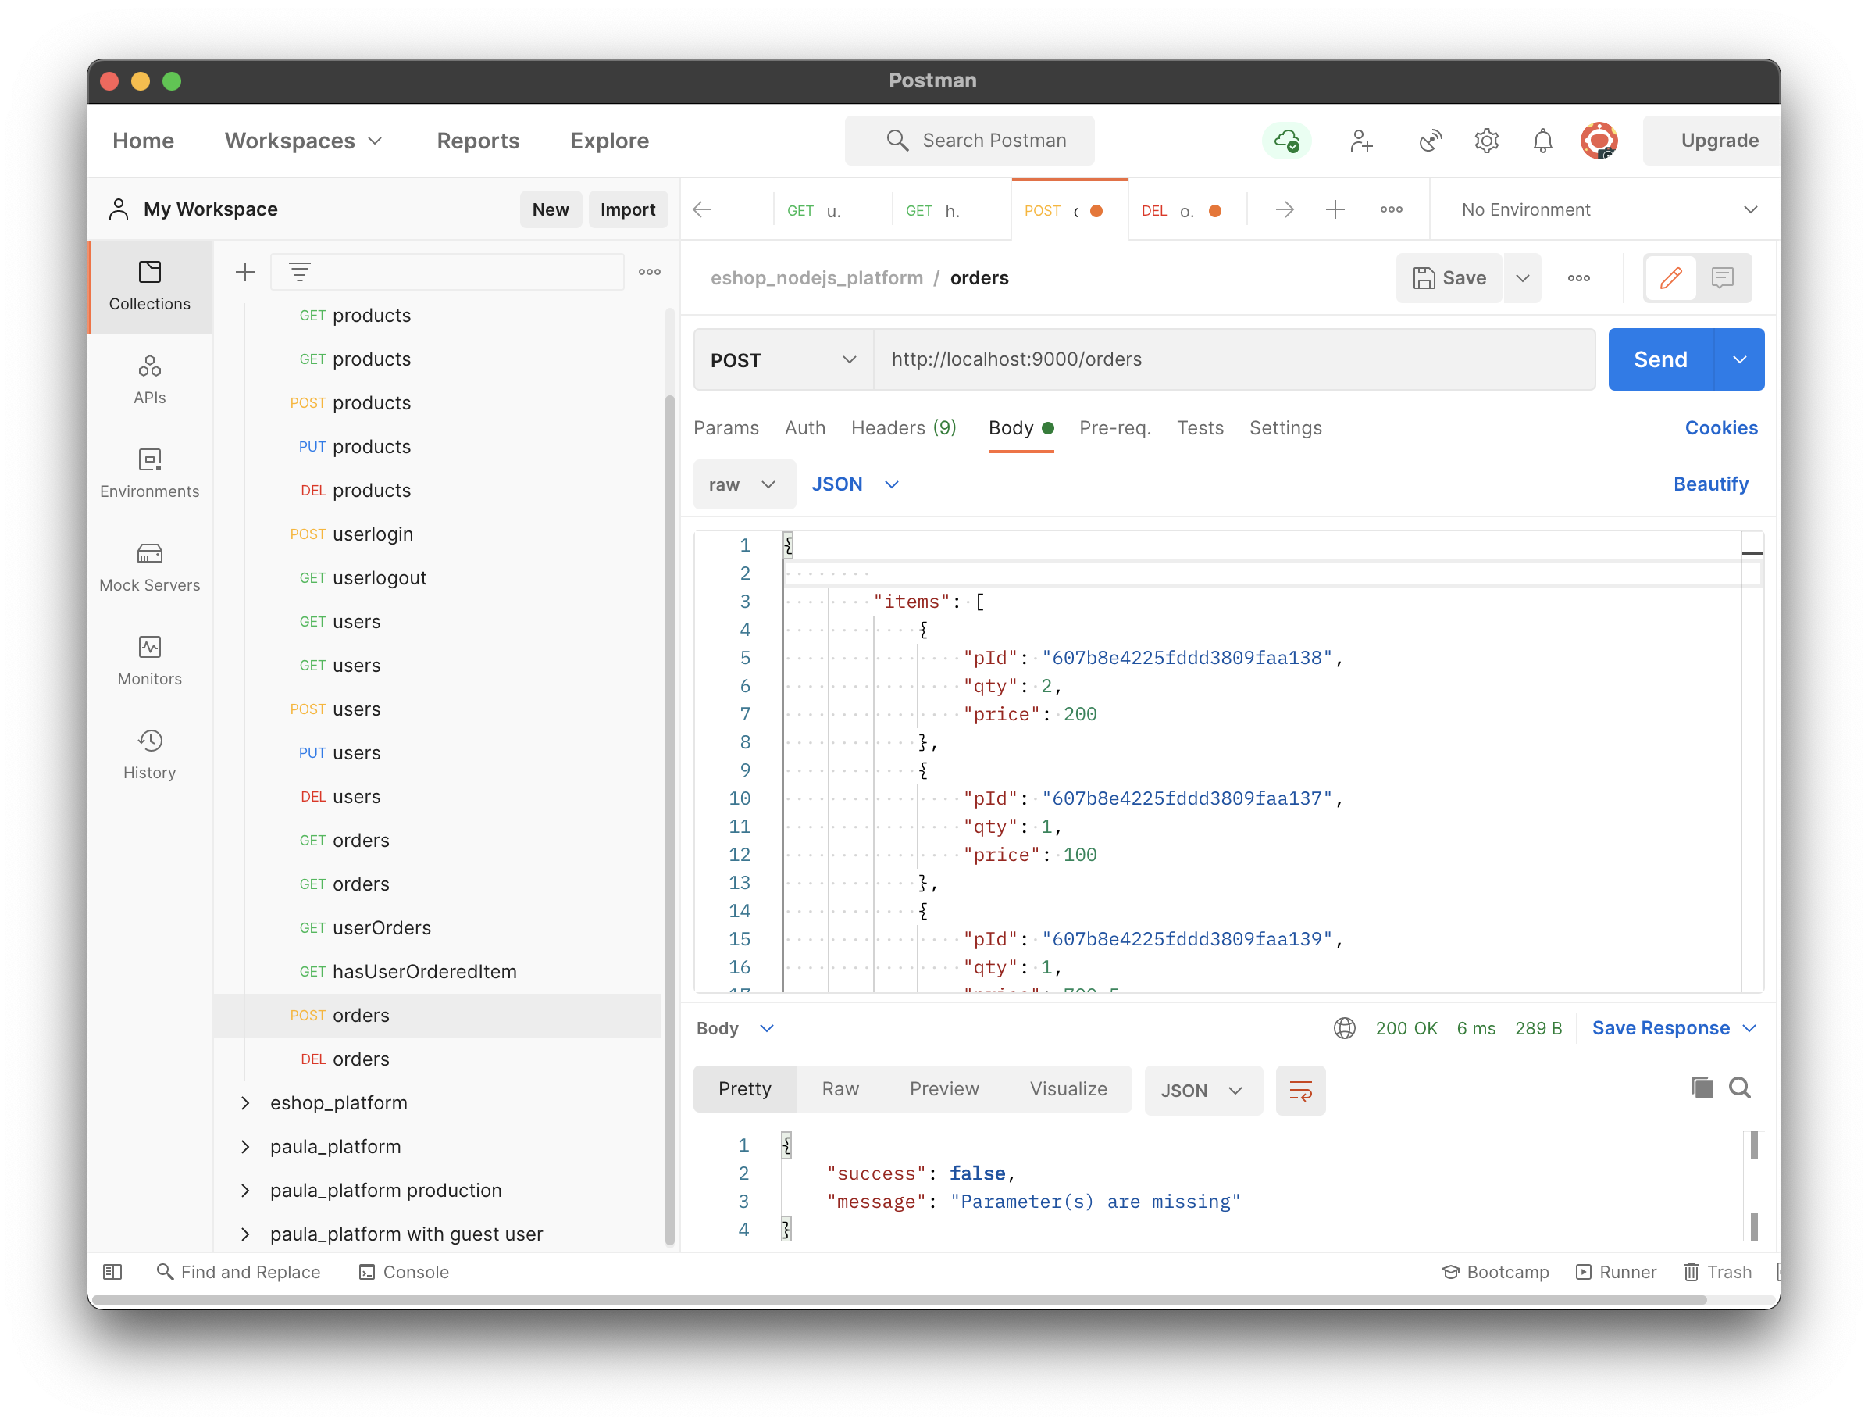

* 1. **GET method**: it is used to get order(s) info from database. If any particular Email or Order ID is provided into URL, it returns info for the order, otherwise it returns all orders exist into the database.

Request: /orders/{id}

Response JSON sample:

{

"_id": "607c68435ca94fd0215e90b0",

"email": "Vpatel5921@conestogac.on.ca",

"dateTime": "2020-11-09 01:18:59",

"totalPrice": 1050.5,

"items": [

{

"_id": "607c68e85ca94fd0215e90b1",

"orderId": "607c68435ca94fd0215e90b0",

"pId": "607b8e4225fddd3809faa138",

"qty": 2,

"price": 200

},

{

"_id": "607c699625fddd3809faa141",

"orderId": "607c68435ca94fd0215e90b0",

"pId": "607b8e4225fddd3809faa137",

"qty": 1,

"price": 100

},

{

"_id": "607c69bb25fddd3809faa142",

"orderId": "607c68435ca94fd0215e90b0",

"pId": "607b8e4225fddd3809faa139",

"qty": 1,

"price": 700.5

}

]

}

**Test case 4.2.1:**

Request data is provided correctly and the order does exist into database.

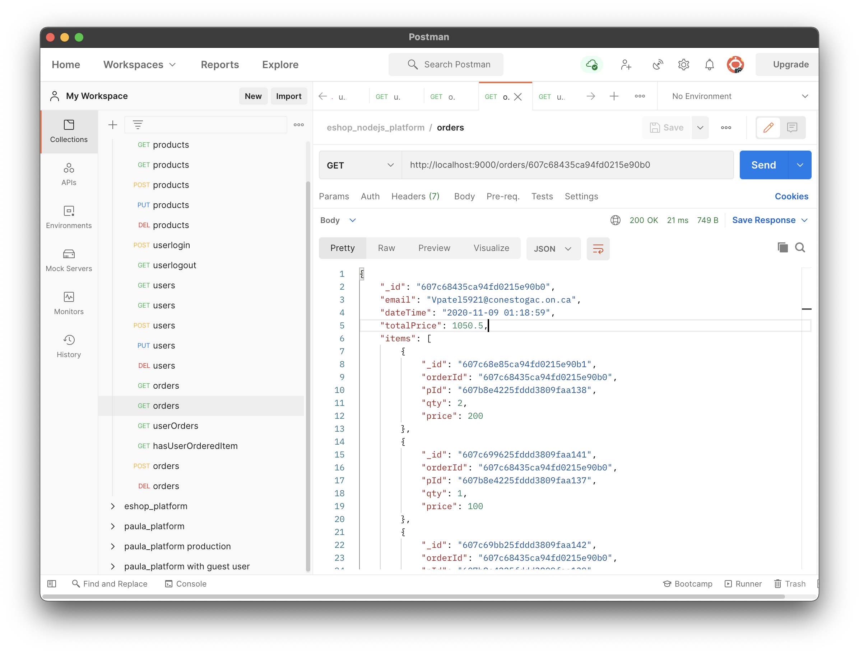

**Test case 4.2.2:**

Request data is provided correctly but the order does not exist into database.

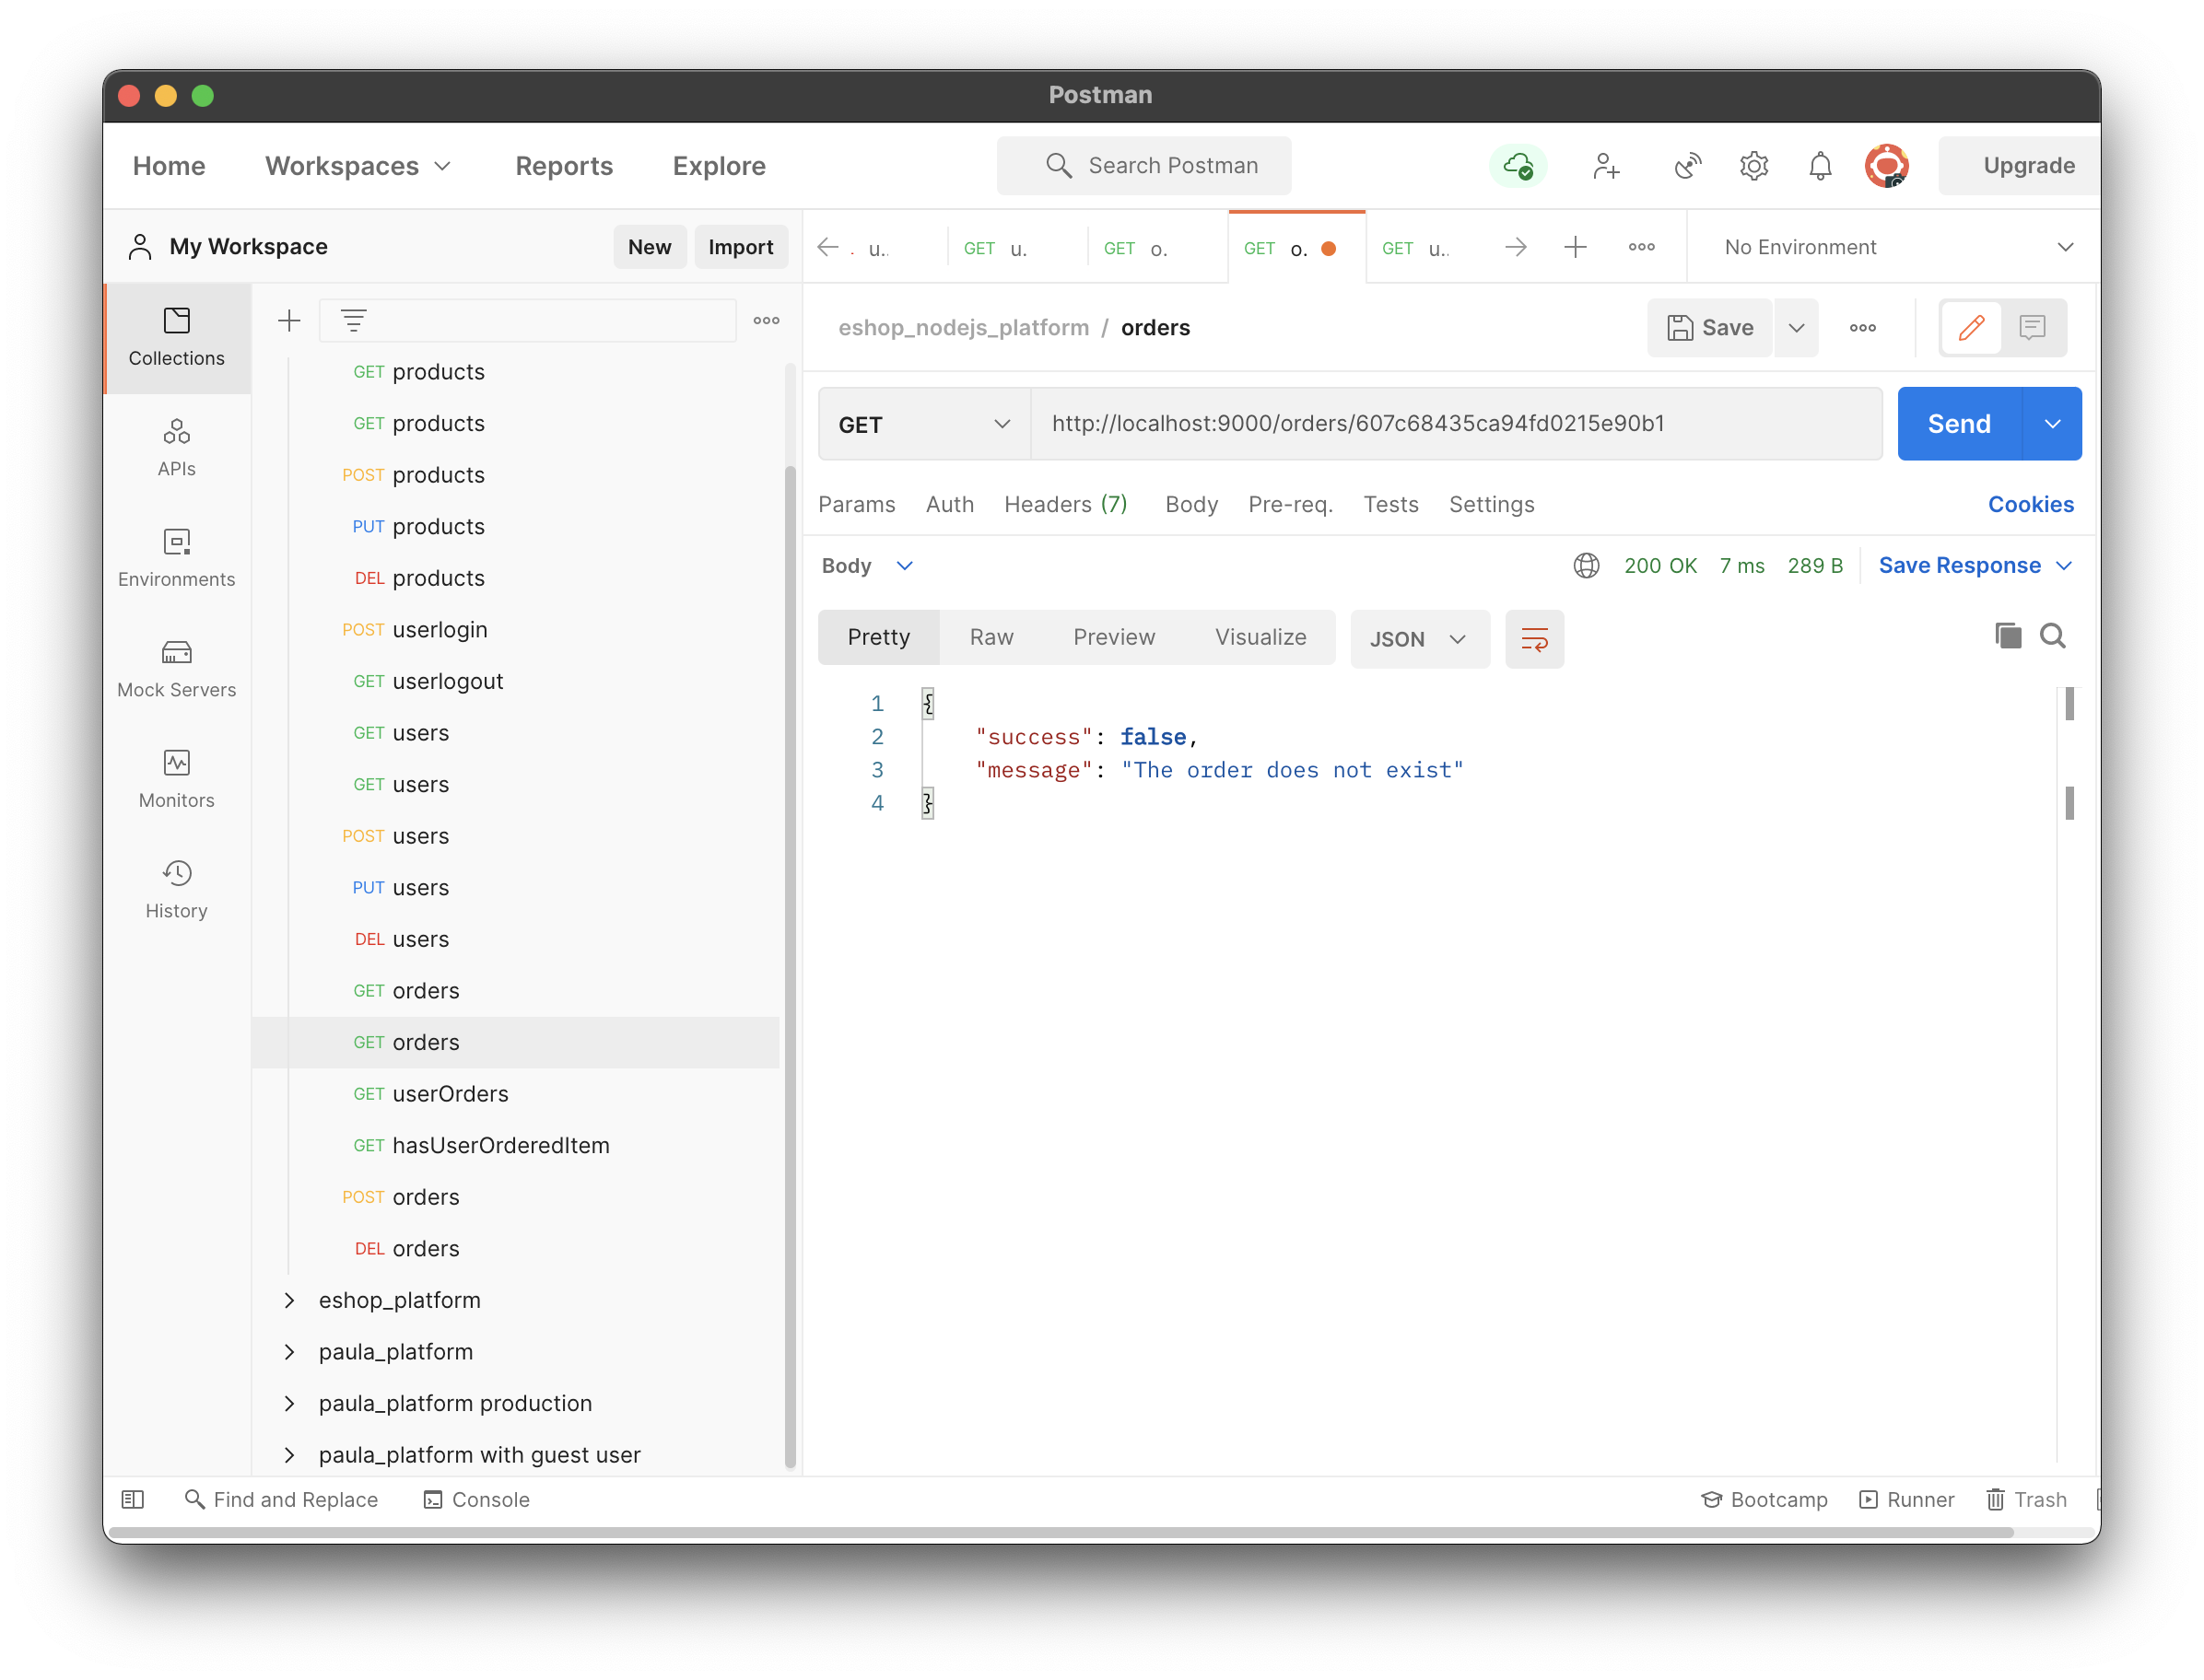

**Test case 4.2.3:**

The request has Email ID to get all orders of the user.

API : /userOrders/{email}

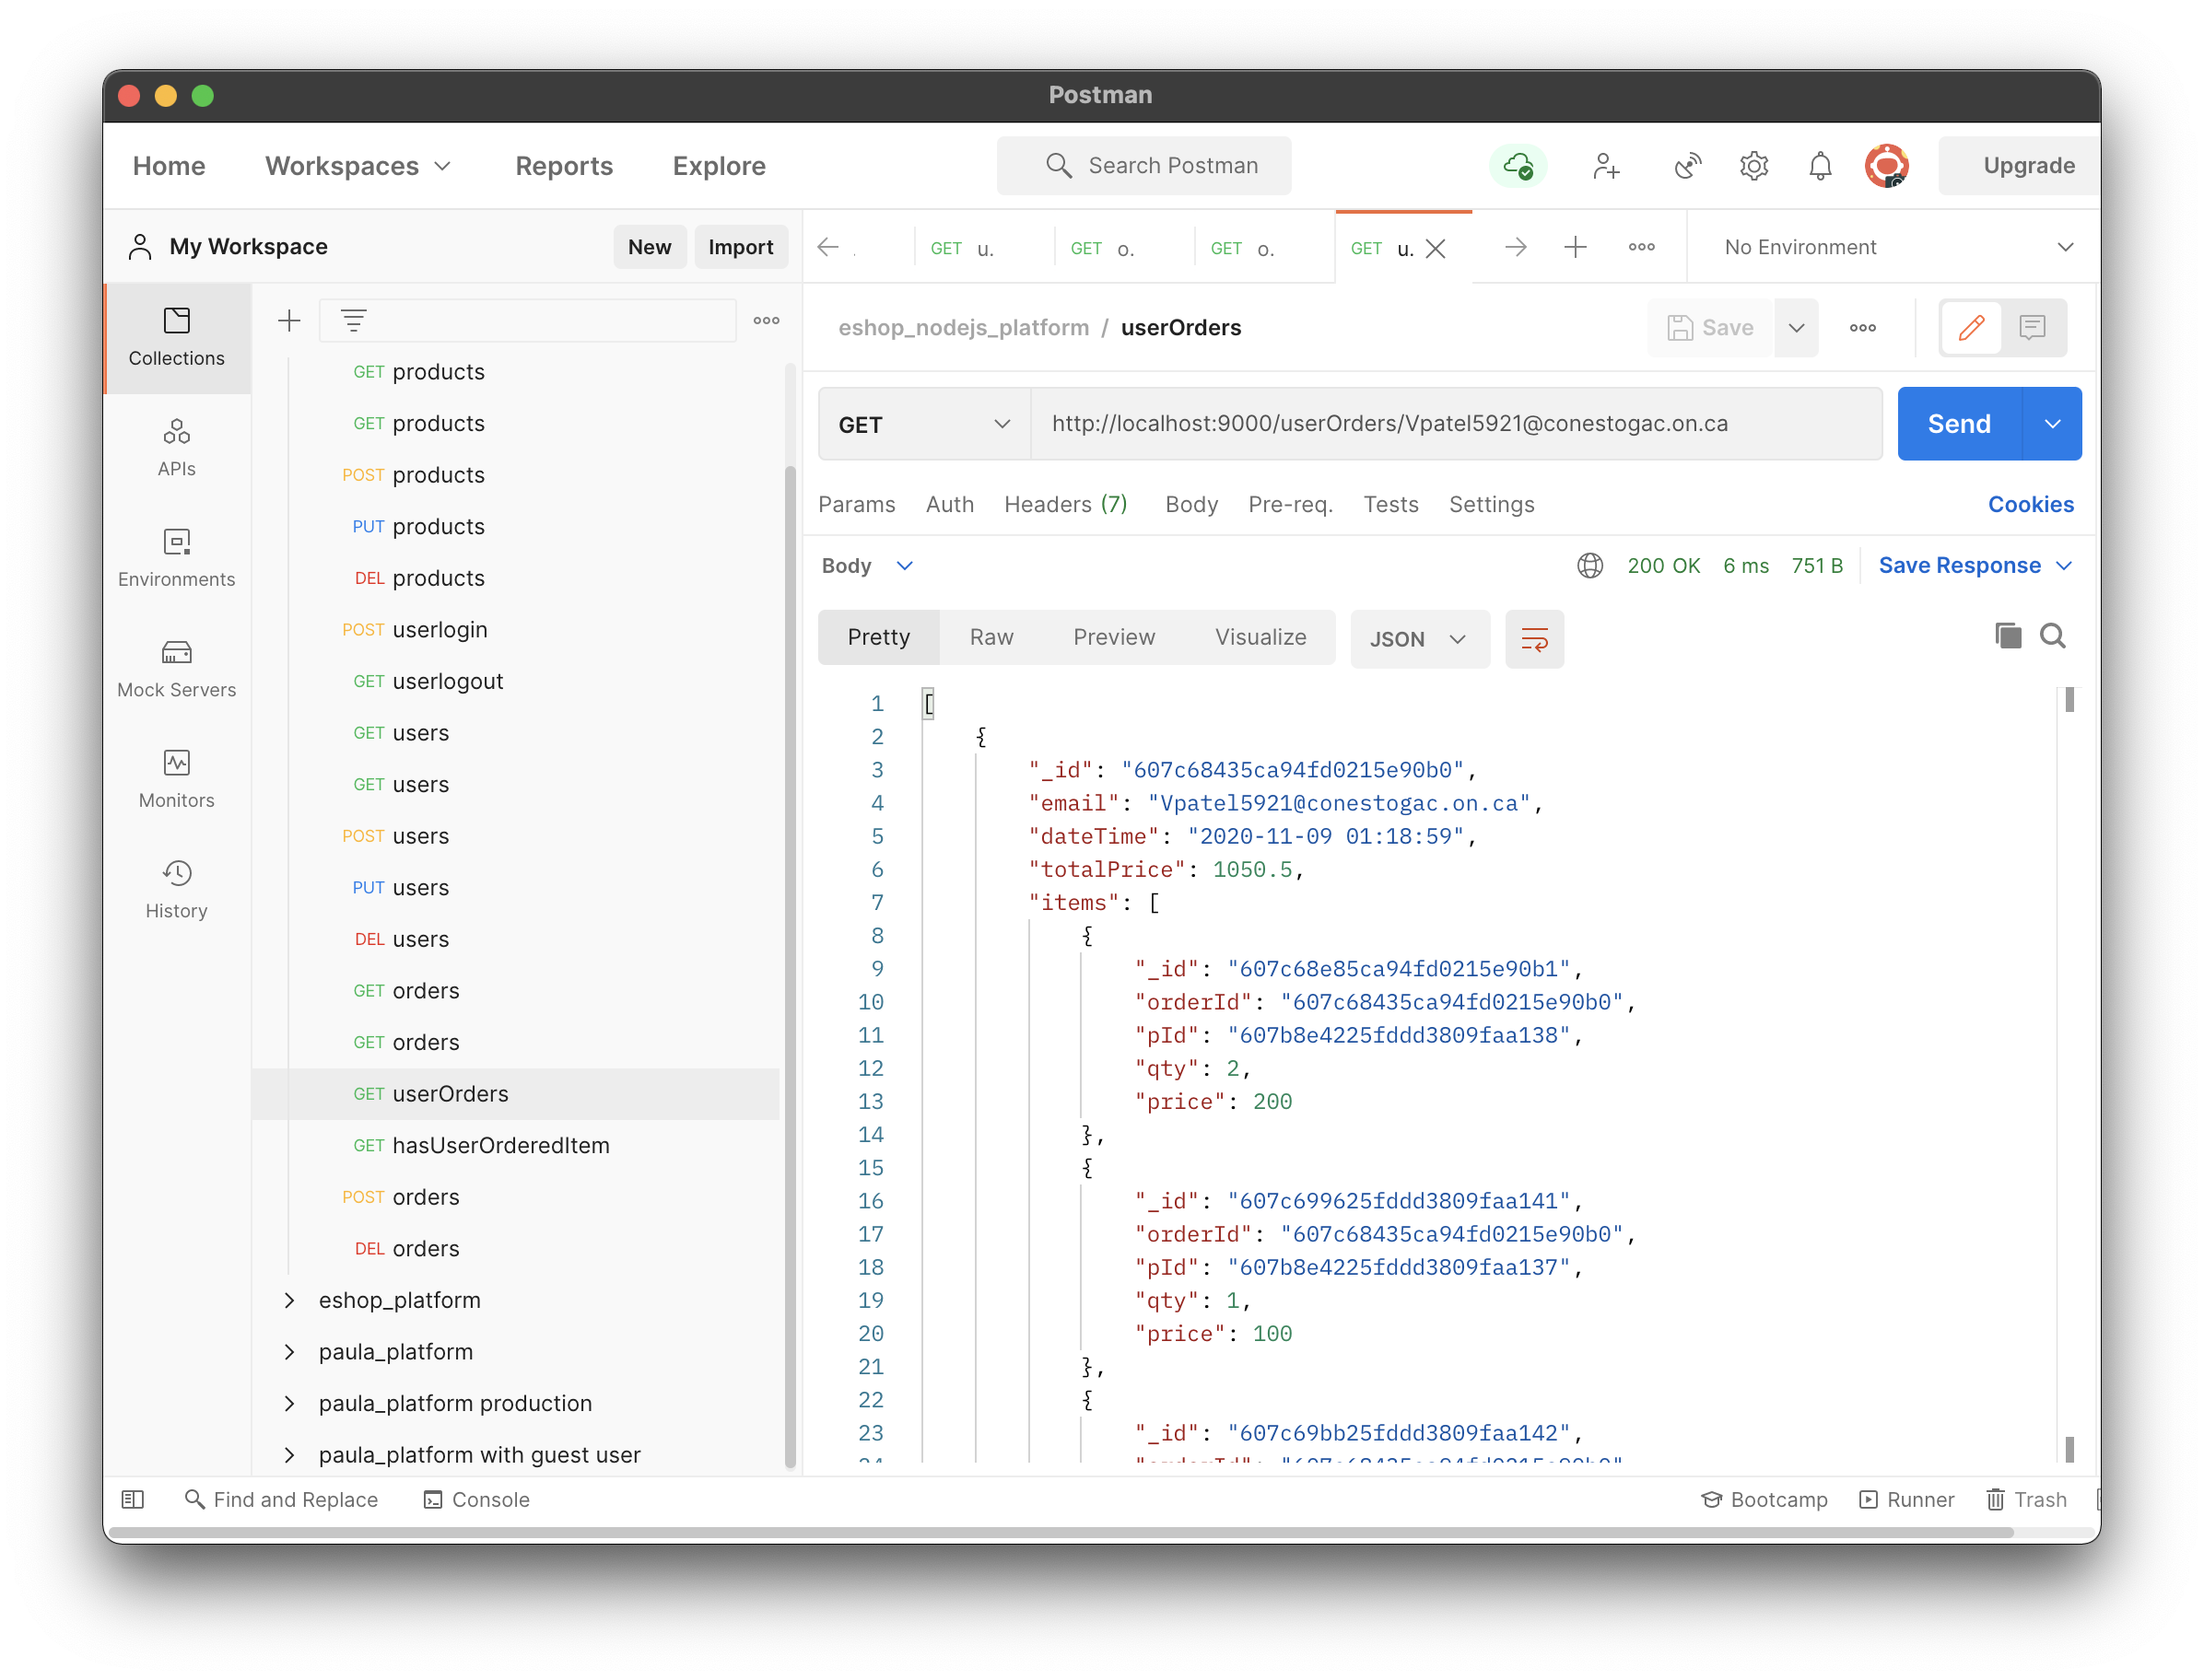

**Test case 4.2.4:**

The request has Email ID and Product ID to know if the user has placed any order for the product or not.

API : /hasUserOrderedItem/{email}/{pId}

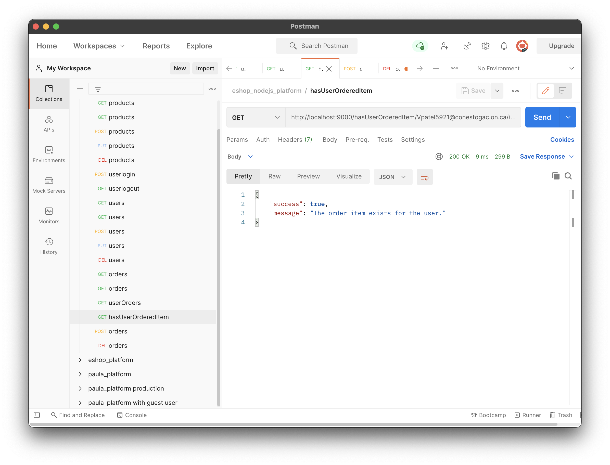

* 1. **DELETE method**: it is used delete any particular order info from database.

Request: /orders/{id}

Response JSON sample:

{

"success": **true**,

"message": "The order is deleted successfully."

}

**Test case 4.4.1:**

The request has Order ID to delete the order.

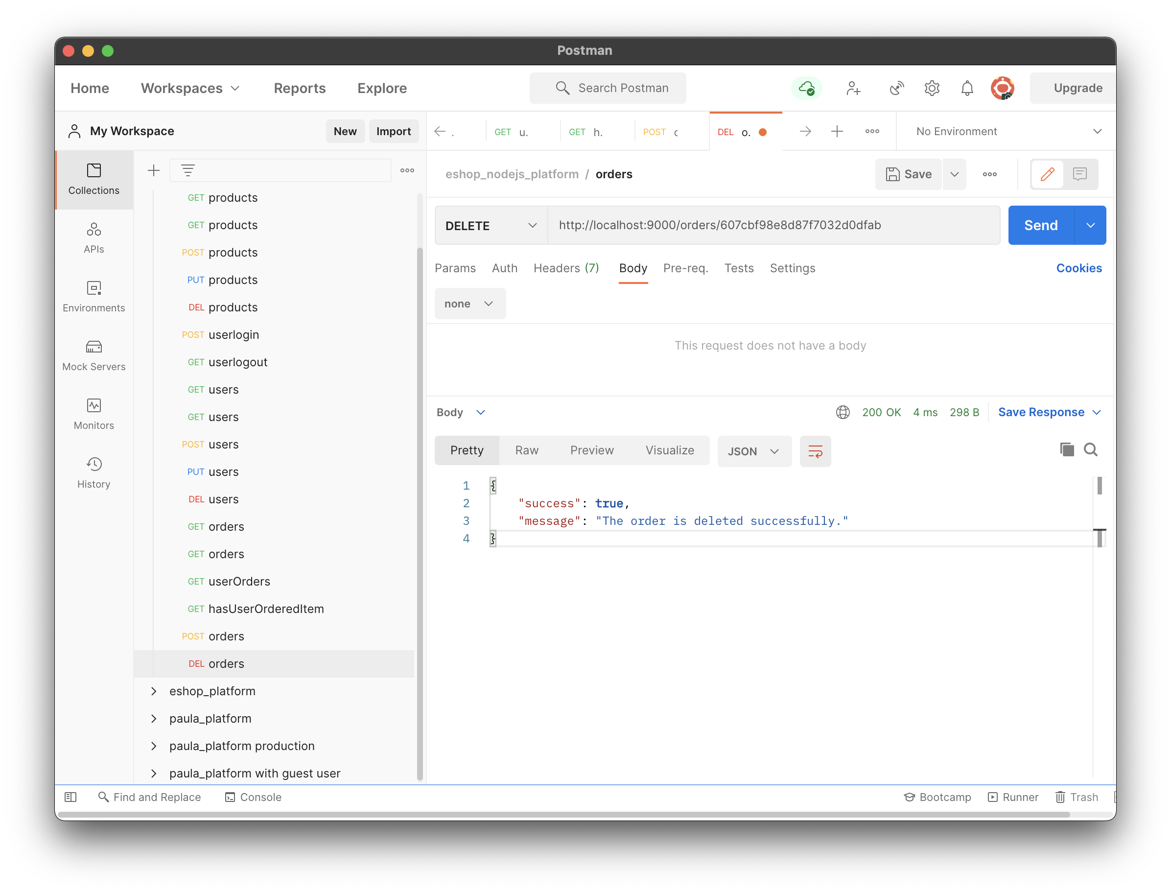

1. **Comments:**

**End Point**: /comments

* 1. **POST method**: it is used to add new comments into database.

Request body JSON sample:

{

  "pId":"607b6621395fc33278380086",

  "text":"Not worth the price",

  "rating":1,

  "username":"Skolappillilraj",

  "email":"Vghori5197@conestogac.on.ca",

  "image1":"../src/photos/item1.jpg",

  "image2":"../src/photos/item2.jpg",

  "image3":"../src/photos/item3.jpg",

  "image4":"../src/photos/item4.jpg",

  "image5":"../src/photos/item5.jpg"

}

Response from JSON Object:

{

    "success": **true**,

    "message": "The comment is added successfully."

}

**Test case 5.1.1:**

All data is provided correctly in request.

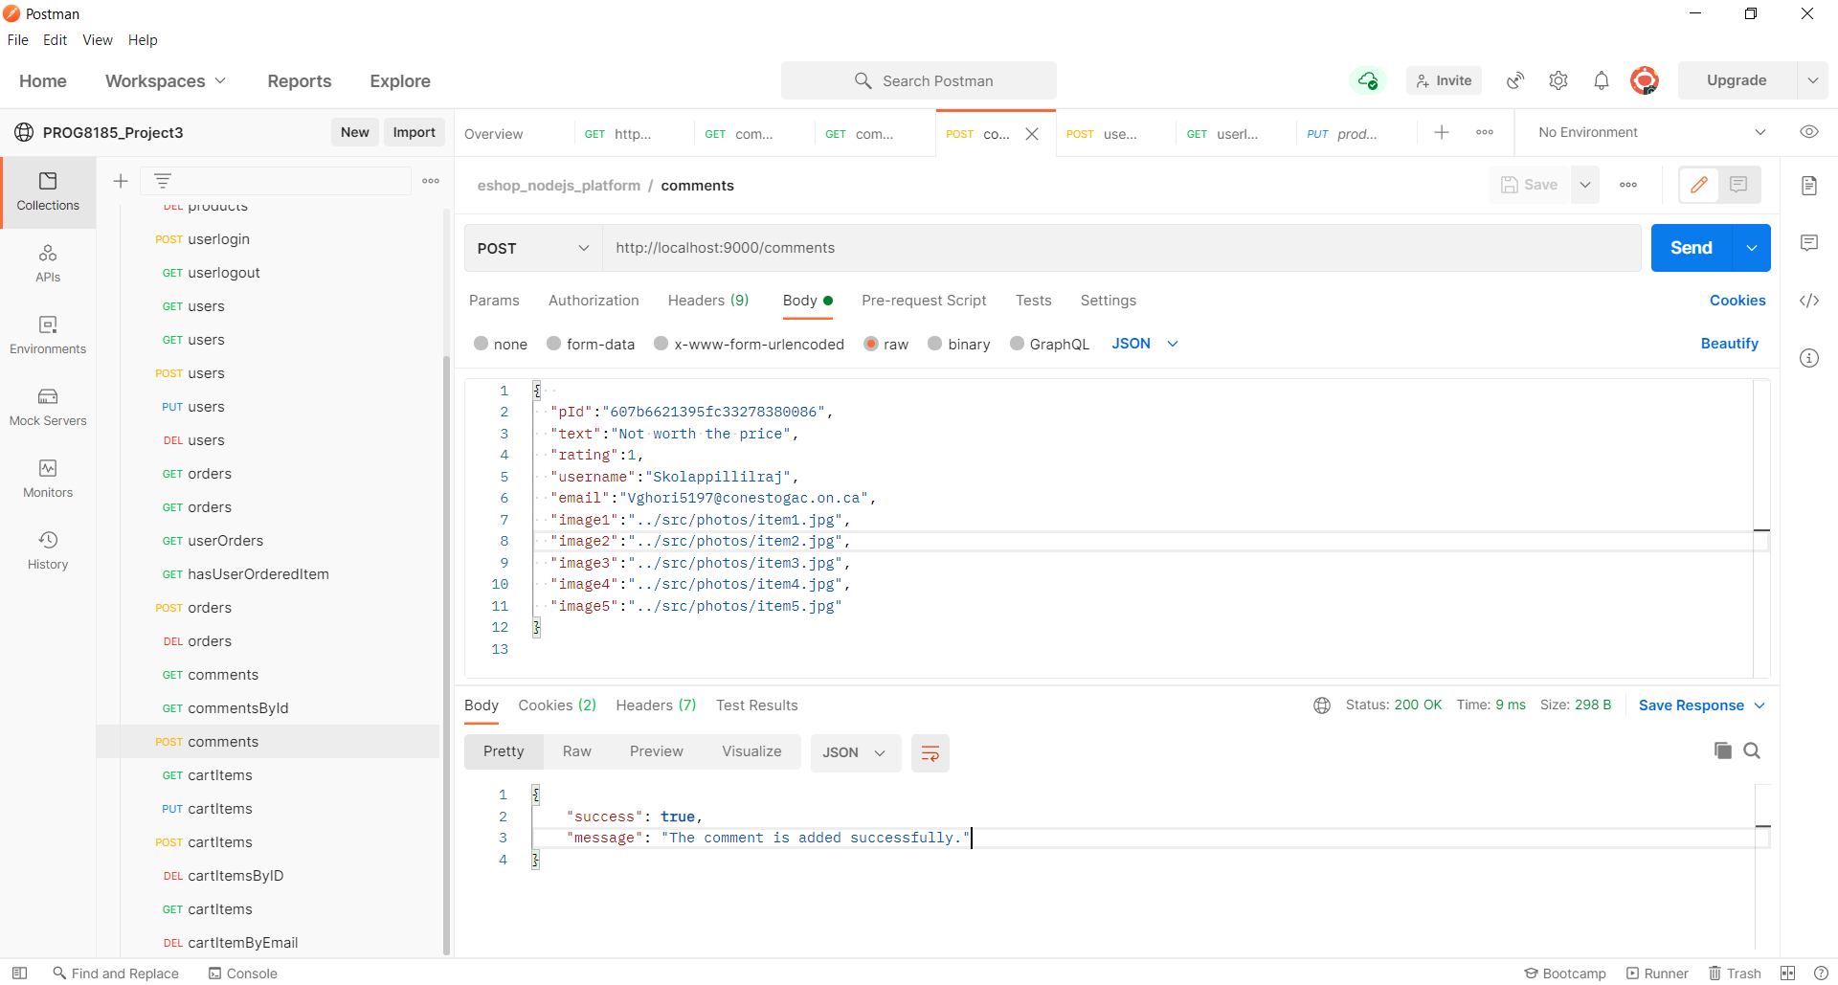

**Test case 5.1.2:**

The request body has some missing data. Comment object has insufficient data.

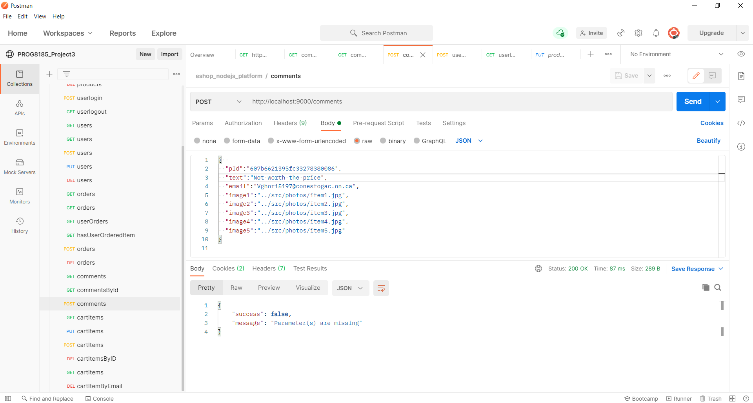

**Test case 5.1.2:**

The request body has invalid user email and trying to add comments.

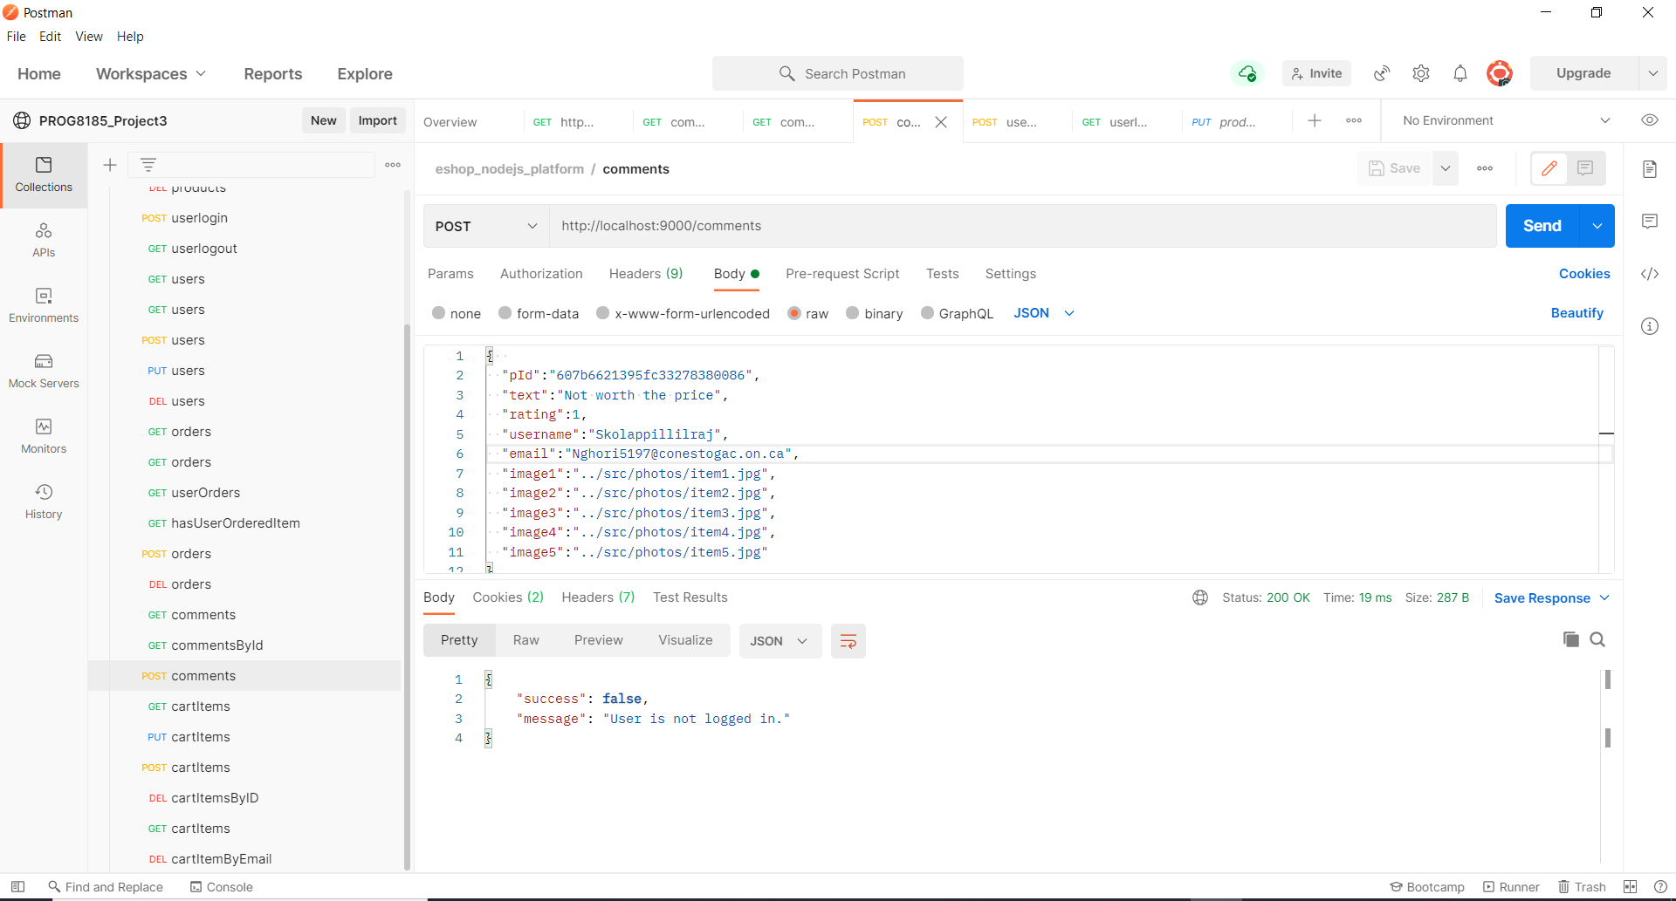

**5.2 GET method**: It is used to get comments information from database. If any particular comment id is provided into URL, it returns information for the comment, otherwise it returns all comment exist into the database.

**Test case 5.2.1**

Request: /comments/607b6621395fc33278380083

Response JSON sample:

{

    "_id": "607dfc28d4ecca38683cacf6",

    "pId": "607b6621395fc33278380083",

    "text": "Not worth the price",

    "rating": 1,

    "username": "Skolappillilraj",

    "email": "Vghori5197@conestogac.on.ca",

    "image1": "../src/photos/item1.jpg",

    "image2": "../src/photos/item2.jpg",

    "image3": "../src/photos/item3.jpg",

    "image4": "../src/photos/item4.jpg",

    "image5": "../src/photos/item5.jpg"

}

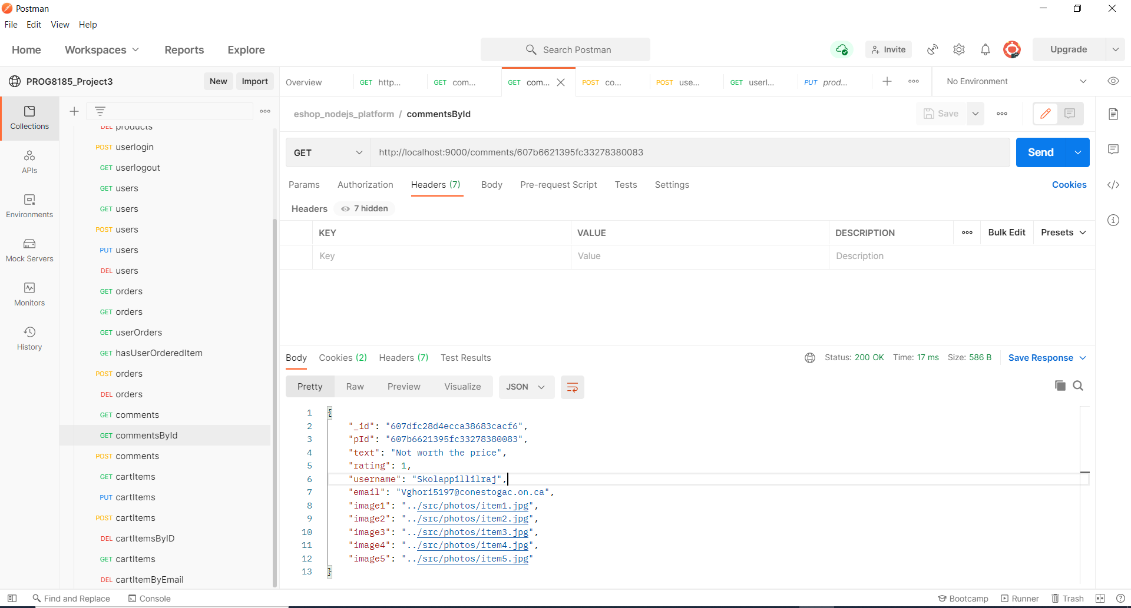

**Test case 5.2.3:**

Request data is provided correctly but the comment does not exist in the database.

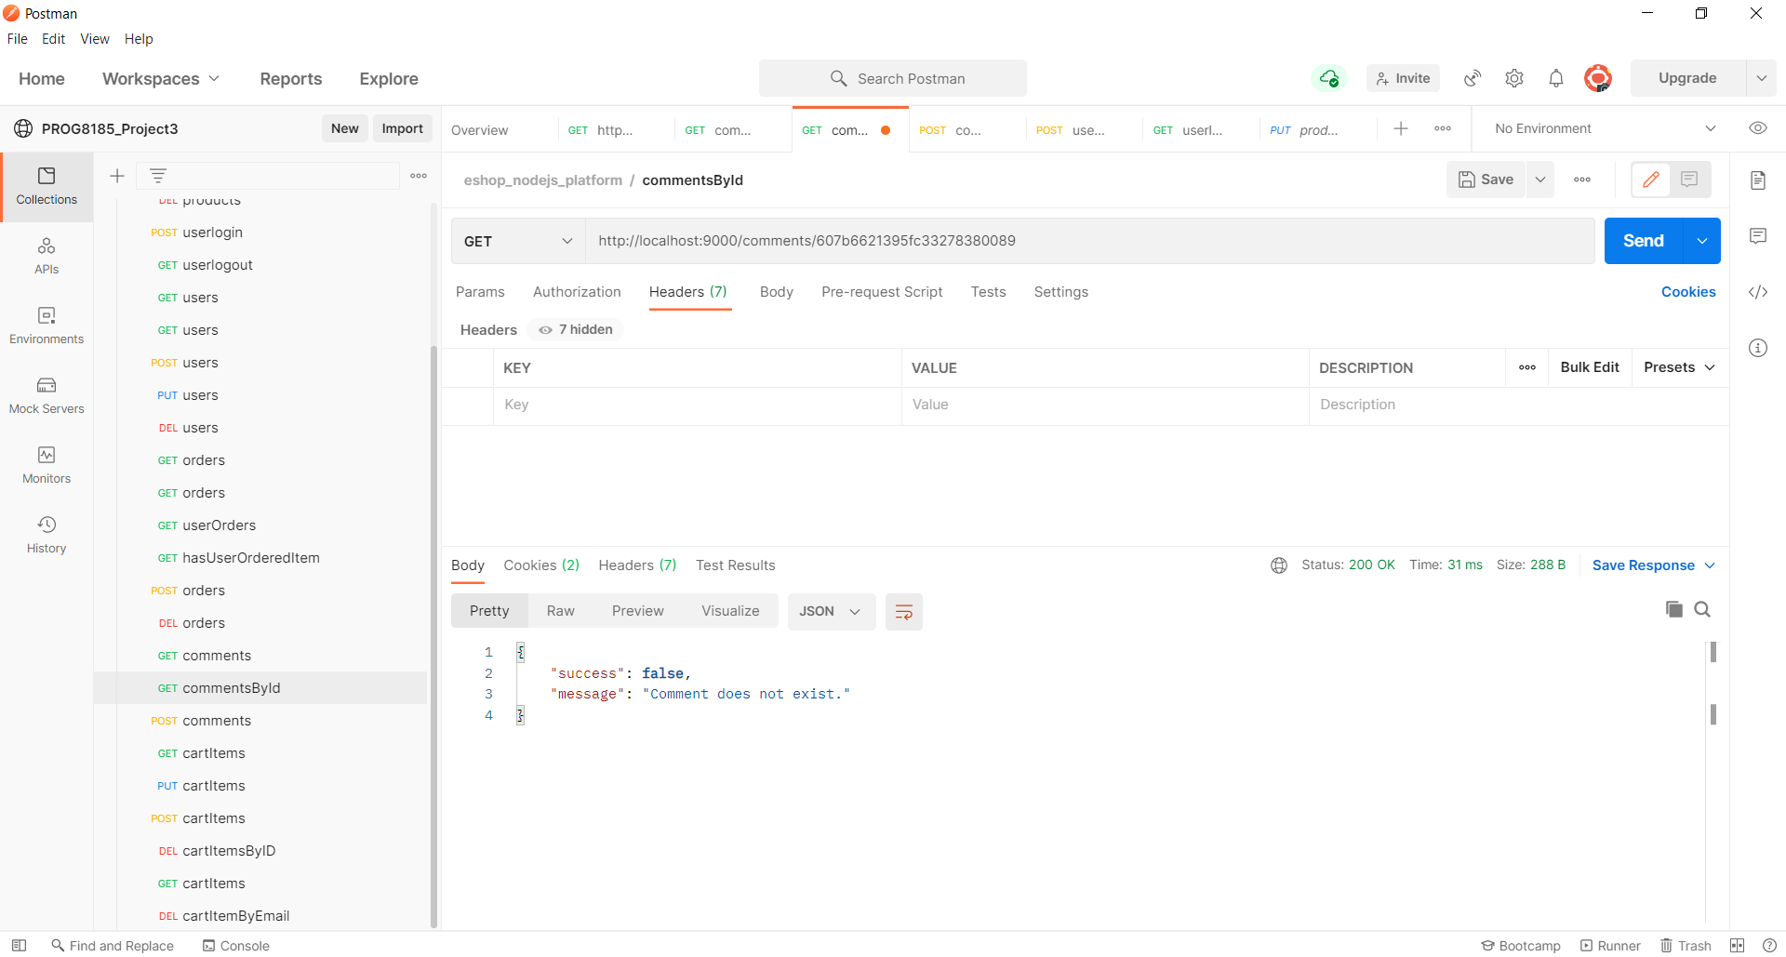

**Test case 5.2.2**

Request: /comments

Response JSON sample:

[

    {

        "_id": "607dfc28d4ecca38683cacf6",

        "pId": "607b6621395fc33278380083",

        "text": "Not worth the price",

        "rating": 1,

        "username": "Skolappillilraj",

        "email": "Vghori5197@conestogac.on.ca",

        "image1": "../src/photos/item1.jpg",

        "image2": "../src/photos/item2.jpg",

        "image3": "../src/photos/item3.jpg",

        "image4": "../src/photos/item4.jpg",

        "image5": "../src/photos/item5.jpg"

    },

    {

        "_id": "607e0542d4ecca38683cacf7",

        "pId": "607b6621395fc33278380084",

        "text": "Not worth the price",

        "rating": 2,

        "username": "Skolappillilraj",

        "email": "Nghori111@conestogac.on.ca",

        "image1": "../src/photos/item1.jpg",

        "image2": "../src/photos/item2.jpg",

        "image3": "../src/photos/item3.jpg",

        "image4": "../src/photos/item4.jpg",

        "image5": "../src/photos/item5.jpg"

    },

    {

        "_id": "607e0681ad2d6748b863dfad",

        "pId": "607b6621395fc33278380086",

        "text": "Not worth the price",

        "rating": 1,

        "username": "Skolappillilraj",

        "image1": "../src/photos/item1.jpg",

        "image2": "../src/photos/item2.jpg",

        "image3": "../src/photos/item3.jpg",

        "image4": "../src/photos/item4.jpg",

        "image5": "../src/photos/item5.jpg"

    },

    {

        "_id": "607e0b4ed4ecca38683cacf8",

        "pId": "607b6621395fc33278380083",

        "text": "Not worth the price",

        "rating": 1,

        "username": "Skolappillilraj",

        "email": "Vghori5197@conestogac.on.ca",

        "image1": "../src/photos/item1.jpg",

        "image2": "../src/photos/item2.jpg",

        "image3": "../src/photos/item3.jpg",

        "image4": "../src/photos/item4.jpg",

        "image5": "../src/photos/item5.jpg"

    },

    {

        "_id": "607e0b5ed4ecca38683cacf9",

        "pId": "607b6621395fc33278380083",

        "text": "Not worth the price",

        "rating": 1,

        "username": "Skolappillilraj",

        "email": "Vghori5197@conestogac.on.ca",

        "image1": "../src/photos/item1.jpg",

        "image2": "../src/photos/item2.jpg",

        "image3": "../src/photos/item3.jpg",

        "image4": "../src/photos/item4.jpg",

        "image5": "../src/photos/item5.jpg"

    }

]

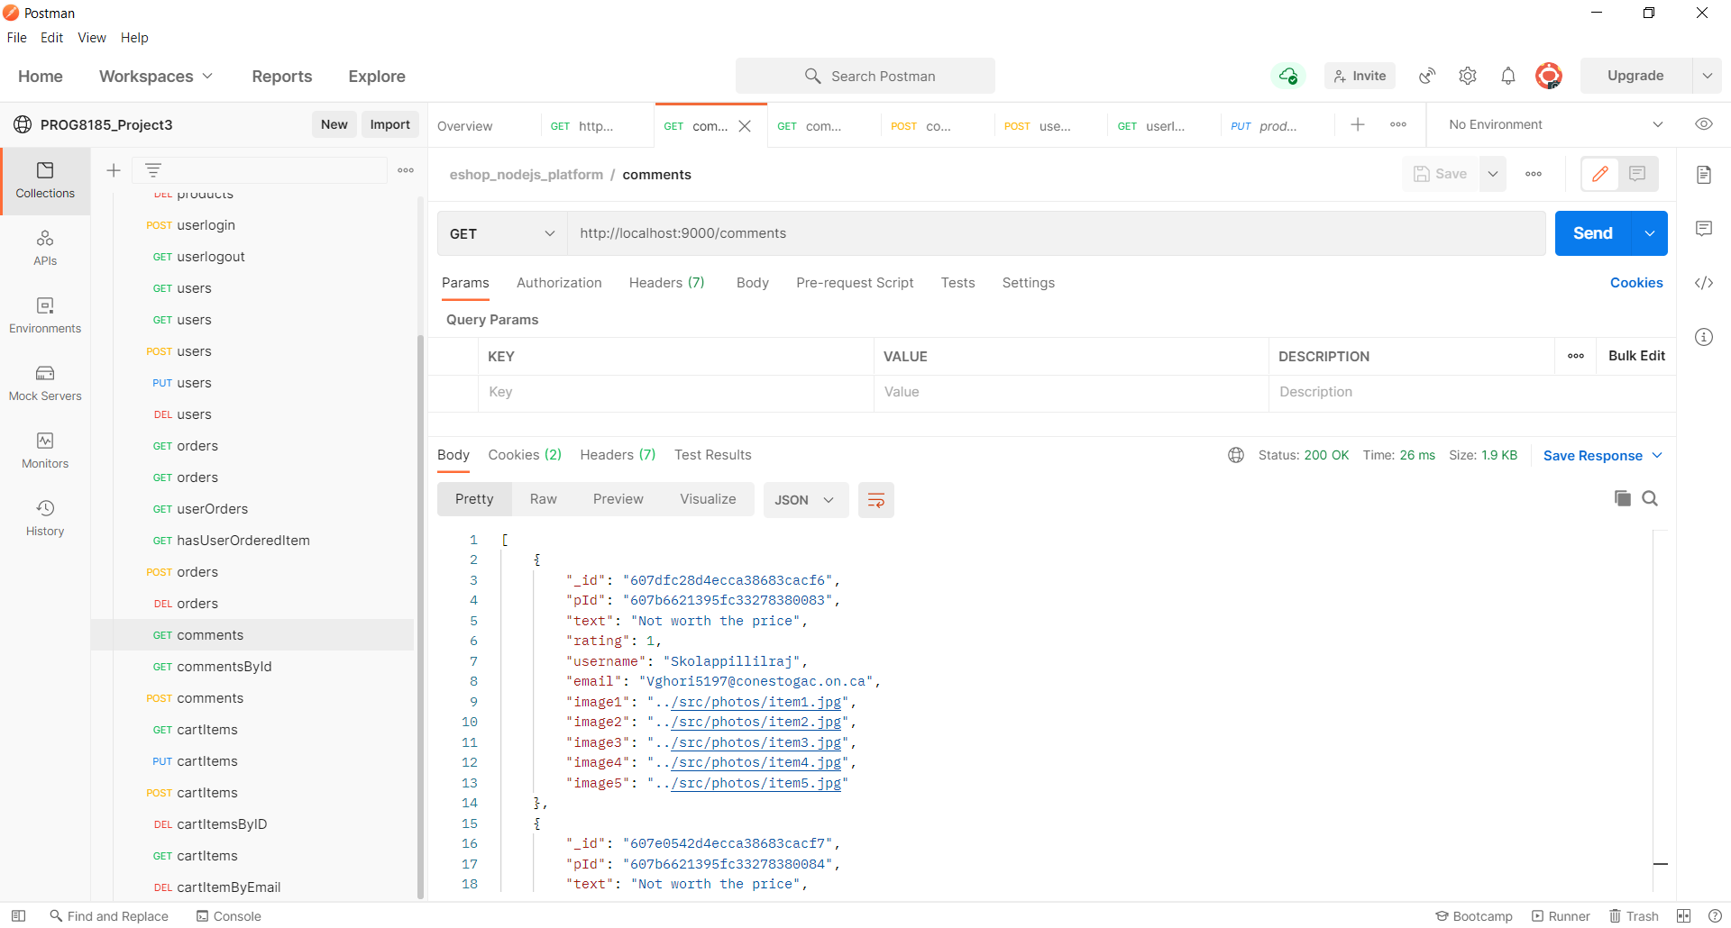

**6.Cart**

End Point: /api/cartItems

**6.1 POST Method**

Request body Json:

{

    "pId": "607b6621395fc33278380084",

    "qty": 6

}

Response Json:

{

    "success": **true**,

    "message": "The product is added successfully into cart."

}

**Test Case 6.1.1**

Product added to cart with correct request body.

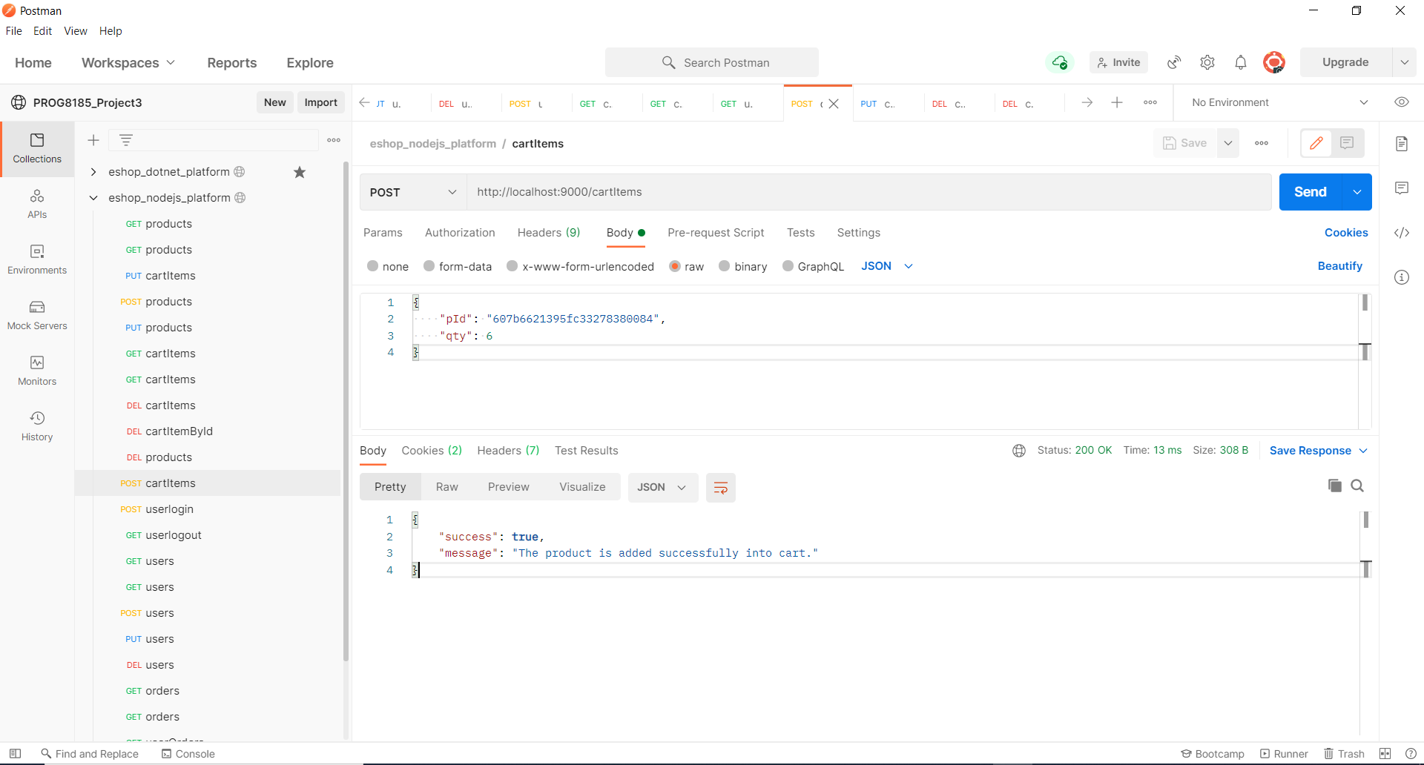

**Test case 6.1.2**

Product with missing input parameters.

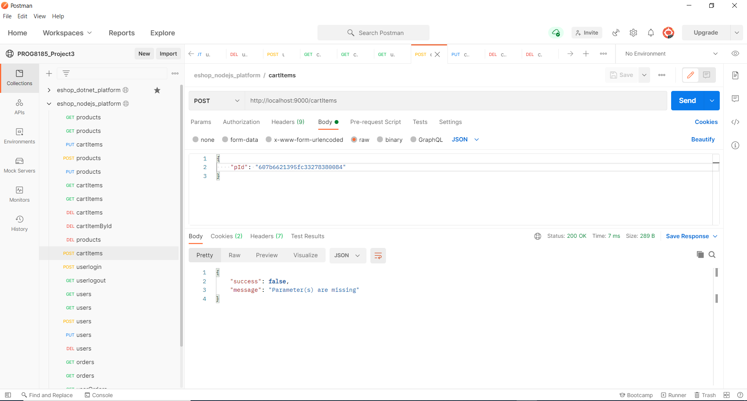

**6.2 GET Method**

Request URL : /api/cartItems

Response body Json:

[

    {

        "_id": "607db4d3bb70cf2438b7fd3d",

        "email": "NGhori3467@conestogac.on.ca",

        "pId": "607b6621395fc33278380084",

        "qty": 6

    },

    {

        "_id": "607d888abb1e1ff2c3afa570",

        "email": "NGhori3467@conestogac.on.ca",

        "pId": "607b6621395fc33278380083",

        "qty": 2

    },

    {

        "_id": "607d8920bb1e1ff2c3afa572",

        "email": "Skolappillilraj8374@conestogac.on.ca",

        "pId": "607b6621395fc33278380084",

        "qty": 5

    }

]

**Test case : 6.2.1**

Try to retrieve all the cartItems information but user is not logged in.

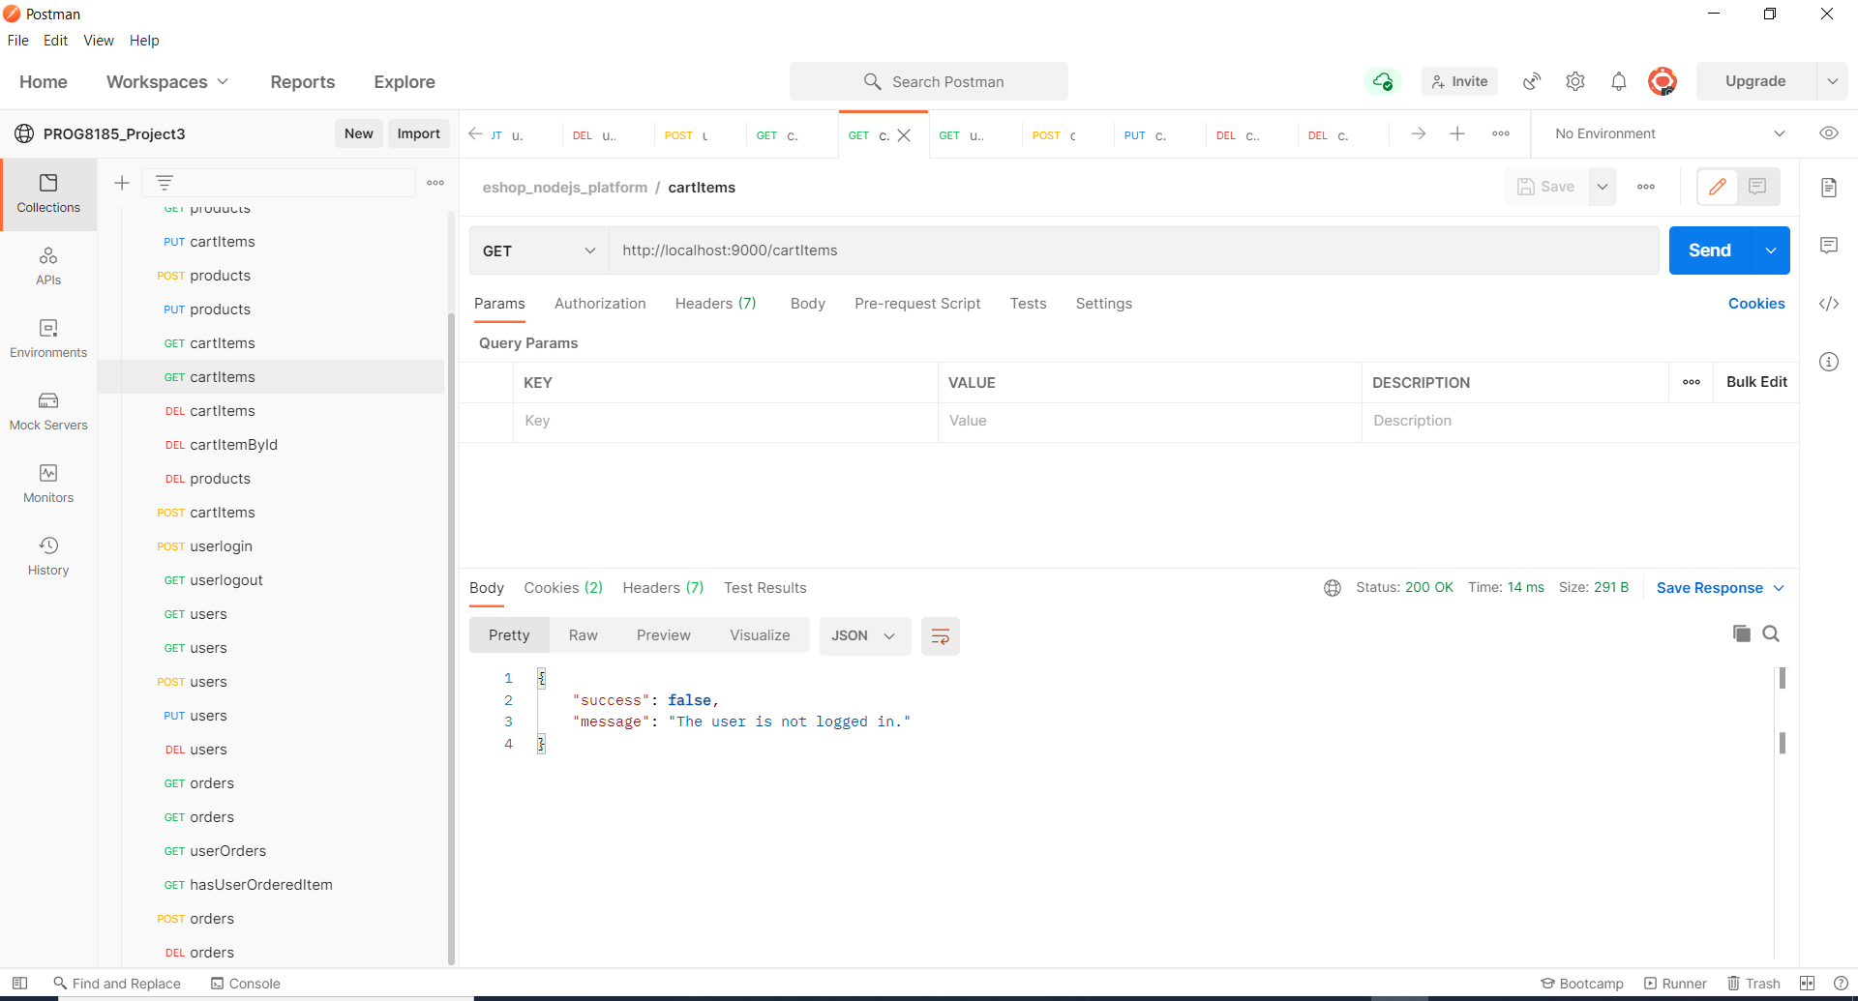

**Test case : 6.2.2**

Retrieves all the products info from cartItems table after checking the username into session.

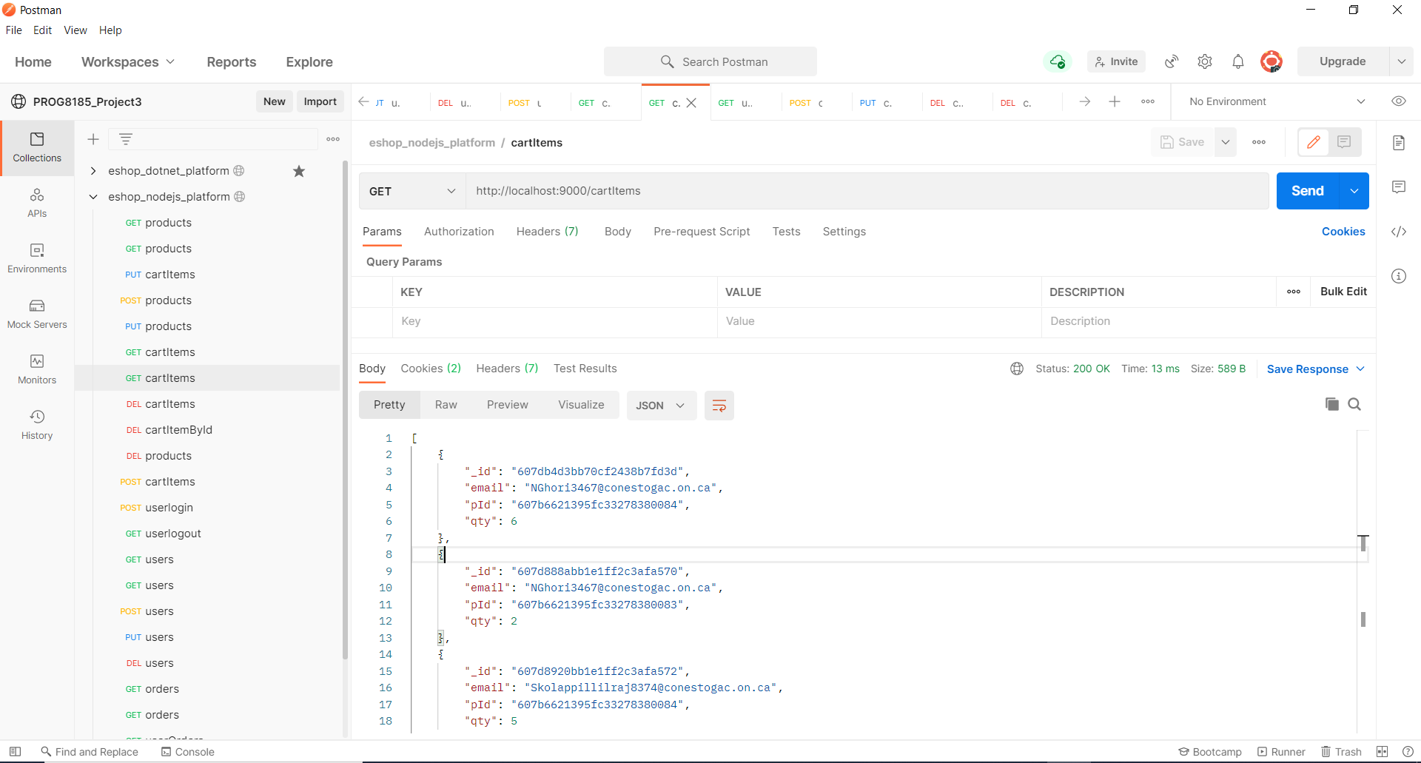

**Test case : 6.2.3**

Retrieves cart information of a particular email id from cartItems table.

Request URL : /api/cartItems/NGhori3467@conestogac.on.ca

Response JSON:

{

    "_id": "607db4d3bb70cf2438b7fd3d",

    "email": "NGhori3467@conestogac.on.ca",

    "pId": "607b6621395fc33278380084",

    "qty": 6

}

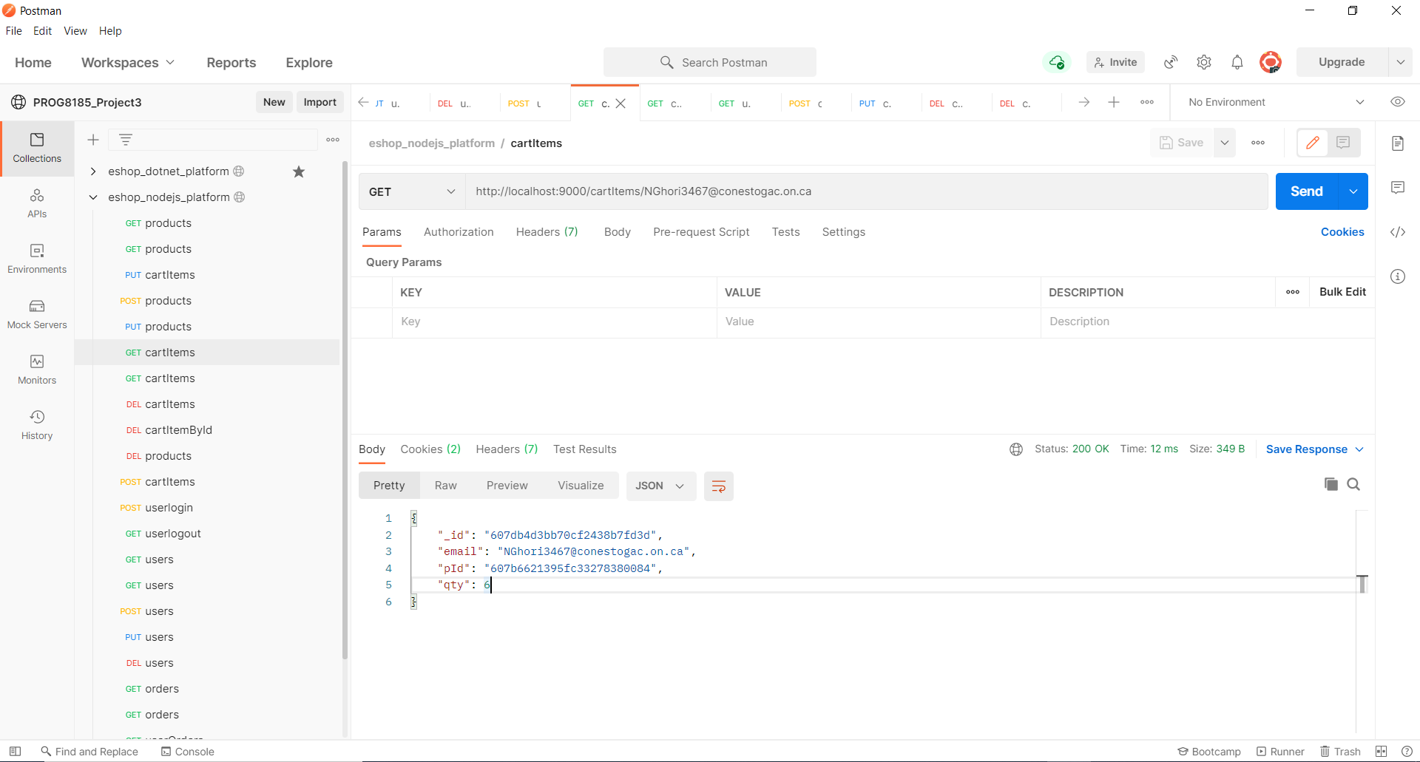

**Test case : 6.2.4**

No cart information is retrieved when wrong email id is given.

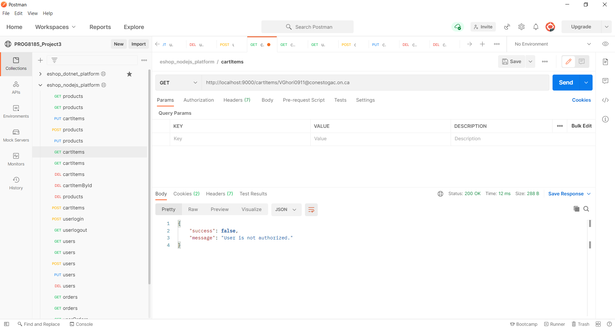

**6.3 PUT Method**

Updates cart info in the cart table.

Request URL : /api/cartItems/ 607d888abb1e1ff2c3afa570

Request body JSON:

{

    "email": "NGhori3467@conestogac.on.ca",

    "pId": "607b6621395fc33278380083",

    "qty": 8

}

Response body JSON:

{

    "success": **true**,

    "message": "The cart item is updated successfully."

}

**Test case : 6.3.1**

CartItem information of a particular user is updated with qty value in the cartItems table.

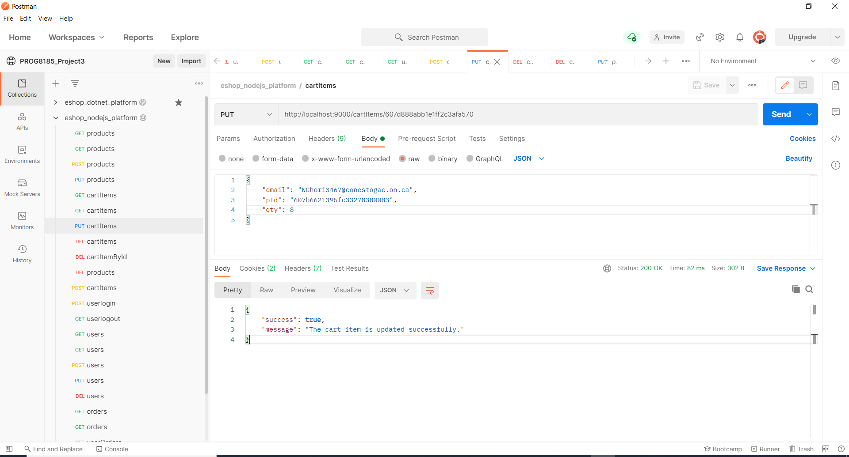

**TestCase: 6.3.2**

No cartItem information is retrieved when wrong id is passed.

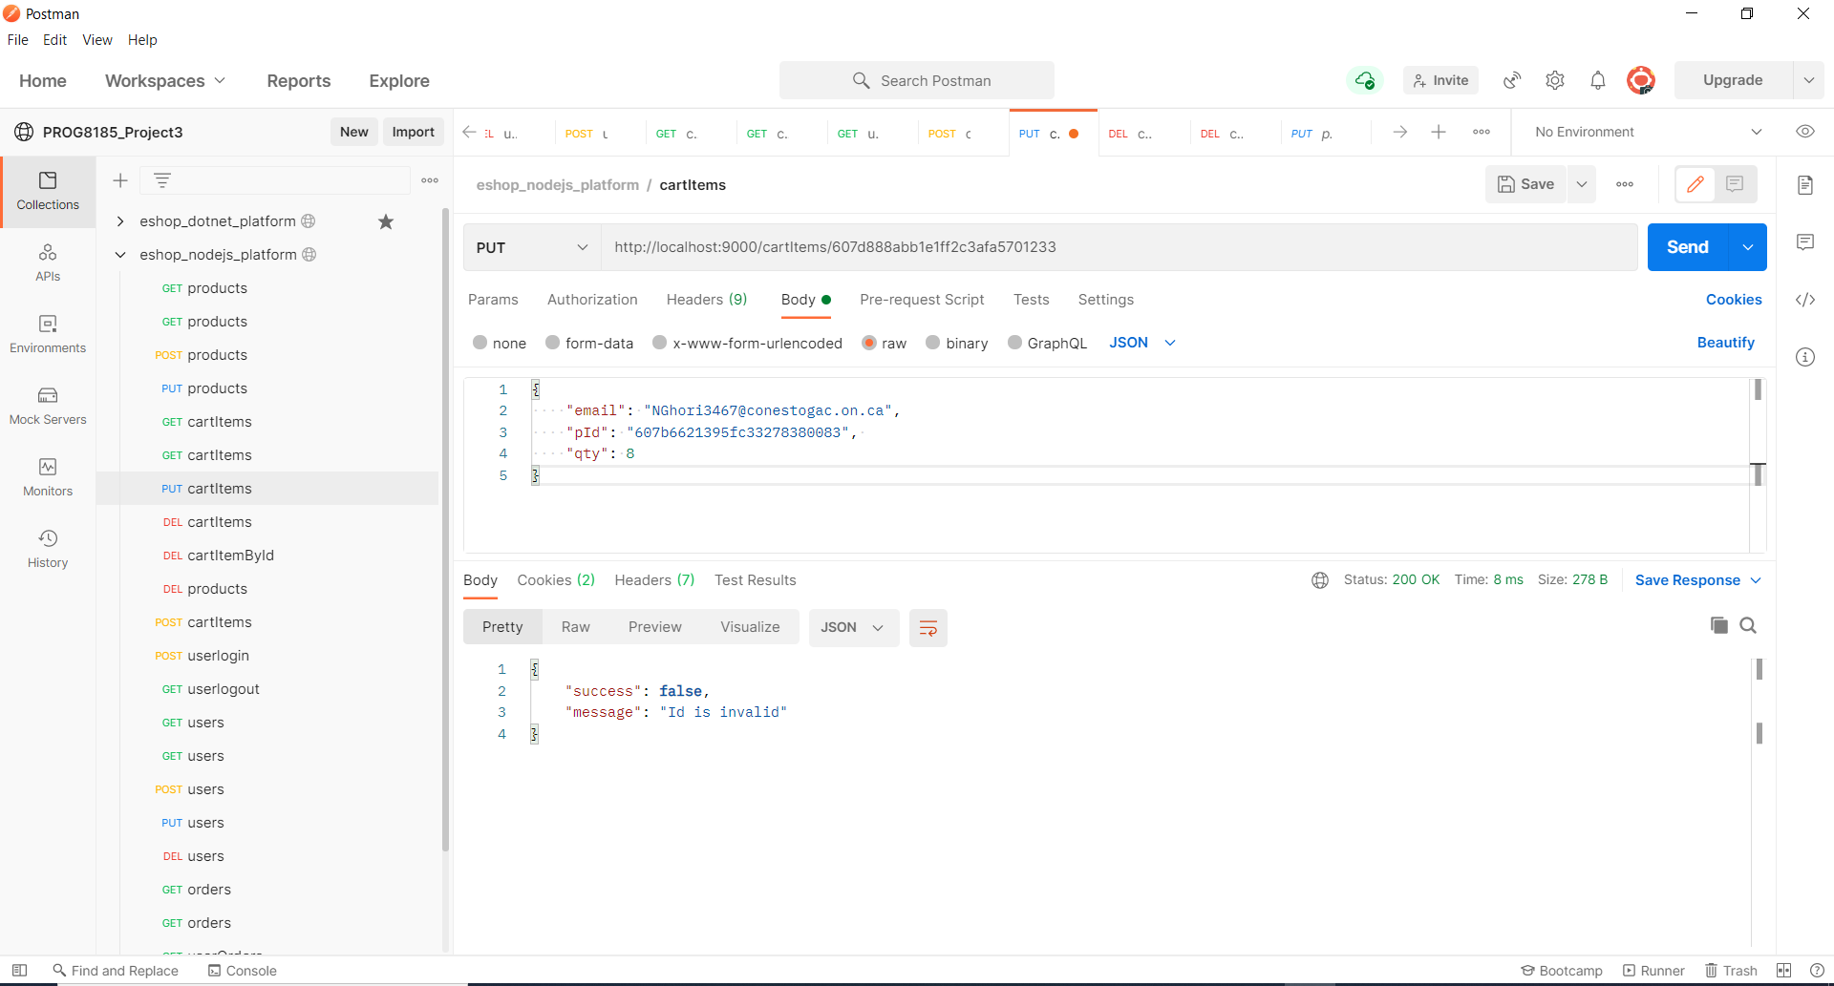

**Test Case : 6.3.3**

Error message is shown when a parameter is missing in the request body.

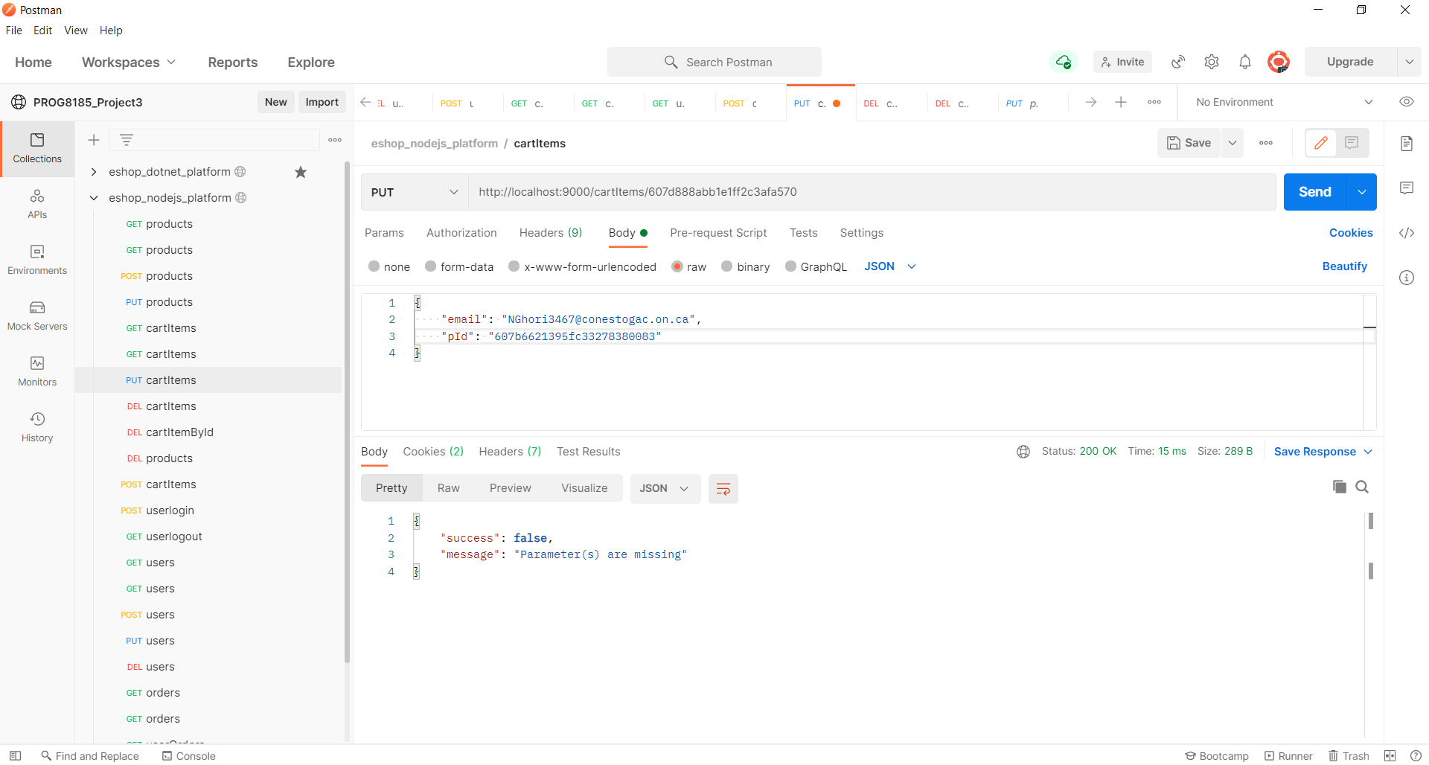

**6.4 DELETE Method**

Delete carts info in the cartItems table.

Request URL : /api/cartItems/ 607d888abb1e1ff2c3afa570

Response from JSON Object:

{

    "success": **true**,

    "message": "The cart item is deleted successfully."

}

Delete a cart from the cartItems table when the cart item id is passed.

**Test case : 6.4.1**

Record from table gets deleted on passing correct cart item id.

Request URL : cartItems/607d888abb1e1ff2c3afa340

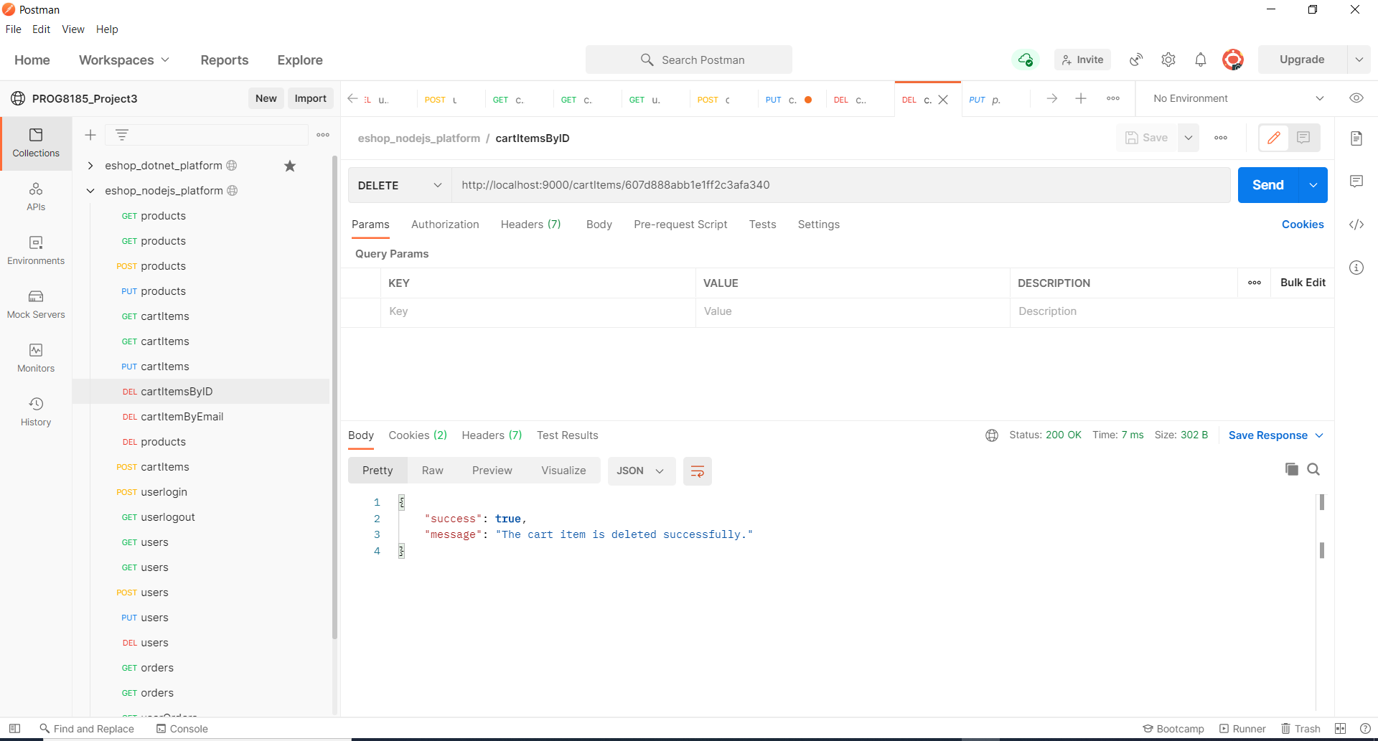

**Test case : 6.4.2**

It will delete all the cartItems of logged in user.

Request URL : cartItemsUser/NGhori3467@conestogac.on.ca

Response from JSON Object:

{

    "success": **false**,

    "message": "The cart is deleted successfully."

}

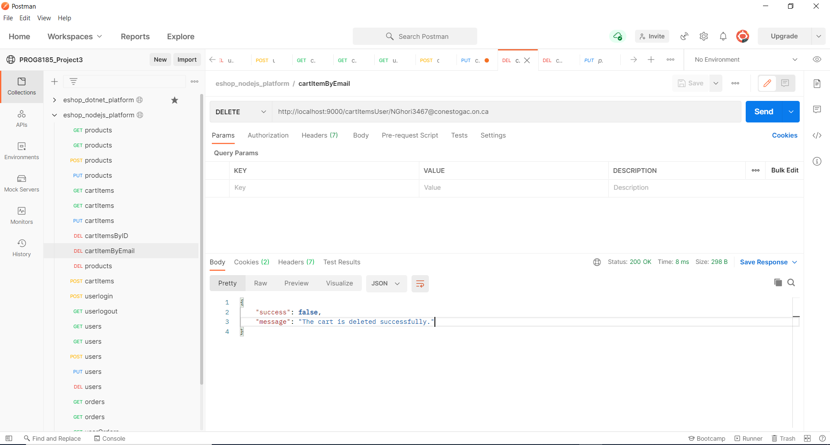

**Test case : 6.4.3**

When user is not authorized it will show an appropriate message.

